Joint Audit and Governance Committee |  |   
Report of Head of Corporate Services
Author: Sally Truman
Telephone:07717271893
Textphone: 18001 07717271893
E-mail: sally.truman@southandvale.gov.uk
Cabinet member responsible: Leigh Rawlins  Tel: 01189 722565  E-mail: Leigh.Rawlins@southoxon.gov.uk  To: Joint Audit and Governance Committee  DATE: 1 July 2025 | Cabinet member responsible: Neil Fawcett  Tel: 07810 482376  E-mail: Neil.Fawcett@whitehorsedc.gov.uk

Annual Complaints Report 2024-2025

Recommendations:
That the committee notes:
- the formal complaints received in 2024-25 and the councils’ performance in responding to complaints against timescales set out in our Corporate Complaints Policy and Procedure, as shown in Appendix 1
- the complaints received by the Local Government and Social Care Ombudsman relating to the councils in 2024-25, as shown in Appendix 2
- the councils’ self-assessment as required by the Housing Ombudsman code of practice, as shown in Appendix 3
- the revised Managing Vexatious and Unreasonable Customer Behaviour Policy as set out in Appendix 4
- the new Remedies and Compensation Policy as set out in Appendix 5

Implications  (further detail within the report) | Financial | Legal | Climate and Ecological | Equality and diversity
Implications  (further detail within the report) | No | Yes | No | No
Signing off officer |  | Nick Bennett |  | Mark Minion

Purpose of Report
- The purpose of this report is to provide a review of formal complaints the councils received during 2024-25 which were considered under the corporate complaints’ procedure. This report is one mechanism by which our complaints-handling processes are scrutinised and staff responding to formal complaints are held to account in accordance with current good practice.
- The report provides the Committee with an update on actions completed and underway in response to the new complaints handling codes published last year by the Local Government and Social Care Ombudsman (LGSCO) and the Housing Ombudsman (HO). Each year the councils must complete a self-assessment against the HO Code, and this is included for information.
- Following our adoption of the new Codes amendments were made to the councils’ Corporate Complaints Policy and Procedure – and we continue to keep this under review. We have updated our Managing Vexatious and Unreasonable Customer Behaviour Policy. We have also introduced a new policy and guidance for staff on remedies and compensation awards resulting from upheld complaints.

Strategic Objectives
- This report sets out how the councils respond to and are adapting their complaints handling processes to ensure that we continue to do so in line with best practice on complaints handling. It therefore underpins all the councils’ respective Council Plan objectives and principles; and makes a specific contribution to Working openly, transparently, responsibly, and in partnership (Vale) and Participation, accessibility and accountability (South).

Background
- In early 2024, both the LGSCO and the HO published new Codes of Practice in relation to handling of formal complaints. The HO code is a statutory code meaning that the councils, as social landlords, must comply with its provisions. The LGSCO code is discretionary, however it sets out current good practice on complaint handling and the councils adopted it as such.

Complaints and Compliments in 2024-25
- The number of complaints received by each council during 2024-25 is set out below, with further detail included at Appendix 1.
South Oxfordshire District Council (SODC)
- During 2024/25, SODC received 99 stage one complaints, which is an increase of 35 (55%) on the previous year. The noticeable difference is the increase in stage one complaints received by Finance from 26 in 2023-24 to 56 in 2024-25. The number of complaints referred to stage two has decreased by 6 to 14 during 2024-25.
Vale of White Horse District Council (VWHDC)
- VWHDC has seen a rise in complaints at each stage in 2024-25, with 99 registered at stage one compared to 75 in 2023-24 (an increase of 32 percent). The noticeable difference is the increase in complaints received by Finance from 34 in 2023-24 to 50 in 2024-25; 18 complaints were referred to stage two, which is an increase of four on the previous year.
Compliments
- We have introduced a facility on our websites for residents to provide comments and compliments should they wish to do so. This enables us to record compliments received council-wide and provide balance in reporting of customer feedback. Where compliments have been received and recorded via the online form or the Customer Service Centre during 2024-25 these are included at Appendix 1.
Developments in reporting
- Staff are currently testing a new complaints module, which is an add-on to our corporate Customer Relationship Management (CRM) system. As well as improving the management of formal complaints this should also provide us with data to develop our reporting further, including tracking actions and summarising learning from complaints, it is expected that this information can be included in next year’s report.
Complaints referred to the Ombudsman
- The LGSCO received 6 complaints relating to SODC, which is a decrease of 2 on the previous year. During 2024-25 the LGSCO made 5 decisions relating to SODC - none of these complaints were upheld. The Ombudsman either closed all after initial enquiries, did not uphold the complaint or referred the complaint back to the council for local resolution.
For VWHDC a total of 13 complaints were received by the Ombudsman, this is an increase of 10 from the previous year. During 2024-25 the LGSCO made 8 decisions relating to VWHDC. The Ombudsman closed 5 complaints, referred 2 back for local resolution and upheld 1 complaint.
During 2024-25 the HO did not receive any complaints for either council in relation to their landlord services.
Summary information on LGSCO complaints is attached at Appendix 2. The annual Ombudsman letters are published on the LGSCO’s website at: lgo.org.uk.
The HO Self-assessment 2024/25
- As the councils are now social landlords, we are required to complete an annual self-assessment of how our complaints handling complies with the HO Code. This must be submitted to the HO and published on our websites by 30 September each year. Our completed self-assessment is attached for information at Appendix 3. It shows that we are compliant with the Code. Two further actions are underway to improve our complaint handling: a training module for all staff is being developed for the councils’ new HR training system, and our new complaints module is scheduled to launch on 1 July.
New/revised policies
- To respond to the changes required in the HO and LGSCO codes we carried out a full review of our Complaints Policy in 2024 and have continued to make minor revisions throughout the year as we develop our understanding of best-practice complaint handling. The current policy is published on our websites at: https://www.southandvale.gov.uk/app/uploads/sites/2/2024/10/Corporate-Complaints-Policy-Sept.2024.pdf or https://www.southandvale.gov.uk/app/uploads/sites/3/2024/10/Corporate-Complaints-Policy-Sept.2024.pdf
- We have also revised our Managing Vexatious and Unreasonable Complainant Policy (attached at Appendix 4) and have taken the opportunity to widen the focus of this policy to cover all customers and not just those who choose to make a complaint. This is to fill a gap in our policy framework relating to visitors to Abbey House or other council buildings, whose ongoing behaviour is abusive, threatening, offensive or otherwise unacceptable. It now gives us a clear framework to address this behaviour.
- The LGSCO and HO both expect councils to have a clear framework on remedies offered and compensation paid as a consequence of formal complaints being upheld. The new Policy and Guidance (attached at Appendix 5) is based upon the HO and LGSCO’s own compensation policies and provides guidance on what levels of compensation could be both appropriate and reasonable based upon the level of service failure experienced or the impact of that failure on the complainant. The councils award very few compensation payments and generally these are low value; the new policy will ensure that rules are applied equitably to any claims across all services.
Financial Implications
- There are no additional financial implications arising directly from this report. Where considered appropriate, and given the specific circumstances surrounding a formal complaint, a head of service may authorise a compensation payment to the complainant; and the new Policy on this provides a framework for such considerations.
Legal Implications
- This report sets out actions taken to comply with the HO and LGSCO codes, including a report of complaints received and performance against statutory targets as required by the codes. It is therefore managing the risk of challenge from the Ombudsman or findings against the councils in relation to the way we handle complaints.

Climate and ecological impact implications
- This report is provided for information only and has no climate and ecological impact implications.

Equalities implications
- This report is for information only and therefore there are no equalities implications.

Risks
- It is important that the councils have robust and efficient complaints handling processes in place to ensure that members of the public receive clear and fair responses to their queries and concerns; and to have oversight and review of the process. This provides transparency for customers and manages reputational risk. Good complaint handling means that we can resolve potential service failures early and prevents matters from escalating further and therefore helps prevent claims against the councils.

Conclusion
- This report sets out a review of formal complaints received during 2024-25. The Committee is asked to review the complaints received, and our response times. Committee is also asked to comment on the self-assessment carried out in line with the requirements of the HO (Appendix 3), and on the revised/new policies included at Appendices 4 and 5.

Background Papers
LGSCO, Complaint Handling Code

HO Service, Complaint Handling Code

Appendix 1
Complaints and Compliments 2024-25

South Oxfordshire District Council

Complaints Received and Response Times

- The following chart shows the number of complaints received at each stage of the process over the past five years. Whilst in recent years there has been a reduction in numbers of stage two and Ombudsman complaints received, the number of stage one complaints received has increased by 35 (55%) from 2023-24 to 2024-25. (Note: the unusually high number in 2020-21 were due to legacy issues from Covid).

- The chart below shows the number of complaints received in 2024-25 for each service area at each stage of the complaints process. As in previous years the highest number of stage one complaints relate to council tax/benefits, planning and housing and environment. Corporate Services has also seen an increase in stage one complaints this year.
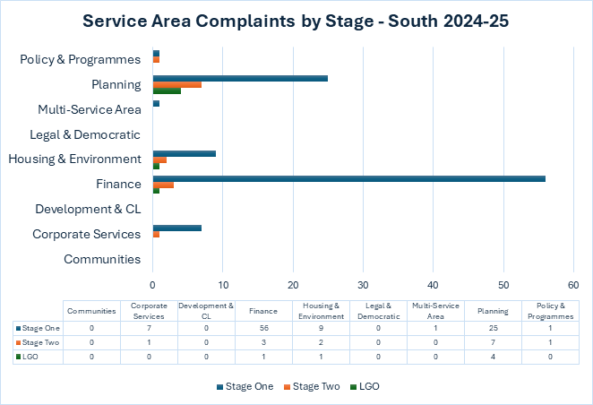

- The following charts show service area performance in providing stage one and two responses within the required timescales of 10 working days for stage one and 20 working days for stage two. We achieved 46 percent of stage one responses and 50 percent of stage two. The new complaints system will enable us to record and report on reasons for late responses and to ensure service areas receive prompt reminders on when responses are due.

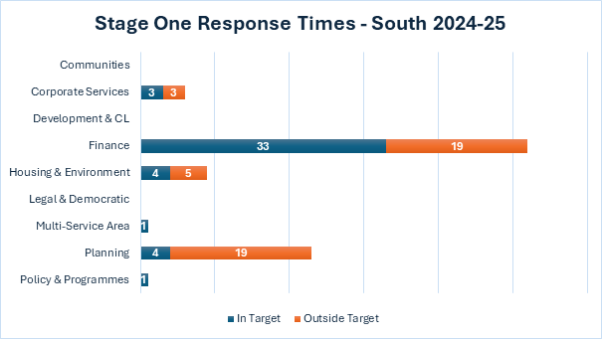

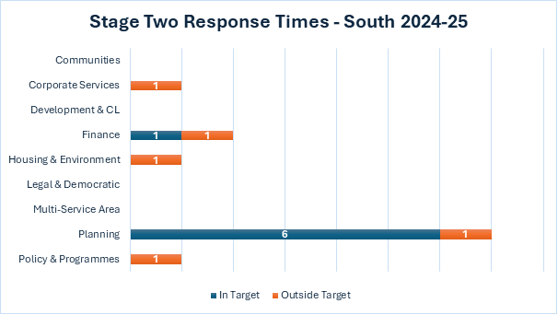

(Please note that the variance in the total number of complaints received, compared with the numbers of complaints responded to in the given year is because a complaint received in late March will be reported as received in one year, and responded to in the following year.)
On the occasions that circumstances do not allow us to meet our deadline, an extension of time will be agreed with the complainant, although they are recorded as outside target because they have exceeded the required timescales.
The average number of days taken to respond to stage one complaints was 16; and at stage two was 30. Note that due to the relatively small number of complaints received, one or two being several days over the deadline can significantly impact on overall performance.

Complaints upheld

- A key theme of the Ombudsman’s new Code of Practice is reporting and learning from complaints. This is something we will continue to develop and respond to once the new complaints module is in place. From the data we have currently, we are able to report this year on the numbers of complaints upheld/partially upheld/not upheld at each stage – see charts below. In 2024-25, 33 complaints (33%) were upheld in full at stage one, with eight (8%) being partially upheld. One complaint (7%) was upheld in full at stage two, with one also being partially upheld.

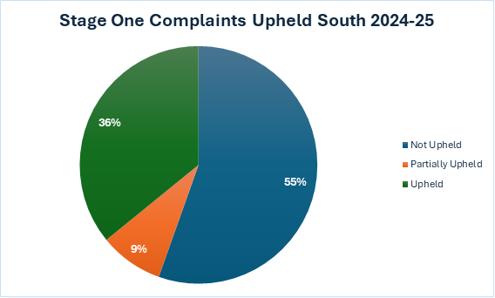
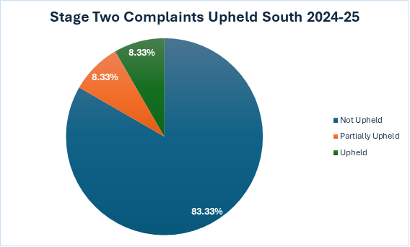

Vale of White Horse District Council

Complaints Received and Response Times

- The chart below shows the number of complaints received at each stage over the past five years. Whilst numbers had been falling over recent years, Vale has seen a rise in complaints at each stage in 2024-25, with 99 stage ones compared to 75 (an increase of 32%). Stage Two and Ombudsman complaints have also increased since last year.
(Note: the unusually high number in 2021-22 were due to legacy issues from Covid.)
Whilst the number of complaints referred to the Ombudsman has risen significantly (from a low base in 2023-24), most of those decided so far were either not investigated
at all or closed after initial investigation (see Appendix 2 for further information).
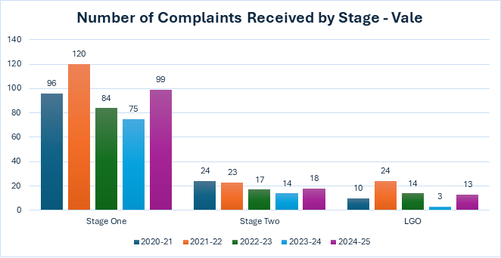

- The chart below shows the number of complaints received in 2024-25 for each service area at each stage of the complaints process. As in previous years the highest number of stage one complaints related to council tax/benefits, followed by Planning, Housing and Environment and Corporate Services.
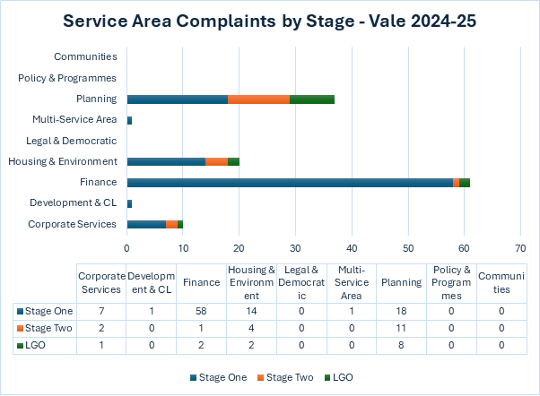

- The following charts show service area performance in providing a stage one response within the target of 10 working days and a stage two response within 20 working days. We achieved the target for 36 percent of stage one responses and 72 percent of stage twos, with 13 planning stage one and 29 finance stage one responses not meeting the target response times. Just 3 stage two responses didn’t meet the target response time.
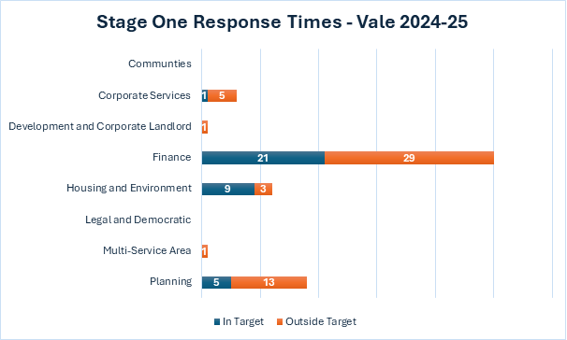
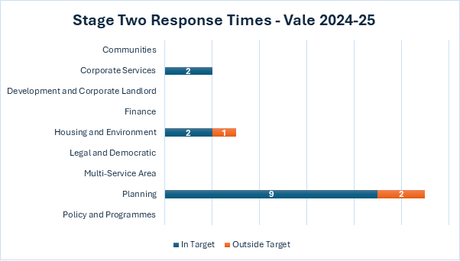

Please note you will see a variance in the total number of complaints received, compared with the numbers of complaints responded to in the given year. This is because a complaint received in late March will be reported as received in one year and responded to in the following.
On the occasions that circumstances do not allow us to meet our deadline, an extension of time will be agreed with the complainant, although they are recorded as outside target because they have exceeded the required target of 10 working days for stage ones and 20 working days for stage twos as set out in our policy.
The average number of days taken to respond to stage one complaints was 20; and at stage two was 30. Note that due to the relatively small number of complaints received, one or two being several days over the deadline can significantly impact on overall performance.

Complaints upheld

- A key theme of the Ombudsman’s new Code of Practice is reporting and learning from complaints. This is something we will continue to develop and respond to. From the data we have, we are able to report this year on the numbers of complaints upheld/partially upheld/not upheld at each stage – see charts below. In 2024-25, 31 complaints (31%) were upheld in full at stage one, with ten (10%) being partially upheld. One complaint (6%) was partially upheld at stage two.
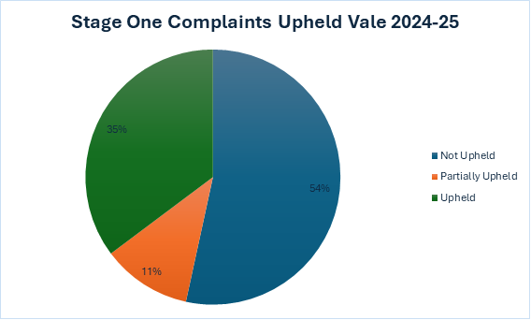
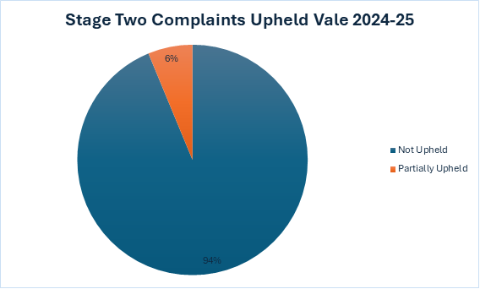

Compliments

- To provide balance (and as previously request by the committee), we also report on positive feedback and compliments received throughout the year. Below is a small selection of those received:

Thanks so much x, I have just been contacted by the resident in question who wanted me to pass on his appreciation. I can't believe your quick response, though I shouldn't really be surprised.

I’d also like to thank you for your help here. I was dreading this job as I assumed it would be really long winded, but you’ve made it really straightforward and I’m extremely grateful for that.
Street naming and numbering

I spoke with one of the Council team today and all is now resolved. Just wanted to say he was excellent, a real pleasure having such a helpful person at the end of the phone line.
Customer service centre

Exceptional advice and help with tree work carried out in a conservation area. x a tree officer was especially helpful.
Planning

Avon Way has been swept by your street cleaner and how beautiful it looks. please thank your team.
Waste and street cleansing

I want to compliment x regarding her fast responses and polite friendly manner relating to concerns on my CIL exception. x kept me informed on all requirements during the process and offered solutions when I couldn't produce some of the required forms, she ultimately resolved my issue by raising my case during her team meeting. Great work, thank you!

CIL team

Appendix 2

Ombudsman cases 2024/25

South Oxfordshire District Council (SODC)

5 complaint decisions were made by the Local Government and Social Care Ombudsman in 2024/25 as shown below:

The complaint investigated was in relation to planning enforcement. The Ombudsman’s decision on this case was:
X complained about the Council’s decisions not to take planning enforcement action against a developer who is building on land next to X’s home. We completed our investigation because we found no fault in the way the way the Council made its decisions.

There were no complaints to the Housing Ombudsman in relation to SODC landlord services in 2024/25.

Vale of White Horse District Council (VWHDC)
8 complaint decisions were made to the Local Government and Social Care Ombudsman in 2024/25 as shown below:

The Complaint upheld related to a planning application, the LGSCO summary of findings is:
Miss X complained about the Council’s handling of her planning application. She said she submitted a second application, incurring added costs for reports and assessments, on the Council’s advice, but it would not succeed. Miss X said the Council has accepted this but has only offered to refund some costs. Miss X said the Council fault distressed her and impacted her financially. There was fault in the way the Council gave Miss X incorrect information, causing her additional costs. The Council has agreed to apologise and repay the costs it agreed Miss X incurred due to the Council fault.
(NB The actions required following this upheld complaint have been completed)

There were no complaints to the Housing Ombudsman in relation to VWHDC landlord services in 2024/25.
Further information about cases reported to the Ombudsman can be viewed on the Local Government and Social Care Ombudsman site: https://www.lgo.org.uk/your-councils-performance.

Appendix 3

Housing Ombudsman Self-Assessment

Appendix A: Self-assessment form
This self-assessment form should be completed by the complaints officer, and it must be reviewed and approved by the landlord’s governing body at least annually.
Once approved, landlords must publish the self-assessment as part of the annual complaints’ performance and service improvement report on their website. The governing body’s response to the report must be published alongside this.
Landlords are required to complete the self-assessment in full and support all statements with evidence, with additional commentary as necessary.
We recognise that there may be a small number of circumstances where landlords are unable to meet the requirements, for example, if they do not have a website. In these circumstances, we expect landlords to deliver the intentions of the Code in an alternative way, for example by publishing information in a public area so that it is easily accessible.

Section 1: Definition of a complaint
Code provision | Code requirement | Comply: Yes / No | Evidence | Commentary / explanation
1.2 | A complaint must be defined as:  ‘an expression of dissatisfaction, however made, about the standard of service, actions or lack of action by the landlord, its own staff, or those acting on its behalf, affecting a resident or group of residents.’ | Yes | Point 8 in our Complaints policy - published on both South Oxfordshire & Vale of White Horse websites:  Vale Complaints Policy  South Complaints Policy | We have adopted the Housing Ombudsman definition for both a service request and a complaint.
1.3 | A resident does not have to use the word ‘complaint’ for it to be treated as such. Whenever a resident expresses dissatisfaction landlords must give them the choice to make complaint. A complaint that is submitted via a third party or representative must be handled in line with the landlord’s complaints policy. | Yes | Point 6 and Point 11 in our Complaints policy | Complainant does not need to use the word ‘complaint’ to have a formal complaint. We require signed confirmation from the complainant to accept a complaint from a third party.
1.4 | Landlords must recognise the difference between a service request and a complaint. This must be set out in their complaints policy. A service request is a request from a resident to the landlord requiring action to be taken to put something right. Service requests are not complaints, but must be recorded, monitored and reviewed regularly. | Yes | Point 8 in our Complaints policy - published on both South Oxfordshire & Vale of White Horse websites:  Vale Complaints Policy  South Complaints Policy | We have adopted the Housing Ombudsman definition for both a service request and a complaint.
1.5 | A complaint must be raised when the resident expresses dissatisfaction with the response to their service request, even if the handling of the service request remains ongoing. Landlords must not stop their efforts to address the service request if the resident complains. | Yes | Point 14 in our complaints policy - published on both South Oxfordshire & Vale of White Horse websites:  Vale Complaints Policy  South Complaints Policy | Complainants have the option at any time to escalate to the formal complaints procedure if they are dissatisfied with response to service request.
1.6 | An expression of dissatisfaction with services made through a survey is not defined as a complaint, though wherever possible, the person completing the survey should be made aware of how they can pursue a complaint if they wish to. Where landlords ask for wider feedback about their services, they also must provide details of how residents can complain. | Yes |  | Housing Compliance Team will respond to comments made on housing related surveys of satisfaction and contact tenants to discuss. Guidance for how to make a complaint is in the process of being added to all surveys hosted by the councils.

Section 2: Exclusions
Code provision | Code requirement | Comply: Yes / No | Evidence | Commentary / explanation
2.1 | Landlords must accept a complaint unless there is a valid reason not to do so. If landlords decide not to accept a complaint they must be able to evidence their reasoning. Each complaint must be considered on its own merits | Yes | Point 15 in our Complaints policy and Appendix 1 for examples of when our formal complaints procedure cannot be used. | This is stated in our complaints policy. Complaints are managed by the corporate complaints team in consultation with the service team. Refusals to be recorded on complaints database and will be recorded in annual report to Joint Audit & Governance Committee.
2.2 | A complaints policy must set out the circumstances in which a matter will not be considered as a complaint or escalated, and these circumstances must be fair and reasonable to residents. Acceptable exclusions include:  The issue giving rise to the complaint occurred over twelve months ago.  - Legal proceedings have started. This is defined as details of the claim, such as the Claim Form and Particulars of Claim, having been filed at court.  - Matters that have previously been considered under the complaints policy. | Yes | Point 15 in our Complaints policy and Appendix 1 for examples of when our formal complaints procedure cannot be used | This is stated in our complaints policy. Complaints are managed by the corporate complaints team in consultation with the service team. Refusals to be recorded on complaints database and will be recorded in annual report to Joint Audit & Governance Committee.
2.3 | Landlords must accept complaints referred to them within 12 months of the issue occurring or the resident becoming aware of the issue, unless they are excluded on other grounds. Landlords must consider whether to apply discretion to accept complaints made outside this time limit where there are good reasons to do so. | Yes | Point 14 in our Complaints policy and Appendix 1 – Point 9 | We will normally expect a complaint to be raised within 12 months of an issue occurring or the complainant becoming aware of the issue; however, we will consider complaints after this period if it is appropriate to do so and will consider each complaint according to its own circumstances.
2.4 | If a landlord decides not to accept a complaint, an explanation must be provided to the resident setting out the reasons why the matter is not suitable for the complaints process and the right to take that decision to the Ombudsman. If the Ombudsman does not agree that the exclusion has been fairly applied, the Ombudsman may tell the landlord to take on the complaint. | Yes | Point 14 in our Complaints policy | This is stated in our complaints policy. Complaints are managed by the corporate complaints team in consultation with the service team. Refusals to be recorded on complaints database and will be recorded in annual report to Joint Audit & Governance Committee.
2.5 | Landlords must not take a blanket approach to excluding complaints; they must consider the individual circumstances of each complaint. | Yes | Point 15 in our Complaints policy | Each complaint is assessed on it’s on own basis following the process outlined in the policy.

Section 3: Accessibility and Awareness
Code provision | Code requirement | Comply: Yes / No | Evidence | Commentary / explanation
3.1 | Landlords must make it easy for residents to complain by providing different channels through which they can make a complaint. Landlords must consider their duties under the Equality Act 2010 and anticipate the needs and reasonable adjustments of residents who may need to access the complaints process. | Yes | Point 9-13 in our Complaints policy.  Point 10. “We have a duty to make reasonable adjustments for residents where appropriate, and as a landlord we must keep a record of any reasonable adjustments agreed with our tenants, as well as a record of any disabilities a tenant has disclosed. Please make us aware if you need support to make a service request or formal complaint.” | Complaints can be made using our online form, over the phone, by email and in person.  We offer assistance to make adjustments for those with accessibility needs.  A complainant is able to have a complaint put forward by a third party with the permission and agreement of the tenant.  Equality, disability, and Discrimination training is a mandatory requirement for all council staff.
3.2 | Residents must be able to raise their complaints in any way and with any member of staff. All staff must be aware of the complaints process and be able to pass details of the complaint to the appropriate person within the landlord. | Yes | Point 9 in our Complaints policy.  Basic training on complaints and what to do if you receive one forms part of our staff induction process.  All staff comms has been issued with guidance in our ‘Team Talk’ newsletter | We plan to include a complaints module on our new staff training site when it launches in Summer 2025 and will make this mandatory for all staff to complete.  In the short term we are informing all staff of changes to complaint handling via our staff newsletter  Specific training for housing staff needed.
3.3 | High volumes of complaints must not be seen as a negative, as they can be indicative of a well-publicised and accessible complaints process. Low complaint volumes are potentially a sign that residents are unable to complain. | Yes | Point 1 in our Complaints policy  Included within our training for complaints handling staff  To be included in mandatory training for all staff | Customer feedback (compliments, comments, and complaints) is important to us, and we want you to tell us when you think we have got something wrong, so we can endeavour to put it right and learn from it how we can improve our services in future.  Compliments and Comments Feedback Form
3.4 | Landlords must make their complaint policy available in a clear and accessible format for all residents. This will detail the two-stage process, what will happen at each stage, and the timeframes for responding. The policy must also be published on the landlord’s website. | Yes | Complaints policy published on our websites | Our Complaints policy is available to all residents. It is published on our websites and details the two-stage process.  Complaint information including the complaints policy is included in rent agreement and tenant pack. Tenant pack is also available in alternative language if requested.
3.5 | The policy must explain how the landlord will publicise details of the complaints policy, including information about the Ombudsman and this Code. | Yes | Point 37 and 38 in our Complaints policy | Section in policy “Monitoring and reporting complaints data”
3.6 | Landlords must give residents the opportunity to have a representative deal with their complaint on their behalf, and to be represented or accompanied at any meeting with the landlord. | Yes | Point 11 & 13 in our complaints policy | Complainants may be accompanied/represented by a friend or advocate at any time.  With signed confirmation a complaint can be submitted on a complainants’ behalf by their chosen representative.
3.7 | Landlords must provide residents with information on their right to access the Ombudsman service and how the individual can engage with the Ombudsman about their complaint. | Yes | Point 29-31 in our complaints policy  Our standard response wording for all complaints at each stage includes this information, and all staff responding to complaints are required to use this wording which is published on our staff intranet

Section 4: Complaint Handling Staff

Code provision | Code requirement | Comply: Yes / No | Evidence | Commentary / explanation
4.1 | Landlords must have a person or team assigned to take responsibility for complaint handling, including liaison with the Ombudsman and ensuring complaints are reported to the governing body (or equivalent). This Code will refer to that person or team as the ‘complaints officer’. This role may be in addition to other duties. | Yes | This is our corporate complaints team – as part of training for staff they are made aware of this and our complaint-handling process, which requires that all complaints are referred to our corporate team to be managed in accordance with our policy – see attached slides | Corporate complaints are handled by a dedicated team within Customer Service Centre, of which includes a registered Link Officer who will liaise with the LGSCO/HO
4.2 | The complaints officer must have access to staff at all levels to facilitate the prompt resolution of complaints. They must also have the authority and autonomy to act to resolve disputes promptly and fairly. | Yes | This is part of our standard process and complaint-handling culture - it is demonstrated in practice by our weekly report of corporate complaints – see attached | Our Senior Management Team (SMT) provides oversight of our complaints and the complaints team reports to the senior management team on a weekly basis.
4.3 | Landlords are expected to prioritise complaint handling and a culture of learning from complaints. All relevant staff must be suitably trained in the importance of complaint handling. It is important that complaints are seen as a core service and must be resourced to handle complaints effectively | Yes | Point 1 and 4 in our policy  Included within our training for complaints handling staff  Our corporate complaints team consists of 2 senior customer service officers and 2 customer service team leaders – see attached Job Descriptions for these roles | Also to be included in mandatory training for all staff (See 3.3)  Our corporate complaints team which is part of our Customer Service Centre, consists of 2 senior customer service officers and 2 customer service team leaders, all of whom are able to deputise for each other and manage complaints to avoid delay

Section 5: The Complaint Handling Process

Code provision | Code requirement | Comply: Yes / No | Evidence | Commentary / explanation
5.1 | Landlords must have a single policy in place for dealing with complaints covered by this Code. Residents must not be treated differently if they complain. | Yes | In our complaints policy on South & Vale websites  Vale Complaints Policy  South Complaints Policy
5.2 | The early and local resolution of issues between landlords and residents is key to effective complaint handling. It is not appropriate to have extra named stages (such as ‘stage 0’ or ‘informal complaint’) as this causes unnecessary confusion. | Yes | In our complaints policy on South & Vale websites  Vale Complaints Policy  South Complaints Policy  Report to SMT on the implications of the new Code | The formal complaints process is two stages. Stage 1 and stage 2 is followed in accordance with the Code.  Previous practice in some teams has been to accept ‘informal’ complaints – the change has been endorsed by our SMT and has been reinforced in staff comms and, content on our staff intranet; it will also be part of ongoing staff training
5.3 | A process with more than two stages is not acceptable under any circumstances as this will make the complaint process unduly long and delay access to the Ombudsman. | Yes | In our complaints policy on South & Vale websites  Vale Complaints Policy  South Complaints Policy  Report to SMT on the implications of the new Code | The formal complaints process is two stages. Stage 1 and stage 2 is followed in accordance with the Code.
5.4 | Where a landlord’s complaint response is handled by a third party (e.g. a contractor or independent adjudicator) at any stage, it must form part of the two stage complaints process set out in this Code. Residents must not be expected to go through two complaints processes. | Yes | Point 16 in our Complaints policy  Report to SMT on the implications of the new Code | Complaints will be investigated and responded to by the relevant service manager with input from our contractor or partner where relevant. Contractors/partners will be able to respond to service requests, but all complaints must be responded to by the relevant council team
5.5 | Landlords are responsible for ensuring that any third parties handle complaints in line with the Code. | Yes |  | Complaints will be investigated and responded to by the relevant service manager with input from our contractor or partner where relevant. Contractors/partners will be able to respond to service requests, but all complaints must be responded to by the relevant council team
5.6 | When a complaint is logged at Stage 1 or escalated to Stage 2, landlords must set out their understanding of the complaint and the outcomes the resident is seeking. The Code will refer to this as “the complaint definition”. If any aspect of the complaint is unclear, the resident must be asked for clarification. | Yes | Point 17 in our Complaints policy | When we acknowledge a complaint, we will check to make sure that we have understood the complaint fully and may seek clarity on the information provided, or extra information before the stage one or stage two investigation can begin.
5.7 | When a complaint is acknowledged at either stage, landlords must be clear which aspects of the complaint they are, and are not, responsible for and clarify any areas where this is not clear. | Yes | Point 15 & 17 in our Complaints policy
5.8 | At each stage of the complaints process, complaint handlers must:  deal with complaints on their merits, act independently, and have an open mind;  give the resident a fair chance to set out their position;  take measures to address any actual or perceived conflict ofinterest; and  consider all relevant information and evidence carefully. | Yes |  | This is part of our complaints process and included within our training for complaints handling staff
5.9 | Where a response to a complaint will fall outside the timescales set out in this Code, the landlord must agree with the resident suitable intervals for keeping them informed about their complaint. | Yes | Point 14 in our Complaints policy | Managed by the Corporate complaints team who will write to the complainant before the deadline to inform of a revised date – any extension will be limited to 10 working days after the original due date. This will be managed through workflow on our newly purchased complaints CRM module
5.10 | Landlords must make reasonable adjustments for residents where appropriate under the Equality Act 2010. Landlords must keep a record of any reasonable adjustments agreed, as well as a record of any disabilities a resident has disclosed. Any agreed reasonable adjustments must be kept under active review. |  |  | Complaints can be made using our online form, over the phone, by email and in person.  We offer assistance to make adjustments for those with accessibility needs.  A complainant can have a complaint put forward by a third party with the permission and agreement of the tenant.  Equality, disability, and Discrimination training is a mandatory requirement for all council staff.
5.11 | Landlords must not refuse to escalate a complaint through all stages of the complaints procedure unless it has valid reasons to do so. Landlords must clearly set out these reasons, and they must comply with the provisions set out in section 2 of this Code. | Yes | Point 22 in our Complaints policy | In a small number of circumstances, the complaint may be escalated straight to stage two. This includes a complaint about the procedure followed during a Code of Conduct complaint, but not for review of the Monitoring Officer’s decision.
5.12 | A full record must be kept of the complaint, and the outcomes at each stage. This must include the original complaint and the date received, all correspondence with the resident, correspondence with other parties, and any relevant supporting documentation such as reports or surveys. | Yes | Complaints file on the corporate complaints database – staff are required to save all documentation relating to a complaint in the relevant file | All correspondence at each stage is saved in the resident’s complaint casefile which links to our complaints database.
5.13 | Landlords must have processes in place to ensure a complaint can be remedied at any stage of its complaints process. Landlords must ensure appropriate remedies can be provided at any stage of the complaints process without the need for escalation. | Yes |  | All complaints-handling staff have the authority to agree non-financial remedies and HoS have authority to agree financial remedies.
5.14 | Landlords must have policies and procedures in place for managing unacceptable behaviour from residents and/or their representatives. Landlords must be able to evidence reasons for putting any restrictions in place and must keep restrictions under regular review. | Yes | Point 36 in our Complaints policy | We have a separate policy for dealing with vexatious and unreasonable behaviour  Vale - Vexatious and unreasonable behaviour policy  South - Vexatious and unreasonable behaviour policy
5.15 | Any restrictions placed on contact due to unacceptable behaviour must be proportionate and demonstrate regard for the provisions of the Equality Act 2010. | Yes | Point 10 – In the vexatious and unreasonable behaviour policy | Vale - Vexatious and unreasonable behaviour policy  South - Vexatious and unreasonable behaviour policy

Section 6: Complaints Stages
Stage 1
Code provision | Code requirement | Comply: Yes / No | Evidence | Commentary / explanation
6.1 | Landlords must have processes in place to consider which complaints can be responded to as early as possible, and which require further investigation. Landlords must consider factors such as the complexity of the complaint and whether the resident is vulnerable or at risk. Most stage 1 complaints can be resolved promptly, and an explanation, apology or resolution provided to the resident. | Yes | Point 20 & 27 in our complaints policy | Stage One responded to within 10 working days of our acknowledgement.  Stage Two responded to within 20 working days.
6.2 | Complaints must be acknowledged, defined and logged at stage 1 of the complaints procedure within five working days of the complaint being received. | Yes | Point 15 in our Complaints policy | This is managed through workflow on our dedicated CRM complaints module
6.3 | Landlords must issue a full response to stage 1 complaints within 10 working days of the complaint being acknowledged. | Yes | Point 20 in our Complaints policy | This is managed through workflow on our dedicated CRM complaints module
6.4 | Landlords must decide whether an extension to this timescale is needed when considering the complexity of the complaint and then inform the resident of the expected timescale for response. Any extension must be no more than 10 working days without good reason, and the reason(s) must be clearly explained to the resident. | Yes |  | Managed by the Corporate complaints team who will write to the complainant before the deadline to inform of a revised date – any extension will be limited to 10 working days after the original due date. This will be managed through workflow on our complaints CRM module
6.5 | When an organisation informs a resident about an extension to these timescales, they must be provided with the contact details of the Ombudsman. | Yes | Included within our standard wording template | This is included as part of our standard template wording that officers must use when responding to Stage One complaints.
6.6 | A complaint response must be provided to the resident when the answer to the complaint is known, not when the outstanding actions required to address the issue are completed. Outstanding actions must still be tracked and actioned promptly with appropriate updates provided to the resident. | Yes | Point 33 in our Complaints policy | Actions required will be recorded on our dedicated complaints database and processes will be in place to ensure these actions are completed and a corporate record kept.
6.7 | Landlords must address all points raised in the complaint definition and provide clear reasons for any decisions, referencing the relevant policy, law and good practice where appropriate. | Yes | Included within our standard wording template | This is included as part of our standard template wording that officers must use when responding to Stage One complaints.
6.8 | Where residents raise additional complaints during the investigation, these must be incorporated into the stage 1 response if they are related and the stage 1 response has not been issued. Where the stage 1 response has been issued, the new issues are unrelated to the issues already being investigated or it would unreasonably delay the response, the new issues must be logged as a new complaint. | Yes | Point 23 in our Complaints policy | Each complaint is considered on its individual circumstances
6.9 | Landlords must confirm the following in writing to the resident at the completion of stage 1 in clear, plain language:  - the complaint stage;  - the complaint definition;  - the decision on the complaint;  - the reasons for any decisions made;  - the details of any remedy offered to put things right;  - details of any outstanding actions; and  - details of how to escalate the matter to stage 2 if the individual is not satisfied with the response. | Yes | In our Complaints policy | This is included as part of our standard template wording that officers must use when responding to Stage One complaints.  All responses are checked and validated by a Corporate Complaints officer before sending.

Stage 2
Code provision | Code requirement | Comply: Yes / No | Evidence | Commentary / explanation
6.10 | If all or part of the complaint is not resolved to the resident’s satisfaction at stage 1, it must be progressed to stage 2 of the landlord’s procedure. Stage 2 is the landlord’s final response. | Yes | Point 24 of our Complaints policy
6.11 | Requests for stage 2 must be acknowledged, defined and logged at stage 2 of the complaints’ procedure within five working days of the escalation request being received. | Yes | Point 27 of our Complaints policy
6.12 | Residents must not be required to explain their reasons for requesting a stage 2 consideration. Landlords are expected to make reasonable efforts to understand why a resident remains unhappy as part of its stage 2 response. | Yes | Point 24 of our Complaints policy
6.13 | The person considering the complaint at stage 2 must not be the same person that considered the complaint at stage 1. | Yes | In our Complaints policy | Stage One – Service Manager  Stage Two – Head of Service
6.14 | Landlords must issue a final response to the stage 2 within 20 working days of the complaint being acknowledged. | Yes | Point 27 of our Complaints policy
6.15 | Landlords must decide whether an extension to this timescale is needed when considering the complexity of the complaint and then inform the resident of the expected timescale for response. Any extension must be no more than 20 working days without good reason, and the reason(s) must be clearly explained to the resident. | Yes |  | Managed by the Corporate complaints team who will write to the complainant before the deadline to inform of a revised date – any extension will be limited to 10 working days after the original due date. This will be managed through workflow on our complaints CRM module
6.16 | When an organisation informs a resident about an extension to these timescales, they must be provided with the contact details of the Ombudsman. | Yes |  | This is included as part of our standard template wording that officers must use when responding to Stage One complaints.
6.17 | A complaint response must be provided to the resident when the answer to the complaint is known, not when the outstanding actions required to address the issue are completed. Outstanding actions must still be tracked and actioned promptly with appropriate updates provided to the resident. | Yes |  | This is included as part of our standard template wording. Actions required will be recorded on our dedicated complaints database and processes will be in place to ensure these actions are completed and a corporate record is kept.
6.18 | Landlords must address all points raised in the complaint definition and provide clear reasons for any decisions, referencing the relevant policy, law and good practice where appropriate. | Yes |  | This is included as part of our standard template wording that officers must use when responding to Stage Two complaints.
6.19 | Landlords must confirm the following in writing to the resident at the completion of stage 2 in clear, plain language:  - the complaint stage;  - the complaint definition;  - the decision on the complaint;  - the reasons for any decisions made;  - the details of any remedy offered to put things right;  - details of any outstanding actions; and  - details of how to escalate the matter to the Ombudsman Service if the individual remains dissatisfied. | Yes |  | This is included as part of our standard template wording that officers must use when responding to Stage Two complaints.  All responses are checked and validated by a Corporate Complaints officer before sending.
6.20 | Stage 2 is the landlord’s final response and must involve all suitable staff members needed to issue such a response. |  | In our complaints policy | Part of our standard process for Stage Two. Stage two is the final response before advising the complainant of their right to contact the Ombudsman.

Section 7: Putting things right
Code provision | Code requirement | Comply: Yes / No | Evidence | Commentary / explanation
7.1 | Where something has gone wrong a landlord must acknowledge this and set out the actions it has already taken, or intends to take, to put things right. These can include:  - Apologising;  - Acknowledging where things have gone wrong;  - Providing an explanation, assistance or reasons;  - Taking action if there has been delay;  - Reconsidering or changing a decision;  - Amending a record or adding a correction or addendum;  - Providing a financial remedy;  - Changing policies, procedures or practices. | Yes | Point 32 & 33 of our Complaints policy | All responses are checked and validated by a Corporate Complaints officer before sending.
7.2 | Any remedy offered must reflect the impact on the resident as a result of any fault identified. | Yes |  | All complaints-handling staff have the authority to agree non-financial remedies and HoS have authority to agree financial remedies. These are considered on a case-by-case basis.
7.3 | The remedy offer must clearly set out what will happen and by when, in agreement with the resident where appropriate. Any remedy proposed must be followed through to completion. | Yes |  | This will be managed through workflow on our complaints CRM module
7.4 | Landlords must take account of the guidance issued by the Ombudsman when deciding on appropriate remedies. | Yes |  | Out compensation policy is takes account of the guidance issued by the Ombudsman

Section 8: Self-assessment, reporting and compliance
Code provision | Code requirement | Comply: Yes / No | Evidence | Commentary / explanation
8.1 | Landlords must produce an annual complaints performance and service improvement report for scrutiny and challenge, which must include:  - the annual self-assessment against this Code to ensure their complaint handling policy remains in line with its requirements.  - a qualitative and quantitative analysis of the landlord’s complaint handling performance. This must also include a summary of the types of complaints the landlord has refused to accept;  - any findings of non-compliance with this Code by the Ombudsman;  - the service improvements made as a result of the learning from complaints;  - any annual report about the landlord’s performance from the Ombudsman; and  - any other relevant reports or publications produced by the Ombudsman in relation to the work of the landlord. | Yes | Point 37 in our Complaints policy  Annual report to JAGC
8.2 | The annual complaints performance and service improvement report must be reported to the landlord’s governing body (or equivalent) and published on the on the section of its website relating to complaints. The governing body’s response to the report must be published alongside this. |  | This is published on Joint Audit and Governance Committee webpages.  South JAGC  Vale JAGC | Link to the published report on the website alongside the JAGC minutes
8.3 | Landlords must also carry out a self-assessment following a significant restructure, merger and/or change in procedures. | Yes |  | This is standard practice of the councils.  As of 1 April 2025, all management functions returned inhouse. We also appointed a new term contractor for housing maintenance.
8.4 | Landlords may be asked to review and update the self-assessment following an Ombudsman investigation. | Yes |  | We would follow direction of the Ombudsman if requested to following an Ombudsman investigation.
8.5 | If a landlord is unable to comply with the Code due to exceptional circumstances, such as a cyber incident, they must inform the Ombudsman, provide information to residents who may be affected, and publish this on their website Landlords must provide a timescale for returning to compliance with the Code. | Yes |  | This is included in our business continuity plan.

Section 9: Scrutiny & oversight: continuous learning and improvement
Code provision | Code requirement | Comply: Yes / No | Evidence | Commentary / explanation
9.1 | Landlords must look beyond the circumstances of the individual complaint and consider whether service improvements can be made as a result of any learning from the complaint. |  |  | This will be managed through workflow and reporting on our complaints CRM module
9.2 | A positive complaint handling culture is integral to the effectiveness with which landlords resolve disputes. Landlords must use complaints as a source of intelligence to identify issues and introduce positive changes in service delivery. | Yes | Point 1 of our Complaints policy
9.3 | Accountability and transparency are also integral to a positive complaint handling culture. Landlords must report back on wider learning and improvements from complaints to stakeholders, such as residents’ panels, staff and relevant committees. | Yes |  | We follow a corporate process, which involves internal quarterly review meetings.
9.4 | Landlords must appoint a suitably senior lead person as accountable for their complaint handling. This person must assess any themes or trends to identify potential systemic issues, serious risks, or policies and procedures that require revision. | Yes |  | Our housing team has an interim Housing Delivery manager who is responsible for monitoring these.
9.5 | In addition to this a member of the governing body (or equivalent) must be appointed to have lead responsibility for complaints to support a positive complaint handling culture. This person is referred to as the Member Responsible for Complaints (‘the MRC’). | Yes |  | This is our portfolio holder for Customer Services.
9.6 | The MRC will be responsible for ensuring the governing body receives regular information on complaints that provides insight on the landlord’s complaint handling performance. This person must have access to suitable information and staff to perform this role and report on their findings. | Yes |  | The portfolio holder for Customer Services will present this information to JAGC as part of the councils’ formal governance processes.
9.7 | As a minimum, the MRC and the governing body (or equivalent) must receive:  - regular updates on the volume, categories and outcomes of complaints, alongside complaint handling performance;  - regular reviews of issues and trends arising from complaint handling;  - regular updates on the outcomes of the Ombudsman’s investigations and progress made in complying with orders related to severe maladministration findings; and  - annual complaints performance and service improvement report. | Yes |  | This is provided to the MRC monthly as part of our portfolio update.
9.8 | Landlords must have a standard objective in relation to complaint handling for all relevant employees or third parties that reflects the need to:  - have a collaborative and co-operative approach towards resolving complaints, working with colleagues across teams and departments;  - take collective responsibility for any shortfalls identified through complaints, rather than blaming others; and  - act within the professional standards for engaging with complaints as set by any relevant professional body. | Yes | Point 1 of our Complaints policy

Appendix 4

Managing Vexatious and Unreasonable

Customer Behaviour Policy

(NB all revisions are highlighted)

INTRODUCTION
- We want to be able to deal with customers in ways that are open, fair and proportionate. A clear policy on dealing with what is considered to be unreasonable behaviour helps staff to understand what is expected of them, what options for taking action are available, and who can authorise such action.

- Some customers may have justifiable complaints but may pursue them in unreasonable ways. Others may pursue complaints which appear to have no substance, or which have already been exhaustively investigated and determined; their contacts with the council may be amicable but nevertheless will place heavy demands on staff time.

- Situations can sometimes escalate, and complainants’ behaviour may become abusive, threatening, offensive or otherwise unacceptable. We recognise that sometimes, but not always, this is because of underlying health or social issues they are experiencing.

- We need to balance our commitment to equality and inclusion and to supporting our more vulnerable customers, along with our aim to learn from complaints to improve our services; against the resources that can be consumed dealing with some vexatious or unreasonable customers.

- We also need to protect the physical and mental wellbeing of our staff and the integrity of our processes.

AIM
- The aim of this policy is to outline the actions that we may take when customers display vexatious or unreasonable behaviour towards our staff, our councillors or the council generally.

DEFINING UNREASONABLE AND VEXATIOUS BEHAVIOUR
- Our definition of unreasonable customer behaviour is: those customers who, because of the nature or frequency of their contacts with the councils, hinder the councils’ consideration of theirs, or other people’s enquiries or consume an unreasonable amount of staff time, and who continue to do so when it has been made clear that it is not possible to achieve the outcome they want.

- Our definition of vexatious behaviour is: customers who are angry or abusive to staff such that they cause staff to feel physically threatened or impact on their mental wellbeing.

- Below are examples of actions and behaviours that may be considered unreasonable or vexatious:

- Abusive, offensive, aggressive, threatening behaviour and/or language.

- Submitting repeat requests or complaints with minor additions/variations and insisting that these are ‘new’ matters.

- Refusing to accept a decision and repeatedly arguing points with no new evidence.

- Persistence in presenting the details of an enquiry or complaint in a confusing manner or refusing to provide evidence to support their claims, despite offers of help to do so.

- Making excessive demands on the time and resources of staff. This will include lengthy and/or frequent phone calls, emails or letters to council staff, or repeated visits to the council offices.

- Adopting a ‘scatter gun’ approach: pursuing parallel enquiries or complaints on the same issue with more than one service area.

- Demanding meetings with staff when it is clear this will not achieve what the customer is seeking to achieve or resolve the matter any further.

- Submitting falsified documentation.

- Refusing to cooperate with set processes, for example refusing to accept that certain issues are not within the scope of the corporate complaints policy and procedure, or that the matter is not the district councils’ responsibility despite being directed to the right organisation.

- Making unjustified complaints about staff who are trying to deal with the issues, including demanding to deal with someone else without good reason.

- Denying or changing statements made at the beginning of an enquiry or complaint.

ACTIONS TAKEN BY THE COUNCILS TO MANAGE UNREASONABLE OR VEXATIOUS BEHAVIOUR
- If such behaviours are displayed towards a member of staff, we will warn the customer that we may:

- Terminate the phone call if the behaviour does not change.

- Terminate the meeting if the behaviour does not change.

- Decline to provide a further response to an email or letter.

- Request them not to attend the councils’ offices further.

- Where behaviour is so extreme that it threatens the immediate safety and welfare of staff, the council will consider other options, for example reporting the matter to the police.

- If the inappropriate behaviour recurs, the relevant head of service will consider invoking this policy. In making this decision, they will review whether:

- The customers matters are being or have been investigated properly and thoroughly, in line with relevant policy and procedures including the councils’ formal corporate complaints procedure available at: www.southoxon.gov.uk/complaints and www.whitehorsedc.gov.uk/complaint

- Decisions reached or actions taken are logical, fair and reasonable.

- Communications with the customer have been adequate.

- That sufficient support has been provided to the customer to explain their enquiry or to submit a complaint.

- Should the head of service decide to invoke this policy, they will write to the customer advising:

- Why a decision has been taken to invoke the policy.

- What specific restriction(s) have been applied. Please see below.

- How long the restrictions will be in place.

- What they can do to have the decision reviewed by the Chief Executive.

- That they have the right to contact the Local Government and Social Care Ombudsman about the fact that they have been treated as an unreasonable or vexatious customer.

- Restrictions may include:

- Advising the customer that all future requests or complaints on the same matter, not raising anything new, will be read and placed on file but not acknowledged.

- Restrictions on the length or number of telephone calls or personal contact, including visits received from the customer.

- Restricting the way contact is made for example only by telephone, letter, or email.

- Restricting the customer to contacting one designated officer.

- Requiring face to face contact to take place in front of a witness.

- Recording of telephone calls, providing the customer has been made aware that calls may or will be recorded.

- A record of any decision made, and related correspondence, will be stored on our corporate complaints database.

- The decision made to invoke this policy will be reviewed by the relevant Head of Service after the agreed period, after which any restrictions in place can be lifted unless there is good reason to extend the limit.

Appendix 5

[Draft] Remedies and Compensation Policy
INTRODUCTION AND SCOPE

- This policy provides guidance to all staff responding to formal complaints on what remedies are possible resulting from a complaint, and when it is appropriate to offer financial compensation for service failure.
- The policy sits alongside our complaints policy and procedure. It applies to complaints recorded through our Corporate Complaints process including those made by our housing tenants - regardless of tenure type, who live in homes owned or managed by South Oxfordshire and Vale of White Horse District Councils.
- It also applies to services supplied by any of the Councils appointed contractors on our behalf.
PURPOSE AND OBJECTIVES

- The purpose of this policy is to make sure that the appropriate remedies are considered in each case, and that any offer of compensation is consistent, fair, and proportionate and consider all facts and issues raised in a complaint.
- The policy is in line with remedies and compensation recommended by the Local Government and Social Care Ombudsman and the Housing Ombudsman.
POLICY STATEMENT

- The Councils are committed to putting people at the centre of everything we do. We aim to provide a high standard of service and resolve any issues before they become a complaint, however we recognise that we do not always get it right first time, sometimes things go wrong, and customers don’t get the service they expect, or we fall short of the standards we have promised. Our aim is to restore customers to the position they would have been in had the service failure not occurred.
- Our remedies and compensation policy recognises that there are other remedies available to put a situation right. It recognises that customers are not automatically entitled to compensation, but in some instances, financial compensation may be the most appropriate form of redress.

DEFINITIONS

Complaint outcome (redress) – may be an apology, accepting responsibility, a commitment to make changes, or to remedy the situation.
Remedy - is any action taken to resolve a complaint which seeks to place the complainant in the position they were in if any service failure had not occurred. It may take into account both subjective and objective factors and may – but will not always - lead to a compensation payment.
Compensation – is a financial payment. It is firstly a payment in recognition of actual financial loss (direct or indirect) or detriment to the complainant. A compensation payment can also be made to compensate for direct or indirect financial loss, inconvenience or distress.

USE OF THIS POLICY

Our commitment
- Whilst this policy provides a general framework, to provide a consistent and fair approach when resolving claims for compensation, all cases will be considered according to their own circumstances.
- We will consider and identify reasonable solutions with customers seeking remedy, ensuring that their personal circumstances are taken into consideration, including any vulnerability, and the nature of the impact as a consequence of any service failure.
- In deciding on any remedy or compensation we will take into account action, or lack of action by the complainant which contributed to or prolonged the impact on them as a result of any service failure.
- Any compensation should be claimed within 6 months of the failure, fault, or event, unless there are exceptional circumstances that prevent this (such as delays due to waiting for works to be completed). In such cases, we will work with Customers to ensure fair and equitable outcomes.
TYPES OF COMPENSATION
Statutory compensation
- Some services may have a statutory framework to compensation payment eg.as a Landlord (see Appendix 2). Where such a statutory framework exists, we have a duty to comply with this.
Compensation for direct or indirect financial loss
- This will be quantifiable and therefore be able to be evidenced by the complainant.
Compensation for emotional distress, inconvenience, time and trouble
- This is more difficult to quantify as it will very much depend upon what the complainant is telling you about the impact on them and therefore requires more of a judgement.

- In all cases compensation should be considered based on the circumstances of the specific case and should be both reasonable and proportionate. It should not lead to the complainant making a profit or advantage, and we should explain clearly how we have reached the decision on the level of compensation.

DIRECT/INDIRECT LOSS PAYMENTS
- This type of compensation is for actual financial loss or payments not received.
- In some cases, there is evidence that our service failure has resulted in the customer suffering a loss that is clear and measurable. These could include increased heating bills due to disrepair, having to pay for alternative accommodation or take away food, paying for cleaning or carrying out repairs where the Councils have failed to meet their obligations.
- When assessing these cases, we will require evidence to support any claim and will assess whether these costs have been reasonably and appropriately incurred.
- Where evidence can’t be reasonably be provided, we will consider on the balance of probability whether the costs would have been likely to have been incurred.
- In order for costs incurred to be compensated the complainant must have raised the matter with the council and given us the opportunity to put things right first.
- Compensation may be paid to cover lost interest, but this is only in exceptional circumstances and for a delay of 6 months or more, or where costs are significant.
- Compensation won’t be paid for loss of wages e.g. when waiting for a site visit, inspection or repair as this is a reasonable expectation.
- Complainants must use the councils’ formal complaints procedure to seek to resolve issues, so costs incurred for professional or legal advice will not be covered.
Note: claims for loss of personal belongings should be an insurance claim, although we may provide compensation for distress or inconvenience as a result of the loss (see below).

COMPENSATION FOR DISTRESS, INCONVENIENCE, TIME AND TROUBLE
- These are discretionary compensation payments and can be made where the councils’ actions have resulted in:

- poor complaint handling
- delays in providing a service
- failure to provide a service that has been charged for
- loss of a service failure to meet target response times
- failure to follow policy and procedure
- unreasonable time taken to resolve a situation
- the customer suffering distress and inconvenience.

- When calculating the amount of compensation to be paid, we will look at the severity of any service failure and the associated impact on the customer. We will take the customer’s personal circumstances into consideration when doing this, including any aggravating factors such as: vulnerability, disability, family circumstances, caring responsibilities, and previous history of the council mishandling issues for this complainant.

- The cost of telephone calls and time taken in contacting the council will not normally be compensated unless these are significantly over and above what might reasonably be expected due to the councils’ failure to resolve an issue.
- We reserve the right to use discretion and flexibility when applying this policy and may deal with a complaint differently depending on the individual circumstances of the household. It may be appropriate to remedy a complaint with actions separately from, or in conjunction with, an offer of compensation. These can include the following:

- Practical actions (such as offering to undertake repairs or redecoration, which would otherwise be a customer’s responsibility).
- Gestures of goodwill (e.g. vouchers).

- In such circumstances, any discretion will be applied fairly and appropriately.
- Where a compensation payment has been made this should not normally be offset against amounts owed to the complainant on a different matter, unless specific legislation relating to that service allows for this.
WHEN COMPENSATION WILL NOT BE CONSIDERED UNDER THIS POLICY

- Compensation may not be considered through this policy in a number of circumstances, including the following:

- Negligence or personal injury (liability claims must be made to our Insurance Team and are not covered by this policy).
- Damage to personal possessions, home contents or personal injury. Liability claims must be made to The Councils Insurance Team and are not covered by this policy. If the customer does not have contents insurance, a claim might be able to be submitted to us and will be passed to our insurers for investigation. Our insurer will investigate if we were negligent and advise if a claim is accepted.
- Alterations to council properties by the complainant that are unauthorised.
- Short-term nuisance caused by building works.
- Neighbourhood nuisance.
- Loss of earnings or annual leave (if, under the terms of their tenancy agreements, Customers Where the fault is due to a customer’s own action or lack of action, including those of a family member, visitor, or neighbour
- Where the compensation claim is subject to a tribunal or legal proceedings.
- Matters relating to services not provided by, or outside the councils’ control.

RESPONSIBILITIES

- The councils’ Senior Management Team have ultimate responsibility for determining and directing the councils’ response to service failures and Ombudsman complaints.
- The Customer Services Manager has ownership of this policy and has responsibility to ensure that complaint handling staff are aware of its content.
- The Head of Corporate Services is responsible for reporting on performance against this and other complaints policies to the councils Joint Audit and Governance Committee which provides oversight of our complaint handling performance against the Ombudsmen statutory codes.

- All staff dealing with complaints must read this policy and comply as far as is reasonably practical with it.

- All complaint-handling staff are able to agree remedies; Heads of Service and above are authorised to agree compensation payments. The councils’ joint Constitution delegates the payment and level of compensation to senior managers.

EQUALITY OF ACCESS

- We will apply this policy consistently and fairly and will not discriminate against anyone based on any specific needs, including relevant characteristics set out in the Equality Act.
- We will provide information that is clear, accessible, and in an appropriate format (such as translated into another language, or in large print) upon request.
- Where appropriate, we will assist customers in making a claim for compensation. We will discuss the compensation process with customers who are experiencing difficulties and guide them through the process of making a complaint. For example, clarifying the policy or helping to complete paperwork.
REVIEW

- This document will be reviewed every two years, or sooner if significant changes occur in the relevant legislation or guidance.

APPENDIX 1 – GUIDANCE ON POSSIBLE LEVELS OF COMPENSATION

- This guidance is adapted from the Housing Ombudsman guidance which the Ombudsman would apply in considering cases referred to them. It should be used as a framework for guidance only, each case should be considered according to its own circumstances and what is reasonable and appropriate.
- It is unlikely that the councils would need to consider the higher levels of compensation set out below, unless there are exceptional circumstances or significant impact on the complainant.
Level of  compensation | finding | Impact on resident | Circumstances
£50 to £100 | Service failure | - Minimal  - Short duration  - May not have significantly affected the overall outcome for the resident  - Might include distress and inconvenience, time and trouble, disappointment, loss of confidence, and delays in getting matters resolved | Minor failure of service and the council did not appropriately acknowledge these and/or fully put them right.  Any proposed action/compensation offered previously does not quite reflect the detriment to the resident and/or is not quite proportionate to the failings identified in the complaint.
£100 to £600 | Maladministration | - No permanent impact | There was a failure which adversely affected the resident.  The council has previously failed to acknowledge its failings and/or has made no attempt to put things right.  Or  The council has acknowledged failings and/or made some attempt to put things right but failed to address the detriment to the resident and/or the offer was not proportionate to the failings identified.
£600 to  £1,000 | Maladministration/ Severe maladministration | - Significant impact  - Physical and/or emotional impact | There was a failure which had a significant impact on the resident.  The circumstances for maladministration apply and the redress needed to put things right is substantial  Or  The circumstances for severe maladministration apply but the redress needed to put things right is at the lower end of that scale.
£1,000 + | Severe maladministration | - Severe long-term impact | There have been serious failings by the council.  There was a single significant failure in service or a series of significant failures which have had a seriously detrimental impact on the resident.  The council’s response to the failures (if any) exacerbated the situation and further undermined the relationship with the complainant.  The council repeatedly failed to provide the same service which had a seriously detrimental impact on the resident; demonstrating a failure to provide a service, put things right and learn from outcomes.  The failures accumulated over a significant period of time (however this will not necessarily be the case as a single significant service failure may be sufficient).

APPENDIX 2 – STATUTORY COMPENSATION PAYMENTS AS A LANDLORD
Home loss and disturbance
- If tenants are decanted (moved) from their home, they may be entitled to compensation. There are two types of payments that may be available:
- statutory home loss payments, this does not apply to those living in temporary accommodation
- disturbance payments.

- Home loss payments compensate for the upset caused by moving from the home.
- Disturbance payments compensate for the actual ‘out of pocket’ costs of moving from the home.
- If they are moved permanently, tenants are entitled to both these payments, although there are certain restrictions.

Home loss payments
- Tenants will qualify for a home loss payment if they have been moved due to one of the following reasons:
- compulsory purchase
- a demolition, improvement or closing order made by the Local Authority
- demolition under any other compulsory order

- To qualify for a home loss payment, a customer must:
- have lived in their home for more than twelve months
- have an Assured or Fixed Term Tenancy, and
- have moved permanently.

The amount of compensation payable is set by the Government each year. We will comply with this.
- Only one home loss payment is made per household.
- If there are any monies owed to us, we will deduct this from the home loss payment. If the option to return to the original home is offered, and the customer chooses to remain in the property they’ve been decanted to, and we allow it, they will not qualify for any home loss payment.
Disturbance payments
- Customers qualify for disturbance payments if they are the legal tenant on the date the move took place, and if they are moved permanently. The move must have been a direct consequence of one or more of the following:
- compulsory purchase order
- a demolition, improvement of closing order
- demolition under any other compulsory order.

- Disturbance payments are made to cover the reasonable expenses of moving. This may include several different items, for example:
- cost of removal
- disconnection / reconnection of appliances
- re-fitting or replacement of carpets and curtains.

Relevant legislation
- Housing Act 1996
- Home Loss Payments (Prescribed Amounts) (England) Regulations 2007, 2020, 2022
- Land Compensation Act 1973 (as amended)
- Sections 153A, 153B and 138C from Part V of the Housing Act 1985
- Right to Repair Regulations 1994 in force from 1st April 1994
- Local Government Act 2000

