

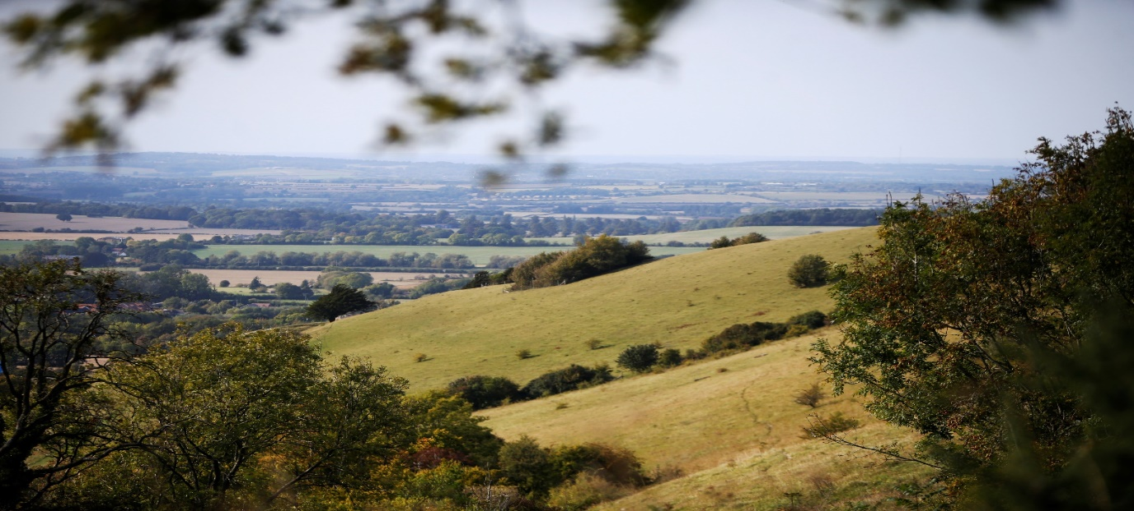
How to apply for third party tree planting projects on district council owned land in South Oxfordshire or the Vale of White Horse

Guidance
This application form is intended for use by organisations and community groups wishing to undertake tree planting projects on land owned by either South Oxfordshire District Council or Vale of White Horse District Council.
Before completing this form, please contact us to check that the land you have identified for tree planting is owned by the district councils. Please email your proposal to climateaction@southandvale.gov.uk including a map clearly identifying the land concerned.
If you receive a positive response to this email, we will invite you to complete the application form below. You should then send the completed application form to climateaction@southandvale.gov.uk.
Before submitting your application, we strongly recommend that you look at the Tree Planting Guide, which provides advice on tree planting. Application approval will be based on availability and suitability of land and adherence to the principles in the policy for planting trees on council-land
If we are to agree to your proposals, you will be required to take full responsibility for the newly planted trees for at least three years following planting to ensure that the planting becomes successfully established. This will include, but not be limited to, watering of newly planted trees (where necessary) weeding, replacement of failures and maintenance of guards and stakes.
Please be aware that the whole process may take three months to complete so please consider this before submitting your application.
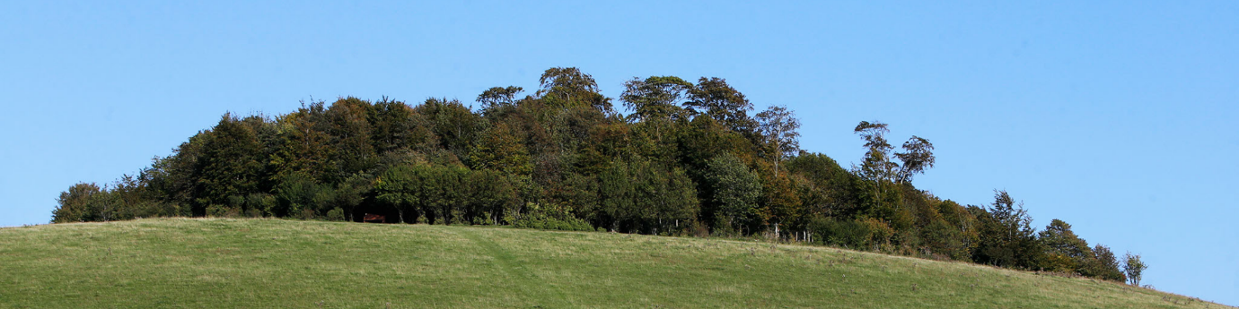

YOUR ORGANISATION
1.1 Name of organisation proposing the project:

1.2 Contact name and position in organisation:

1.3 Telephone No (landline): Mobile No:
E-mail:
Website: Social media:

1.4 Preferred address for correspondence:

1.5 Please provide details about the status of your organisation, e.g. is it a registered charity, parish council or a community group?

Do you have a formal constitution? YES NO
If your organisation is a charity, please provide the charity number;

Do you have a set of rules governing your organisation? YES NO
If YES, please provide a copy.

1.6 Please provide some background information about your organisation, its aims, when was it established and say how your proposals contribute to the aims of our council plans At the heart of the Vale council plan The way ahead council plan South.

1.7 What insurance cover does your organisation have? (e.g. public liability insurance). Please include detail of all cover.

1.8 Does your organisation have policies in place for the following: the safety of children and vulnerable adults, working with volunteers and health and safety? Community groups undertaking tree planting projects on Council owned land will be required to be appropriately insured and have policies or procedures in place to ensure the safety of their volunteers and all users of the site.

Your proposed planting site and how you will maintain it
2.1 What is the address and post code of site? Please give the area or dimensions of the proposed planting site.
Please provide a Location Plan and some digital photographs of the proposed planting site.

2.2 What is the current use of the land? Please consider the rate/frequency of use, is tree planting likely to conflict with other user’s needs (i.e. is it an area used for informal sport or recreation?) are there any underground or overhead services which may affect the planting.

2.3 Please provide a Tree Planting Plan clearly showing the location and layout of the planting proposals (i.e. locations for the individual trees to be planted and/or the spacings if woodland planting).

2.4 Please provide details of the type of planting proposed, including species choice, numbers of trees, size of planting stock and type of tree stakes and guards proposed?

2.5 Please provide a Maintenance Plan giving details of how you intend to maintain the planting for a minimum of three seasons following the planting to ensure successful establishment? For some types of planting the Council may require a longer maintenance period.

2.6 Please provide details of how your planting project is being funded and any conditions attached to that funding?

2.7 Please provide details of the source of the tree stock to be planted?

Other details about your project
  - Please outline if / how you consulted the local community about this proposal and how any potential conflicts been addressed?

  - How will the local community benefit from and engage with the project?

3.3 Who is involved with the project? What experience, skills and resources does your group offer?

3.4 Proposed timetable of work.
Anticipated start date:
Anticipated completion date:

3.5 Could the weather or other factors affect this timetable (i.e. availability of funding, flooding, availability of volunteers etc)?

Submitting your application
4.1 Submit your application and supporting documents by email to climateaction@southandvale.gov.uk We do not require a hard copy.

4.2 We will assess your proposals against our corporate property register and with internal specialist teams who are responsible for managing land. We may contact you to find out more about your proposals and arrange a site visit.

4.3 We will aim to contact you within three months of receipt of an application to confirm if your project is acceptable and the next steps.
If it is acceptable then we will require your organisation to enter into an agreement with the relevant council which may have conditions attached. The agreement will need to be in place before any planting takes place.
