


Contents
Template Structure 4
Using the Template 4
Additional Support 4
1. INTRODUCTION 9
2. CONSULTATION AIMS 9
3. BACKGROUND 10
The Designated Neighbourhood Plan Area 10
Initiation of Neighbourhood Planning 10
4. CONSULTATION PROCESS – SUMMARY 11
Ongoing Communication and Community Engagement 11
Community Surveys 11
Regulation 14 – Pre-Submission Consultation and Publicity 12
Regulation 16 – Submission Consultation and Publicity 12
5. INITIAL RESIDENTS’ SURVEY 13
Survey Content and Topics 14
Publicity and Promotion 16
Sharing Results and Follow-Up Engagement 17
6. FOLLOW UP RESIDENTS’ SURVEY 18
Survey Content and Topics 18
Vision and Objectives 20
Publicity and Promotion 20
Sharing Results and Next Steps 21
7. HOUSING NEEDS SURVEY 21
8. LOCAL GREEN SPACES SURVEY 22
Survey Content and Topics 22
Publicity and Promotion 23
Sharing Results and Next Steps 23
9. NON-DESIGNATED HERITAGE ASSETS SURVEY 24
Survey Content and Topics 24
Publicity and Promotion 25
Sharing Results and Next Steps 25
10. REGULATION 14 – PRE-SUBMISSION CONSULTATION AND PUBLICITY 26
Publicity and Promotion 26
Review and Response to Consultation Feedback 29
11. MEETING THE STATUTORY REQUIREMENTS 30
12. APPENDICES 32
Appendix 1: COMMUNITY ENGAGEMENT TIMELINE 32
Appeidx 2: REGULATION 14 – STATUTORY CONSULTEES 33
Appendix 3: REGULATION 14 RESPONSES 36
Appendix 4: Privacy Statement 39

How to Use this Document
This consultation statement template is designed to support neighbourhood plan groups in preparing the statutory consultation statement required under Regulation 15 of the Neighbourhood Planning (General) Regulations 2012 (as amended). The purpose of the document is to provide a clear framework and practical examples to help groups demonstrate how consultation and engagement have been carried out during the preparation of their neighbourhood plan.

Template Structure
The document uses two types of text to distinguish between guidance and editable content:
Black text provides explanations, prompts and example wording that illustrate what should be included. This can be left unchanged where it is generic and applies to all Consultation Statements.
Example: Following the early stages of engagement and analysis of survey findings, a draft pre-submission version of the neighbourhood plan was prepared.
Blue text in square brackets [example] highlights where locally specific details must be inserted (e.g., names of consultees, dates of surveys and summaries of feedback).
Example: [Town/Parish/Forum] submitted an application for the designation of a Neighbourhood Area, which was considered and approved on [day/month/year].

Using the Template
Neighbourhood planning groups are encouraged to:
- follow the structure and headings provided to ensure all statutory requirements are covered;
- replace the blue placeholder text with details specific to their plan and consultation activities;
- insert additional sections or evidence where appropriate (for example, surveys or events); and
- remove any sections that do not apply to their particular plan.
By using this template, groups can have confidence that their consultation statement provides a transparent and robust record of engagement, while meeting the legal requirements set out in the Regulations.
Throughout the template ‘steering group’ is referred to as the default group, however this can be changed to whichever type of ‘body’ (e.g. advisory committee, working party, committee or sub-committee) the qualifying body establishes to prepare the neighbourhood plan.

Additional Support
This template is intended to be used alongside the wider neighbourhood planning guidance and support provided by South Oxfordshire. Groups are encouraged to seek advice from the Council directly at key stages to help ensure statutory obligations are met and best practice is followed.

[EXAMPLE COVER PAGE]
[PLAN AREA]
Neighbourhood Development Plan

[PHOTO OR GRAPHIC REPRESENTING YOUR AREA]

Consultation Statement

V[1.0] - [Month and Year]
Contents
Template Structure 4
Using the Template 4
Additional Support 4
1. INTRODUCTION 9
2. CONSULTATION AIMS 9
3. BACKGROUND 10
The Designated Neighbourhood Plan Area 10
Initiation of Neighbourhood Planning 10
4. CONSULTATION PROCESS – SUMMARY 11
Ongoing Communication and Community Engagement 11
Community Surveys 11
Regulation 14 – Pre-Submission Consultation and Publicity 12
Regulation 16 – Submission Consultation and Publicity 12
5. INITIAL RESIDENTS’ SURVEY 13
Survey Content and Topics 14
Publicity and Promotion 16
Sharing Results and Follow-Up Engagement 17
6. FOLLOW UP RESIDENTS’ SURVEY 18
Survey Content and Topics 18
Vision and Objectives 20
Publicity and Promotion 20
Sharing Results and Next Steps 21
7. HOUSING NEEDS SURVEY 21
8. LOCAL GREEN SPACES SURVEY 22
Survey Content and Topics 22
Publicity and Promotion 23
Sharing Results and Next Steps 23
9. NON-DESIGNATED HERITAGE ASSETS SURVEY 24
Survey Content and Topics 24
Publicity and Promotion 25
Sharing Results and Next Steps 25
10. REGULATION 14 – PRE-SUBMISSION CONSULTATION AND PUBLICITY 26
Publicity and Promotion 26
Review and Response to Consultation Feedback 29
11. MEETING THE STATUTORY REQUIREMENTS 30
12. APPENDICES 32
TABLE 1: COMMUNITY ENGAGEMENT TIMELINE 32
TABLE 2: REGULATION 14 – STATUTORY CONSULTEES 33
TABLE 3: REGULATION 14 RESPONSES 36

INTRODUCTION
    - This consultation statement has been prepared to fulfil the legal obligations of the Neighbourhood Planning (General) Regulations 2012 (as amended).
    - It has been prepared by [Plan Area] Neighbourhood Plan Steering Group on behalf of [Plan Area] [Town/Parish/Forum], with support from South Oxfordshire [and Consultants or Third Parties].
    - Section 15(2) of Part 5 of the Regulations sets out what a consultation statement is:
- contains details of the persons and bodies who were consulted about the proposed neighbourhood development plan or neighbourhood development plan as proposed to be modified.;
- explains how they were consulted;
- summarises the main issues and concerns raised by the persons consulted; and
- describes how these issues and concerns have been considered and, where relevant, addressed in the proposed neighbourhood development plan or neighbourhood development plan as proposed to be modified.

CONSULTATION AIMS

    - The consultation process for the [Plan Area] Neighbourhood Plan was designed to:
- involve the community as fully as possible at every stage of the plan’s development, ensuring that the views of residents and stakeholders shaped the plan from the outset;
- reach a broad cross-section of the community by using a variety of communication methods and consultation techniques [such as relevant communication methods and consultation techniques, e.g., social media, bulletin boards, surveys and exhibitions];
- hold engagement events at key stages in the process where important community decisions were required; and
- share outcomes of consultations promptly with residents, through both printed materials and online platforms [such as relevant materials/platforms e.g., posters, flyers, Facebook community groups and/or the neighbourhood plan webpage].
    - Throughout the preparation of the [Plan Area] Neighbourhood Plan, the neighbourhood planning [steering] group engaged with local residents, South Oxfordshire and other relevant stakeholders. A detailed summary of consultation activities is set out in Table 1.

BACKGROUND

The Designated Neighbourhood Plan Area

    - [Town/Parish/Forum] submitted an application for the designation of a Neighbourhood Area, which was considered and approved on [day/month/year].
    - The [Plan Area] Neighbourhood Plan area encompasses [the whole/part] of [Town/Parish], which is situated in the South Oxfordshire district of Oxfordshire, England. For planning purposes, [Town/Parish/Forum] is covered by South Oxfordshire District Council.
    - The designated area has a population of around [number] residents, mainly in [number] settlement areas, [names of settlement areas]. There are also many countryside areas which have small pockets of settlement, including [parts of] [name of small pockets of settlement].

Initiation of Neighbourhood Planning
    - To ensure that any future development is in keeping with the needs and wants of the community, work was initiated in [day/month/year] on a neighbourhood plan for [Town/Parish/Forum]. [This included the creation of a steering group made up of residents and Town/Parish Councillor’s].
    - An initial public meeting was held at [location] on [day/month/year] to discuss what a neighbourhood plan is, outline the neighbourhood planning process and invite residents to volunteer. Subsequent meetings were held at [location] on [day/month/year].

CONSULTATION PROCESS – SUMMARY

Ongoing Communication and Community Engagement

    - Throughout the development of the [Plan Area] Neighbourhood Plan, the [Town/Parish/Forum] ensured that residents were kept informed of, and engaged with, the process through a range of communication channels. Regular updates were provided [via bulletin boards, social media sites, Town/Parish/Forum Meetings and through discussion with residents etc.].
    - In addition to this, a dedicated ‘Neighbourhood Plan’ section was created on the [Town/Parish/Forum] website to:
- explain what a neighbourhood plan is and why the [Town/Parish/Forum] are undertaking one,
- encourage volunteers to take part in its preparation,
- keep the community informed of progress,
- provide access to engagement materials, such as survey results, and
- share the plan and supporting documents during the Regulation 14 Pre-Submission Consultation and the Regulation 16 Consultation.
    - Minutes from steering group meetings were also published on the website for full transparency.

Community Surveys
    - To ensure broad participation and capture a wide range of views, [number] key surveys were undertaken as part of the consultation process:
- Initial Residents’ Survey - conducted in [date], this survey was [e.g. hand-delivered, posted or distributed online via Google Forms/SurveyMonkey] and invited local residents to express interest in being involved in shaping the plan by sharing their likes and dislikes about the [Plan Area]. It gathered views on what the neighbourhood plan should cover as well as residents’ priorities for the future of their area. The results were shared publicly [through bulletin boards, social media sites, Town/Parish/Forum Meetings and at community events/exhibitions].
- [Follow Up Residents’ Survey – conducted in [date], this survey was [e.g. hand-delivered, posted or distributed online via Google Forms/SurveyMonkey] and built on the responses gathered from the previous initial residents’ survey. It explored general policy themes such as housing, biodiversity, traffic and transport and set out draft policies for residents to comment on.
- Housing Needs Survey – a parish-wide survey was conducted in [date] by [e.g. hand-delivery, post or distributed online via Google Forms/SurveyMonkey] to gather information on local housing requirements. The findings provide important evidence to inform the housing policies within the neighbourhood plan.
- Local Green Spaces Survey – conducted in [date], this survey was [e.g. hand-delivered, posted or distributed online via Google Forms/SurveyMonkey] and invited residents to identify open spaces of special importance to the community. Respondents were asked to highlight areas valued for their beauty, historic significance, recreational value, tranquillity or richness of wildlife and to explain why these spaces should be protected. The results were used to provide evidence to support the designation of Local Green Spaces within the neighbourhood plan.
- Non-Designated Heritage Asset Survey - conducted in [date], this survey was [e.g. hand-delivered, posted, or distributed online via Google Forms/SurveyMonkey] and sought community input on locally significant buildings, landmarks and features that may not be formally recognised through existing heritage listings. Residents were encouraged to nominate and describe assets they felt were important to the character and history of the area. The findings were used to provide evidence to support the designation of Non-Designated Heritage Assets and inform policies on conserving local heritage within the neighbourhood plan].

Regulation 14 – Pre-Submission Consultation and Publicity
    - Following the early stages of engagement and analysis of survey findings, a draft pre-submission version of the neighbourhood plan was prepared. In accordance with Regulation 14 of the Neighbourhood Planning (General) Regulations 2012 (as amended), a formal consultation period took place from [start date] to [end date].
    - During this period, residents and stakeholders were invited to review and comment on the draft plan. Feedback was collected using [e.g. an online form such as Google Forms/SurveyMonkey] as well as hard copy response forms, which could be submitted by [email, post, or in person].

Regulation 16 – Submission Consultation and Publicity
Use the below text before Regulation 16.
    - The next formal stage of consultation, Regulation 16 (Submission), will take place following submission of the plan to the local planning authority.

INITIAL RESIDENTS’ SURVEY

    - In [date] the [Plan Area] Neighbourhood Plan Steering Group, in collaboration with [Consultants or Third Parties], conducted an initial community survey. The purpose of the survey was to encourage residents to participate in shaping the neighbourhood plan and to gather their views on key issues to inform the plan’s vision, objectives and potential policy themes.
    - Before the survey was made available, in [date] [posters, flyers, social media posts] were [posted/published] notifying residents of, and explaining, the survey.
    - The survey was made available via [e.g. an online form such as Google Forms/SurveyMonkey] as well as hard copy response forms, which were [e.g. hand-delivered or posted]. Completed forms could be returned via [email, post or in person at [location]. While the vast majority of responses were submitted [in person/online], a number were also received [by hard copy, in person/via email/online].
    - In total, [number] responses were collected, representing [number]% of the [Plan Area] population (based on [number] residents). The survey featured both quantitative questions (e.g. tick-box responses, generating percentages) and qualitative questions (open-text responses), allowing for a rich and varied dataset.
    - Examples of both are shown in Figures 1 and 2 below.

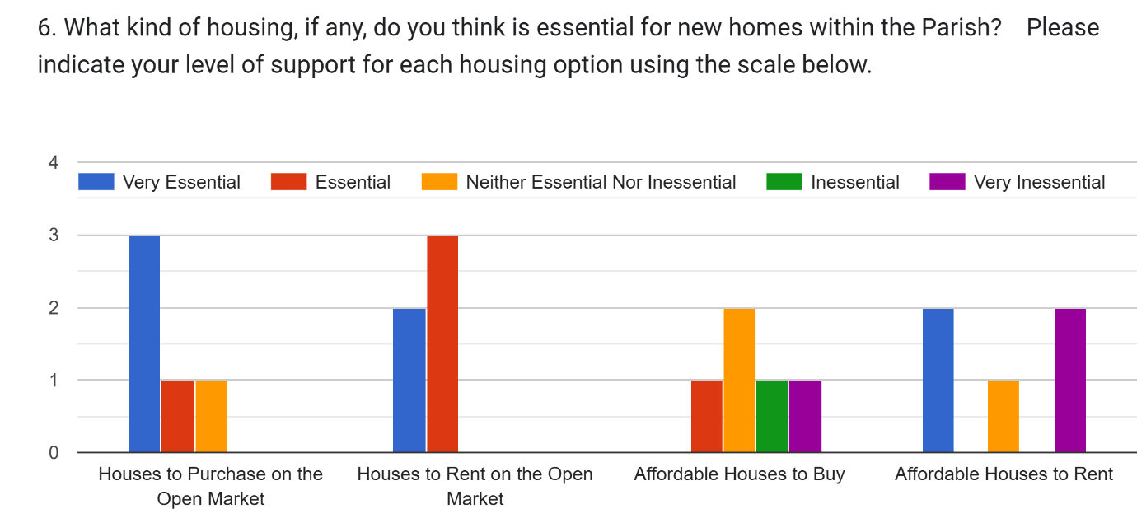
Figure 1. Community Survey - Question [Number] (Quantitative Data)

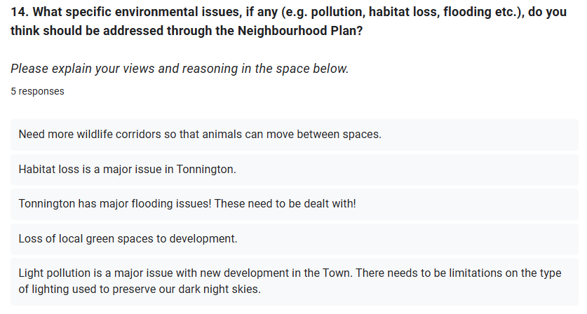
Figure 2. Community Survey - Question [Number] (Qualitative Data)

Survey Content and Topics
    - The survey explored a range of topics relevant to the neighbourhood plan, including:
- [what residents liked about living in [Plan Area] (used to shape the draft vision and objectives - see Figure 3);
- what residents disliked about living in [Plan Area] (used to shape the draft vision and objectives);
- residents’ priorities for the future and what they most valued about the parish (used to inform key themes for policies - see Figure 4); and
- specific topic areas such as:
  - housing,
  - road safety and transport/connectivity,
  - heritage,
  - important views,
  - local green spaces,
  - community facilities, and
  - local employment opportunities].

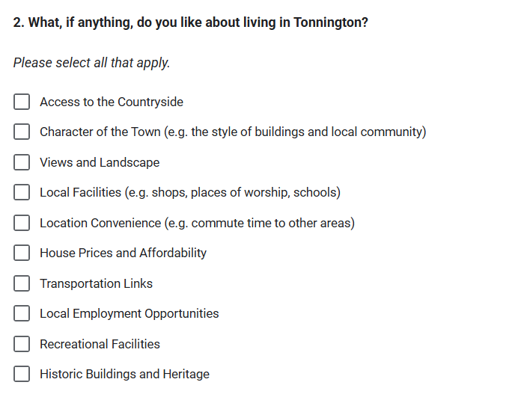
Figure 3. Community Survey – Question [Number] (Shaped Vision and Objectives)

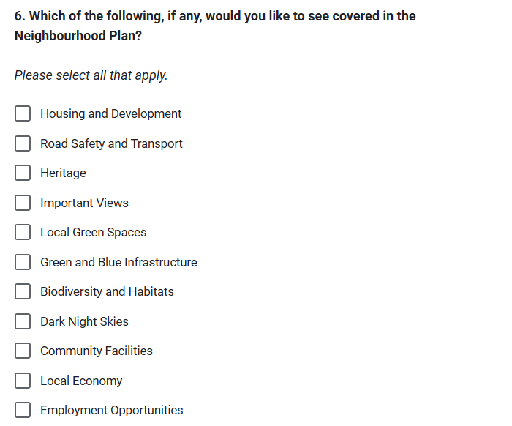
Figure 4. Community Survey - Question [Number] (Shaped Key Themes/Policies)

Publicity and Promotion
    - The survey was publicised using a variety of methods to ensure broad reach and participation:
- [a leaflet was designed and displayed around the [Plan Area] (see Figure 5 below) on noticeboards in [locations]. This was in addition to public places such as [locations].
- an online post was published [social media pages]; and
- direct links to the survey were provided online on [social media] and the [Town/Parish/Forum] website as well as printed on physical promotional materials].

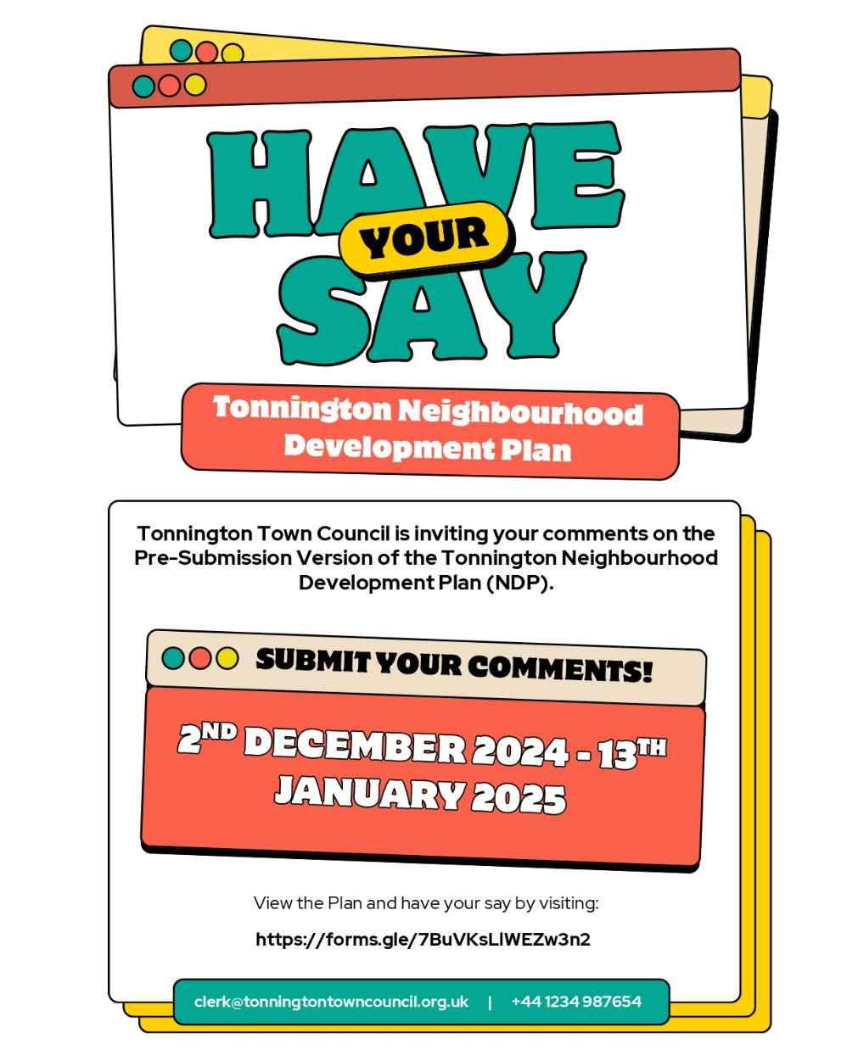
Figure 5. Publicity Material - Initial Community Survey Leaflet

Sharing Results and Follow-Up Engagement
    - Once the survey closed, all responses were compiled, analysed and published [e.g. on the [Town/Parish/Forum] website]. To further engage residents and explore emerging themes, the Steering Group hosted [number] in-person events, as listed below, to present key findings and gather feedback.
- [location] on [date].
    - At the event:
- [exhibition boards displayed survey results, particularly those used to develop the vision, objectives and policy themes;
- residents were invited to respond to follow-up questions based on initial findings, for example:
  - should a housing site allocation be included in the plan?]
    - [While the survey results were not revisited in full, this session provided an opportunity for more detailed consultation on specific elements raised during the initial engagement].

FOLLOW UP RESIDENTS’ SURVEY
Please note that a Follow Up Residents’ Survey may not be conducted by every group. Where this is the case, this section can be disregarded.

    - In [date] the [Plan Area] Neighbourhood Plan steering group, in collaboration with [Consultants or Third Parties], carried out a second, more detailed community survey. This survey built upon the findings of the initial residents’ survey undertaken in [date] by presenting a draft vision and objectives alongside emerging themes and potential policies for residents to review and provide feedback on.
    - The survey was made available via [e.g. an online platform such as Google Forms/SurveyMonkey] as well as hard copy response forms, which were [e.g. hand-delivered or posted] to households across the [Plan Area]. Completed forms could be returned by [email, post or in person at [location]]. In total, [number] responses were received, representing [number]% of the [Plan Area] population (based on [number] residents).

Survey Content and Topics
    - The survey invited residents to comment on emerging draft policies and priorities across a range of topic areas central to the neighbourhood plan. These included:
- [housing need and potential development options,
- biodiversity, green spaces and environmental protection;
- traffic, road safety and transport/connectivity;
- community facilities and services;
- local economy and employment; and
- the overall vision and objectives for the future of [Plan Area]].

    - The survey combined quantitative questions (e.g. tick-box options gauging the level of support for draft objectives or policy themes) with qualitative questions (free-text opportunities for residents to suggest changes or raise concerns). This provided both statistical evidence and detailed feedback to refine the draft policies.
    - Figures 6 and 7 below illustrate examples of how questions were presented and the type of responses received.
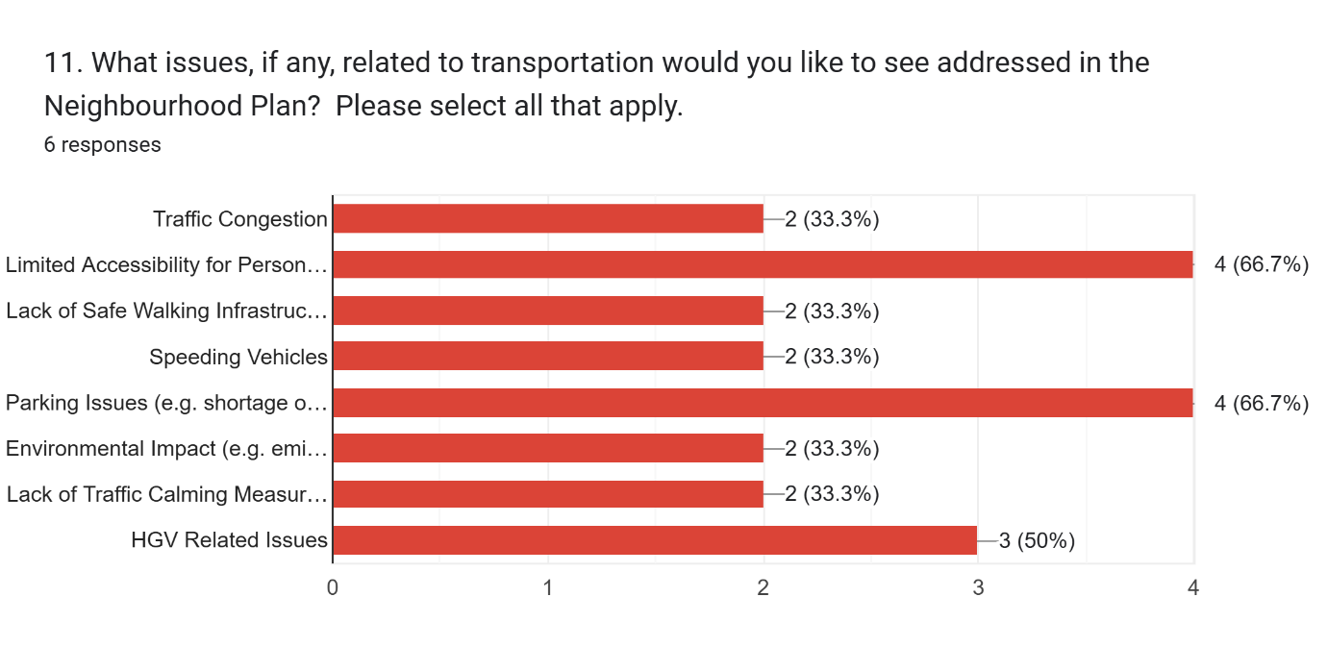
Figure 6. In-Depth Survey – Question [Number] (Quantitative Data)
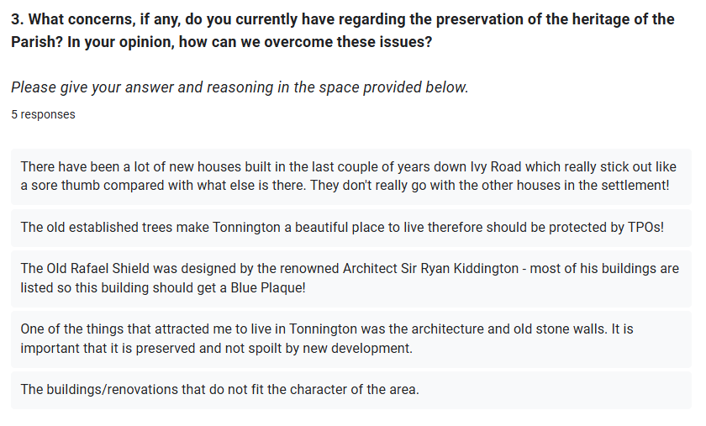
Figure 7. In-Depth Survey – Question [Number] (Qualitative Feedback)

Vision and Objectives
    - A central part of the survey was consultation on the draft vision and objectives for the neighbourhood plan. Residents were asked:
- [whether they supported the proposed vision statement for [Plan Area];
- which objectives they considered most important for shaping the plan; and
- whether any objectives should be amended, added or removed].
    - Feedback received on the vision and objectives was used to refine the overarching direction of the plan and ensure that draft policies aligned with community priorities.

Publicity and Promotion
    - The survey was promoted widely to ensure residents were aware of the opportunity to shape draft policies, objectives and the vision for [Plan Area]. Promotion methods included:
- [delivery of a leaflet to all households, outlining the purpose of the survey and how to respond;
- posters displayed on local noticeboards in [locations];
- social media posts via [pages/groups]; and
- links to the survey hosted on the [Town/Parish/Forum] website].
    - Examples of promotional materials are shown in Figure 8 below.
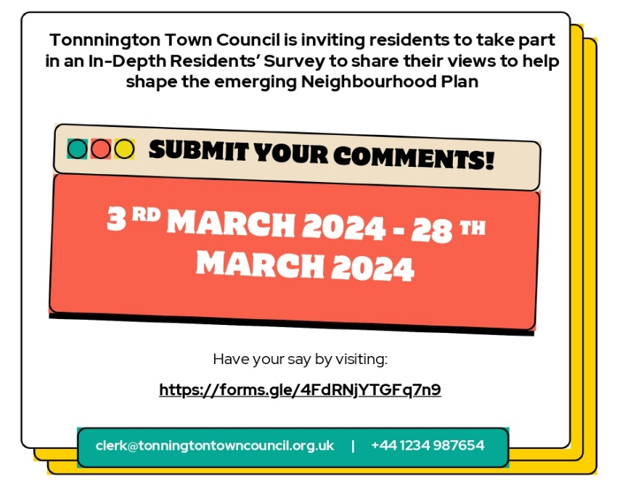

Figure 8. Publicity Material – In-Depth Residents’ Survey
Sharing Results and Next Steps
    - Once the survey closed, responses were collated and analysed by the steering group. [The findings were published on the [Town/Parish/Forum] website and summarised at [number] community events held at [locations] on [dates]].
    - At these events:
- [exhibition boards presented survey findings, including levels of support for each draft objective, policy and vision;
- residents were invited to discuss the results and provide further input; and
- feedback was used to refine and amend the draft neighbourhood plan policies, objectives and vision ahead of the Regulation 14 consultation stage].

HOUSING NEEDS SURVEY
Please note that a Housing Needs Survey may not be conducted by every group. Where this is the case, this section can be disregarded.

    - At the request of the steering group, a Housing Needs Survey (HNS) was carried out by [Other Body] in [date] to assess the housing requirements of [Plan Area] residents over the next [number] years and beyond. The findings were intended to inform the development of locally appropriate housing policies within the neighbourhood plan.
    - [Other Body] distributed [number] questionnaires to households across the [Plan area] [electronically or in person], achieving a response rate of approximately [number]%, with [number] completed surveys returned.
    - Part 1 of the survey was completed by [number] respondents and focused on [e.g. general housing information, such as:
- whether there is insufficient housing in the [Plan area] for people to move to,
- whether respondents would support a housing development scheme of some kind,
- what size of housing development scheme respondents would support, and
- what tenures most supported for a housing development scheme].
    - Part 2 of the survey was completed by [number] respondents and focused on [e.g. for individuals or households who were planning to move to the [Plan area] over the next five years].
    - Following feedback from the steering group, including [e.g. a request to incorporate contextual information such as average property prices], [Consultant or Other Body] amended the draft report. The final Housing Needs Assessment report was finalised in [date] and is available in full on the [Town/Parish/Forum website].

LOCAL GREEN SPACES SURVEY
Please note that a Local Green Spaces Survey may not be conducted by every group. Where this is the case, this section can be disregarded.

    - In [date] the [Plan Area] Neighbourhood Plan steering group carried out a Local Green Spaces Survey to identify open spaces of special value to the community. This survey was made available via [e.g. an online platform such as Google Forms/SurveyMonkey] and also distributed in hard copy, which was [hand-delivered/posted] to households across [Plan Area]]. Completed forms could be returned by [email, post, or in person at [location]]. In total, [number] responses were received, representing [number]% of the [Plan Area] population (based on [number] residents).

Survey Content and Topics
    - The purpose of the survey was to give residents the opportunity to nominate and comment on areas of land that they considered important to protect. Respondents were invited to highlight spaces that they felt were locally significant because of one or more of the following criteria:
- beauty;
- historic significance;
- recreational value (including as a playing field, park or amenity space);
- tranquillity; or
- richness of wildlife.
    - Residents were also encouraged to explain in their own words why these sites were valued by the community and how they should be safeguarded for future generations.
    - Figure 9 below shows examples of how spaces were identified.
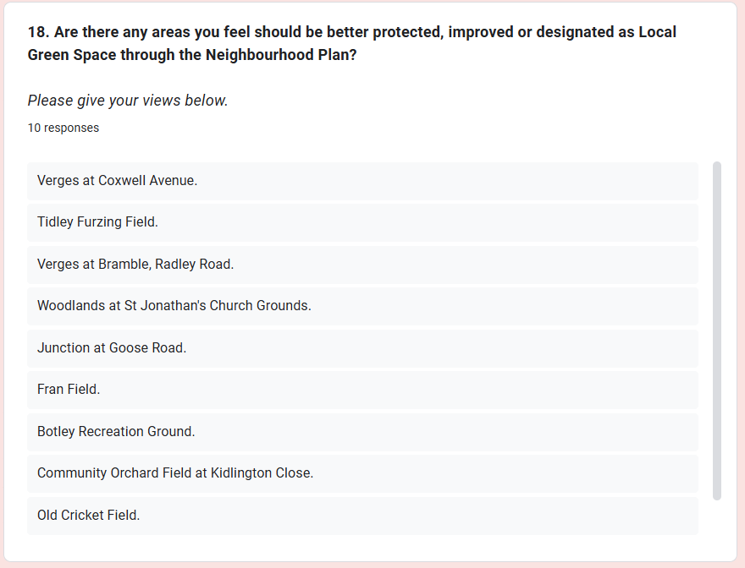
Figure 9. Local Green Spaces Survey – Nominated Sites (Qualitative Feedback)

Publicity and Promotion
    - The survey was publicised using a range of methods to maximise awareness and participation, including:
- [a leaflet delivered to households explaining the purpose of the survey;
- posters on community noticeboards in [locations];
- social media posts via [pages/groups]; and
- links hosted on the [Town/Parish/Forum] website].

Sharing Results and Next Steps
    - Once the survey closed, all responses were collated and analysed. The results provided an evidence base to support the designation of Local Green Spaces within the draft neighbourhood plan.
    - [These findings were presented to residents at [number] community events held at [locations] on [dates]. At these events:
- exhibition boards displayed maps and photos of the nominated spaces;
- supporting evidence was presented showing how each site met the Local Green Space criteria; and
- residents were invited to provide further comments before the draft designations were finalised].

NON-DESIGNATED HERITAGE ASSETS SURVEY
Please note that a Non-Designated Heritage Assets Survey may not be conducted by every group. Where this is the case, this section can be disregarded.

    - In [date] the [Plan Area] Neighbourhood Plan steering group carried out a non-designated heritage assets survey to identify buildings, landmarks and features of local significance that are not formally recognised through statutory heritage listings. The survey was made available via [e.g. an online platform such as Google Forms/SurveyMonkey] and also distributed in hard copy, which was [hand-delivered/posted] to households across the [Plan Area]. Completed forms could be returned by [email, post, or in person at [location]]. In total, [number] responses were received, representing [number]% of the [Plan Area] population (based on [number] residents).

Survey Content and Topics
    - The purpose of the survey was to capture community knowledge and appreciation of local heritage assets. Residents were encouraged to nominate sites or features they considered to be of special importance, including:
- historic buildings [e.g. farmhouses, chapels, cottages, schools];
- landmarks [e.g. wells, bridges, war memorials];
- locally distinctive features [e.g. boundary walls, milestones, traditional street furniture]; and
- other places that contribute to the historic character, identity or sense of place in [Plan Area].
    - Respondents were asked to explain the significance of their nominations, including their historical, architectural, cultural or community value.
    - Figure 10 below illustrates examples of nominated assets.
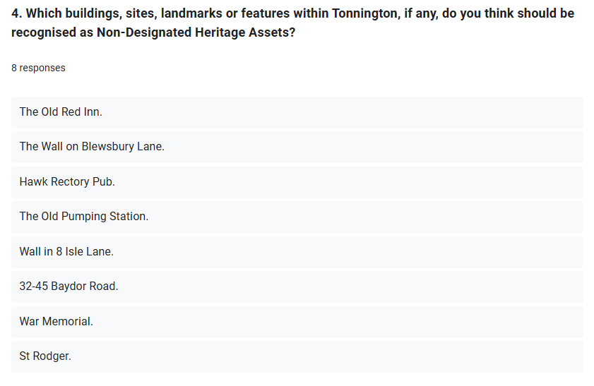
Figure 10. Non-Designated Heritage Assets Survey –Nominated Assets (Qualitative Feedback)

Publicity and Promotion
    - The survey was publicised to ensure broad awareness and participation, including through:
- [a leaflet delivered to households, setting out the purpose of the survey;
- posters displayed on local noticeboards in [locations];
- announcements on [Plan Area] social media pages/groups; and
- direct links to the survey hosted on the [Town/Parish/Forum] website].

Sharing Results and Next Steps
    - Once the survey closed, responses were collated and analysed. The findings were used to provide evidence to support the designation of non-designated heritage assets within the draft neighbourhood plan.
    - [The results were shared at [number] community events held at [locations] on [dates], where residents were invited to review the nominated assets and comment on their significance. At these events:
- exhibition boards displayed photographs and descriptions of nominated sites;
- supporting evidence was presented showing how each asset contributed to local heritage and character; and
- feedback helped inform the development of policies to conserve and enhance heritage in [Plan Area]].

REGULATION 14 – PRE-SUBMISSION CONSULTATION AND PUBLICITY

    - In accordance with Regulation 14 of the Neighbourhood Planning (General) Regulations 2012 (as amended), the steering group conducted a formal pre-submission consultation and publicity on the draft [Plan Area] Neighbourhood Plan and its supporting documents, including [e.g. Character Appraisal, Design Code, Housing Needs Assessment etc.] over a six week period, starting on [date and time] and ending on [date and time].
    - The purpose of this consultation was to give residents, statutory consultees and other stakeholders the opportunity to review the draft neighbourhood plan in full and provide formal feedback before it was submitted for independent examination.

Publicity and Promotion
    - To raise awareness of the consultation and encourage participation, the steering group undertook a range of publicity activities, including:
  - [the production of a flyer/poster (see Figure 11) which was displayed on noticeboards across [Plan Area] in [settlement names];
  - a dedicated social media campaign, including a shared visual on [Facebook Groups/pages] and the [Town/Parish/Forum] website (see Figure 12); and
  - direct contact with statutory consultees, who were notified via email at the start of the consultation period].
    - A full list of statutory consultees contacted as part of the Regulation 14 consultation process is provided in Table 2.
    - All consultation documents were made available on the [Town/Parish/Forum] website to ensure easy access for residents and stakeholders.
    - Responses could be submitted in [number] ways:
- [online, via a dedicated [e.g. Google Form] (see Figure 13); and
- offline, using a downloadable [e.g. Word] response form (see Figure 14), which could be returned by email, post or delivered in person].

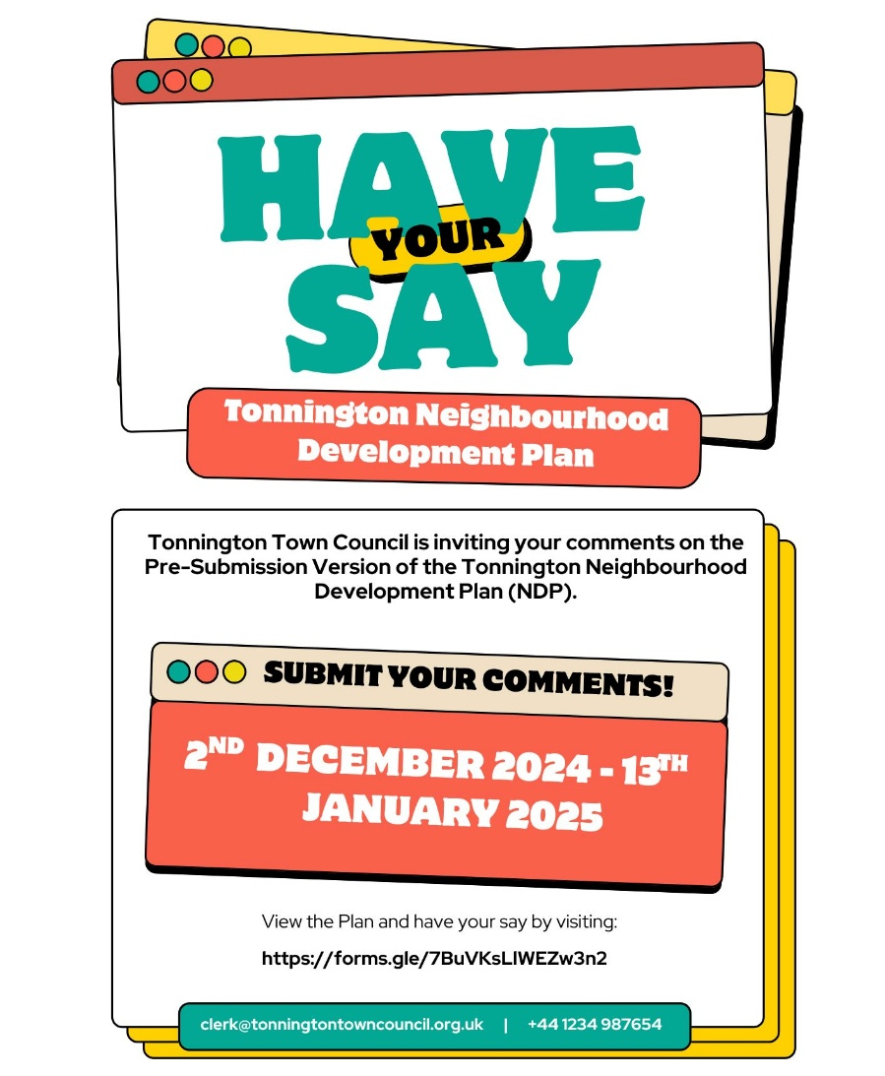
Figure 11. Publicity Material – Pre-Submission Consultation Poster
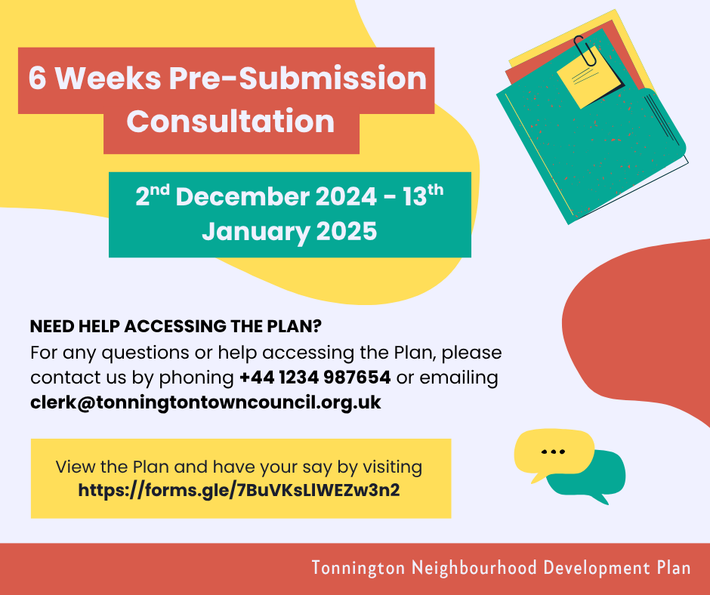
Figure 12. Publicity Material – Pre-Submission Consultation Social Media Visual
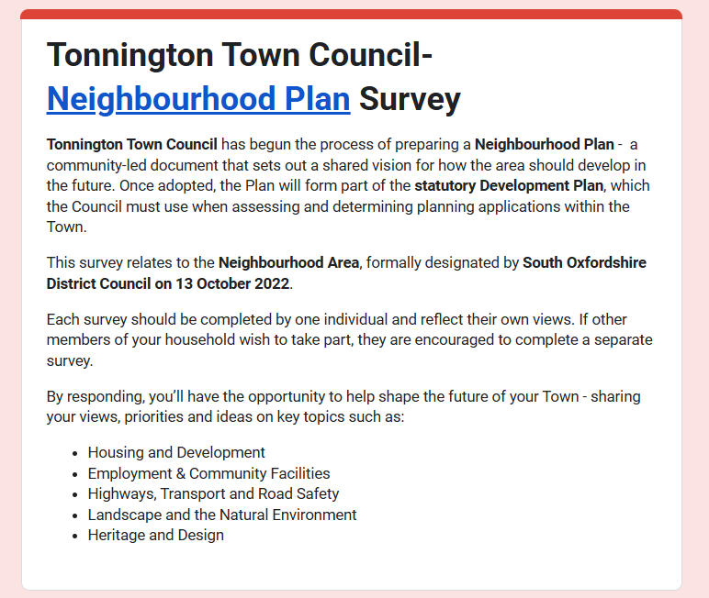
Figure 13. Pre-Submission Consultation – Online Response Form
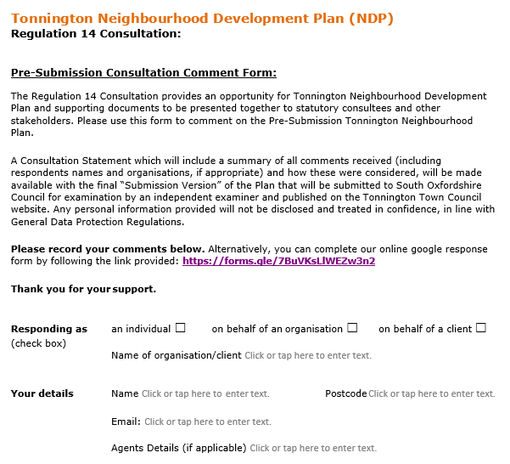
Figure 14. Pre-Submission Consultation – Downloadable Response Form

Review and Response to Consultation Feedback
    - All responses received during the consultation were systematically recorded in a central response log maintained by the steering group. This spreadsheet captured each individual comment, the steering group’s response and any resulting amendments to the draft plan.
    - Each comment was reviewed and categorised in line with an agreed decision-making framework:
- Noted but not actioned - where the steering group considered no change necessary, a clear explanation was provided to justify the decision.
- Actioned in part or in principle - where elements of a comment were incorporated into the plan, with an explanation of which aspects were taken forward.
- Fully actioned - where a comment directly resulted in amendments to the draft plan, with details of the changes recorded.
    - This structured approach ensured transparency, accountability and a clear audit trail of how community and stakeholder input shaped the plan.
    - A full summary of the comments received, alongside the steering group’s response and details of any amendments to the draft plan, is included in Table 3.

MEETING THE STATUTORY REQUIREMENTS

    - This consultation statement has been prepared by the [Plan Area] Neighbourhood Plan steering group on behalf of [Parish/Town Council/Neighbourhood Forum], with support from [Local Planning Authority] and [consultants, if relevant].
    - This consultation statement has been prepared in accordance with the legal obligations set out in Part 5, Section 15(2) of the Neighbourhood Planning (General) Regulations 2012 (as amended). It demonstrates how the statutory requirements for consultation have been met throughout the development of the [Plan Area] Neighbourhood Plan.
    - In compliance with Section 15(2), this consultation statement:
- contains details of the persons and bodies who were consulted about the proposed neighbourhood development plan or neighbourhood development plan as proposed to be modified.;
- explains how they were consulted;
- summarises the main issues and concerns raised by the persons consulted; and
- describes how these issues and concerns have been considered and, where relevant, addressed in the proposed neighbourhood development plan or neighbourhood development plan as proposed to be modified.
    - In accordance with paragraph 1 of Schedule 1 of the Neighbourhood Planning (General) Regulations 2012 (as amended), specific consideration was given to the requirement to consult the following where they exercise functions in the neighbourhood area:
- voluntary bodies some or all of whose activities benefit all or any part of the neighbourhood area;
- bodies which represent the interests of different racial, ethnic or national groups in the neighbourhood area;
- bodies which represent the interests of different religious groups in the neighbourhood area;
- bodies which represent the interests of persons carrying on business in the neighbourhood area; and
- bodies which represent the interests of disabled persons in the neighbourhood area.
    - To meet these requirements, the steering group undertook an equalities check to ensure that no groups were excluded. Evidence was sought [from residents and stakeholders] to identify whether such organisations were active in the [Plan Area], including enquiries relating to [e.g. minority groups, faith groups, local businesses, community organisations and care providers].
    - Consultation activities included [e.g. leaflet distribution, targeted outreach and conversations with residents], [with the [Plan Area] divided into smaller areas for more effective engagement]. This process confirmed that [findings, e.g. “only one care facility was identified as a representative organisation” / “no formal representative bodies were identified”].

APPENDICES

Appendix 1: COMMUNITY ENGAGEMENT TIMELINE

No. | Date | Activity/Event
1 | [Date – Date] | Initial Residents’ Survey - the first community-wide survey, inviting residents to identify what they valued and disliked about living in [Plan Area]. It explored key topics such as [e.g. housing, road safety, transport, heritage, important views, local green spaces, community facilities and employment] and helped shape the draft vision, objectives and themes. Responses were collected online and via hand-delivered/posted forms.
2 | [Date] | [Initial Survey Results Exhibitions - a series of in-person exhibitions held at [locations]. Display boards presented key survey findings and residents were invited to respond to follow up questions based on initial findings, [e.g. whether to include a housing allocation]].
3 | [Date – Date] | [Follow Up Residents’ Survey - a second, more detailed survey, presenting a draft vision, objectives and emerging policies for community feedback].
4 | [Date] | [Follow Up Survey Results Exhibitions - community exhibitions were held at [locations], where results of the second survey were displayed on boards. Residents discussed findings and shared further input to refine the draft plan].
5 | [Date –  Date] | [Housing Needs Survey - delivered by [Other Body], this paper-based questionnaire was distributed to [number] households in the [Plan Area]. It identified housing needs over the next [x] years, providing evidence for housing-related policies].
6 | [Date –  Date] | [Local Green Spaces Survey - residents nominated and explained why specific green spaces should be protected, citing criteria such as beauty, historic significance, recreation, tranquility or wildlife value. Results informed potential Local Green Space designations].
7 | [Date –  Date] | [Non-Designated Heritage Assets Survey - residents identified locally important but unlisted heritage features such as buildings, landmarks and distinctive features. Feedback provided evidence for potential non-designated heritage asset policies].
9 | [Date –  Date] | Regulation 14 Pre-Submission Consultation - a full draft of the neighbourhood plan was published for formal consultation under Regulation 14 of the Neighbourhood Planning (General) Regulations 2012 (as amended). Statutory consultees, residents and stakeholders were invited to provide feedback.

Appeidx 2: REGULATION 14 – STATUTORY CONSULTEES
The full list of statutory consultees is set out in paragraph 1 of Schedule 1 of the Neighbourhood Planning (General) Regulations (as amended), and the district council can assist in ensuring you consult all the relevant bodies. The table below can be used as a starting point.
Please note that not all of the example consultees listed below will be relevant or applicable in every case and the actual list may be either more limited or more extensive depending on local circumstances.
Organisation |  | Contacted | Responded
Parish/Town Councils
[Parish/Town Council] |  | Y | Y/N
[Parish/Town Council] |  | Y | Y/N
[Parish/Town Council] |  | Y | Y/N
[Parish/Town Council] |  | Y | Y/N
[Parish/Town Council] |  | Y | Y/N
[Parish/Town Council] |  | Y | Y/N
Local Authority Districts and Unitary Councils
South Oxfordshire District Council |  | Y | Y/N
Vale of White Horse District Council |  | Y | Y/N
Oxford City Council |  | Y | Y/N
Cherwell District Council |  | Y | Y/N
West Oxfordshire District Council |  | Y | Y/N
Swindon Unitary Authority |  | Y | Y/N
West Berkshire Unitary Authority |  | Y | Y/N
Buckinghamshire Unitary Authority |  | Y | Y/N
Reading Unitary Authority |  | Y | Y/N
Wokingham Unitary Authority |  | Y | Y/N
Cotswold District Council |  | Y | Y/N
County Councils
Oxfordshire County Council | Y |  | Y/N
Utilities
BT | Y |  | Y/N
EE | Y |  | Y/N
Three | Y |  | Y/N
Vodafone | Y |  | Y/N
O2 | Y |  | Y/N
Virgin | Y |  | Y/N
National Grid | Y |  | Y/N
National Grid Electricity Transmission | Y |  | Y/N
Network Rail | Y |  | Y/N
SSE Telecoms | Y |  | Y/N
Scottish and Southern Energy | Y |  | Y/N
Thames Water | Y |  | Y/N
The Coal Authority | Y |  | Y/N
National Gas | Y |  | Y/N
Marine Management Organisation | Y |  | Y/N
UK Power Networks | Y |  | Y/N
Thames Water | Y |  | Y/N
Office for Nuclear Regulation | Y |  | Y/N
Cadent Gas | Y |  | Y/N
Central and Local Government Agencies
Environment Agency | Y |  | Y/N
Highways England | Y |  | Y/N
Historic England | Y |  | Y/N
Homes England | Y |  | Y/N
Natural England | Y |  | Y/N
Environment Agency | Y |  | Y/N
Oxfordshire Clinical Commissioning Group | Y |  | Y/N
Buckinghamshire, Oxfordshire and Berkshire West Integrated Care Board | Y |  | Y/N
Bath and North-east Somerset, Swindon and Wiltshire Integrated Care Board | Y |  | Y/N
NGOs and Other Campaigning Groups
Campaign to Protect Rural England | Y |  | Y/N
National Trust | Y |  | Y/N
Age UK | Y |  | Y/N
Community First Oxfordshire | Y |  | Y/N
[Other NGOs and Other Campaigning Groups] | Y |  | Y/N

Appendix 3: REGULATION 14 RESPONSES
The table below has been populated with illustrative examples of Regulation 14 consultation responses. Neighbourhood plan groups should replace these with the actual comments received during their own Regulation 14 consultation.
Further guidance on compiling this table, as well as other consultation evidence, is provided in the Consultation Statement Guide.
Note 1: All headings, sub-headings, policies, paragraphs and figures referenced relate to the pre-submission draft plan. In many cases these have since been amended in the submission draft.
Note 2: In certain instances, personal names or other identifying details included within comments have been redacted to protect individual privacy.
ID | Reference | Comment | Steering Group Response to Comments | Changes to Plan
1 | [E.g. 1.1.4] | [E.g. This is an out-of-date version of the NPPF]. | [E.g. Action]. | [E.g. Neighbourhood Plan amended to reflect latest NPPF].
2 | [E.g. 3.5.2 – Bullet Point Three] | [E.g. This is a land issue therefore it needs to be deleted]. | [E.g. Community aspirations are allowed to be included in a Neighbourhood Plan where they are highlighted as such]. | [E.g. No action].
3 | [E.g. Policy S9 – Dark Night Skies] | [E.g. What is the evidence for the inclusion of this policy?] | [E.g. Community consultation highlighted concerns about light pollution and the importance of preserving dark night skies. This was supported by CPRE Dark Skies Mapping, which identifies light pollution as a local issue]. | [E.g. No action].
4 | [E.g. Policy SO3 – Green and Blue Infrastructure] | [E.g. We would suggest the following text could be added to Policy SO - “Where possible, Watercourse/River restoration should be explored and delivered"]. | [E.g. Action]. | [E.g. Text added, as per comment].
5 | [E.g. Design Guide, Page 32] | [E.g. There is a typing error within the first sentence of the third bullet point “dwellings must to be designed”]. | [E.g. Action]. | [E.g. Actioned, as per comment].
6 | [E.g. Local Green Spaces, LGS4] | [E.g. LGS4 should be deleted]. | [E.g. The objections are noted. However, this site was put forward by community consultation and passes the Local Green Space methodology]. | [E.g. No action].
7 | [E.g. Policy SO7.5, Housing] | [E.g. The largest brownfield site (SHLAA Ref 98) in the Plan area is the most appropriate for development. The Plan fails to consider this]. | [E.g. Although a site has not been allocated, a supportive housing policy is included, see SO7.5]. | [E.g. No action].
8 | [E.g. Non-Designated Heritage Assets] | [E.g. Sheep Farm House should be removed from the Non-Designated Heritage Assets list]. | [E.g. Action]. | [E.g. Sheep Farm House removed as a Non-Designated Heritage Asset, as per comment].
9 | [E.g. Figure 27] | [E.g. Figure 27 is currently unclear – needs to be higher definition and a key included for clarity]. | [E.g. Action]. | [E.g. Actioned, as per comment].
10 | [E.g. Policy SO5 – Flooding and Drainage] | [E.g. This duplicates Local Plan Policy EP4 and therefore does not need repeating in the Plan. Instead, the Neighbourhood Plan could signpost to the Local Plan]. | [E.g. Amend to include specific sites prone to flooding so that Policy SO5 is more locally specific]. | [E.g. Local sites prone to flooding added to Policy SO5].

Appendix 4: Privacy Statement
The privacy statement below is for illustrative purposes only and the steering group should work with the parish/town council to ensure an appropriate privacy statement is produced which aligns with the council’s policies and procedures.

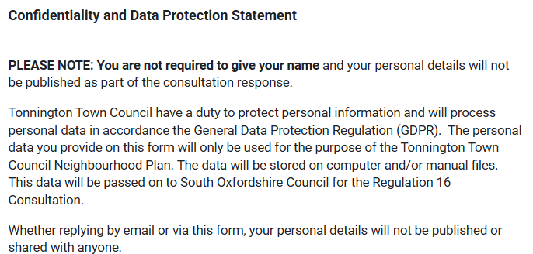



Please note that the following are not all statutory consultees.

