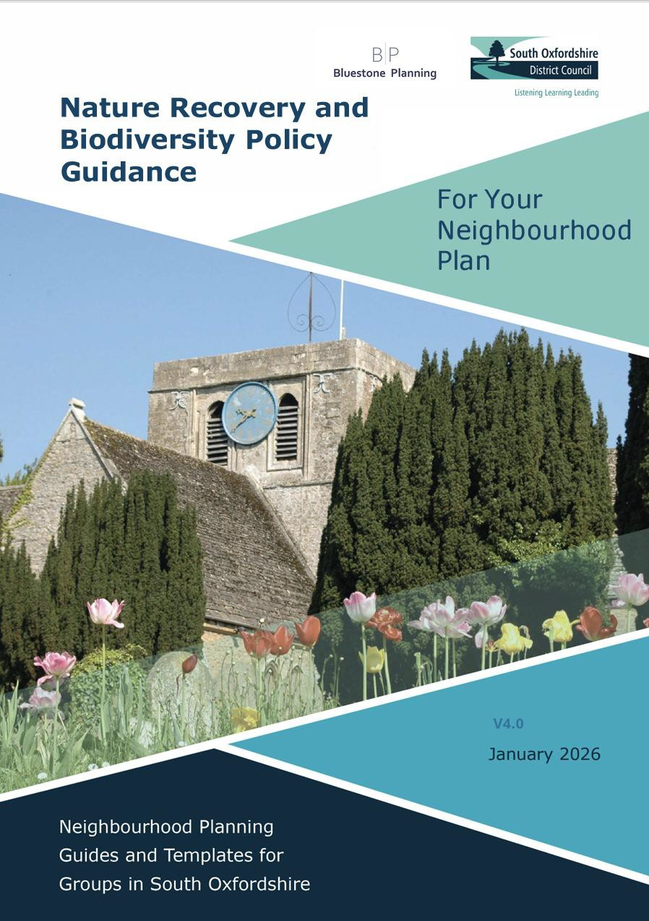
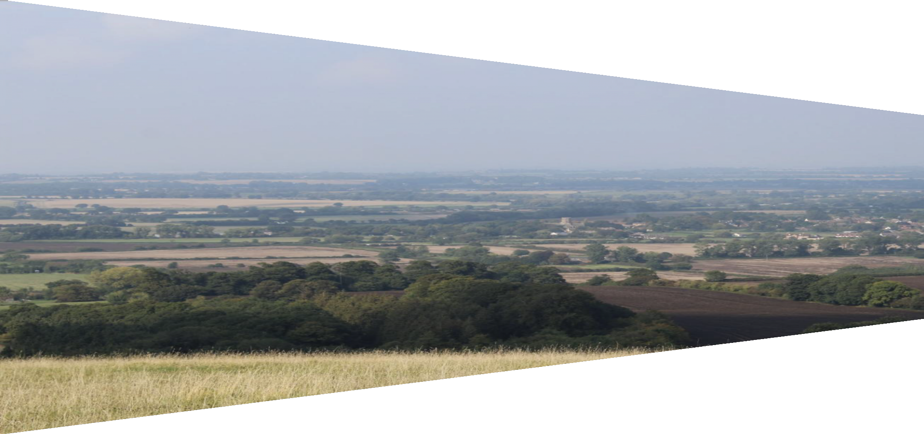
Neighbourhood Plan Template

V3.5


Contents

How to Use this Document 3
Template Structure 3
Using the Template 3
Additional Support 3
1. Introduction and Background 8
1.1 Neighbourhood Plan Status 8
1.2 Submitting Body 8
1.3 Designation 8
1.4 Basic Conditions 9
1.5 Plan Period, Monitoring and Review 10
1.6 Neighbourhood Plan Stages 10
2. Planning Policy Context 11
2.1 National Planning Policy 11
2.2 South Oxfordshire Local Plan 2011-2035 13
2.3 The Oxfordshire Minerals and Waste Local Plan 15
3. The Neighbourhood Plan Area 15
3.1 Overview of [Plan Area] 15
3.2 [Plan Area] Through History 15
3.3 Historical Development 16
3.4 [Plan Area] Profile 16
Population 16
Household 17
4. Issues and Opportunities 18
4.1 Overview of Land Use Issues 18
4.2 Overview of Non-Land Use Issues 19
4.3 Vision and Objectives 19
Objectives for the Natural Environment 20
Objectives for the Built Environment 21
5. List of Policies 22
6. The Natural Environment 22
6.1 Background 22
6.2 National Character Areas 22
6.3 Landscape Character Areas 24
Natural Features 25
6.4 Important Views and Vistas 26
Important Views 27
6.5 Local Green Spaces 28
Local Green Spaces 30
6.6 Biodiversity and Habitats 31
6.7 Green and Blue Infrastructure 34
6.8 Dark Skies 35
6.9 Landscape Buffers 36
6.10 Flooding and Drainage 41
7. The Built Environment 42
7.2 Heritage 43
Historic Environment 43
7.3 Character and Design 46
7.4 Sustainable Construction, Resources and Climate Change 47
7.5 Housing 49
Housing Need 49
Housing, Infill and Redevelopment 53
Dwelling Extensions 54
Housing Allocation 55
7.6 Local Economy 55
7.7 Community Facilities 56
7.8 Transport and Infrastructure 57
8. Community Aspirations 60

How to Use this Document
This neighbourhood plan template is designed to support neighbourhood planning groups in preparing their own neighbourhood plan. It provides a clear structure and ready-to-use content to help simplify and streamline the drafting process.

Template Structure
This document uses two types of text to distinguish between guidance and editable content:
- Black text provides information, prompts and examples that can be used by groups without editing to be locally specific.
Example: Once a neighbourhood plan is approved through a referendum, it becomes part of the development plan.
- Blue text in square brackets [example] needs to be revised or tailored to reflect the specific characteristics, needs and aspirations of your area.
Example: On [date], [Town/Parish/Forum] formed a Steering Group to develop the neighbourhood plan.

Using the Template
Neighbourhood planning groups are encouraged to:
- Use the black text as a guide for what to include in each section;
- Replace the blue text in [brackets] with information that reflects the local context; and
- Add or remove sections and sentences as needed to suit the scale and scope of their plan.
By combining structured guidance with editable template wording, this document allows groups to focus their efforts on creating a plan that reflects local priorities - while streamlining the drafting process.

Additional Support
This template is supported by a separate Neighbourhood Planning Guide, which provides:
- Detailed step-by-step advice on each stage of the process; and
- Tips, tools, and practical examples from other plans;
The guide and template are intended to work together - the guide offers depth and explanation, while the template gives you a ready-to-use framework for creating a plan that meets both local needs and statutory requirements.

EXAMPLE COVER PAGE
[PLAN AREA]
Neighbourhood Development Plan

PHOTO OR GRAPHIC REPRESENTING YOUR AREA

Pre-Submission Draft to [year]
[usually in line with date of Local Plan]

V1.0 [Month and Year]

Prepared by
[Steering Group/Committee Name] on behalf of [Town/Parish Council/Forum]
In conjunction with
[Consultants or third parties]

Foreword
The [plan area] neighbourhood plan has been created to help guide development and future growth across our area, aiming to enhance the quality of life for all residents.
This plan is significant as it provides a local roadmap for sustainable development, allowing our community to have a say over its future. [Relevant context related to the plan area and what the plan seeks to achieve].
Through extensive community engagement, notably [community consultations carried out] we have gathered insight and feedback from [number] residents that have shaped our vision for the future: [vision].
We extend our gratitude to [relevant individuals, organisations and stakeholders] who contributed their time and ideas, making this plan a true reflection of our collective aspirations.

Sources
This plan incorporates information from the following agencies and public bodies in whom copyright resides:
Ordnance Survey © Crown copyright and database rights 2025 OS data licensed under the Public Service Geospatial Agreement, Licence No:
Environment Agency maps and data © Environment Agency 2025
Natural England https://www.gov.uk/government/organisations/natural-england
Historic England https://historicengland.org.uk/
Office for National Statistics: licensed under the Open Government Licence V.3.0
Contents
1. Introduction and Background 8
1.1 Neighbourhood Plan Status 8
1.2 Submitting Body 8
1.3 Designation 8
1.4 Basic Conditions 9
1.5 Plan Period, Monitoring and Review 10
1.6 Neighbourhood Plan Stages 10
2. Planning Policy Context 11
2.1 National Planning Policy 11
2.2 South Oxfordshire Local Plan 2011-2035 13
2.3 The Oxfordshire Minerals and Waste Local Plan 15
3. The Neighbourhood Plan Area 15
3.1 Overview of [Plan Area] 15
3.2 [Plan Area] Through History 15
3.3 Historical Development 16
3.4 [Plan Area] Profile 16
Population 16
Household 17
4. Issues and Opportunities 18
4.1 Overview of Land Use Issues 18
4.2 Overview of Non-Land Use Issues 19
4.3 Vision and Objectives 19
Objectives for the Natural Environment 20
Objectives for the Built Environment 21
5. List of Policies 22
6. The Natural Environment 22
6.1 Background 22
6.2 National Character Areas 22
6.3 Landscape Character Areas 24
Natural Features 25
6.4 Important Views and Vistas 26
Important Views 27
6.5 Local Green Spaces 28
Local Green Spaces 30
6.6 Biodiversity and Habitats 31
6.7 Green and Blue Infrastructure 34
6.8 Dark Skies 35
6.9 Landscape Buffers 36
6.10 Flooding and Drainage 41
7. The Built Environment 42
7.2 Heritage 43
Historic Environment 43
7.3 Character and Design 46
7.4 Sustainable Construction, Resources and Climate Change 47
7.5 Housing 49
Housing Need 49
Housing, Infill and Redevelopment 53
Dwelling Extensions 54
Housing Allocation 55
7.6 Local Economy 55
7.7 Community Facilities 56
7.8 Transport and Infrastructure 57
8. Community Aspirations 60

Introduction and Background

Neighbourhood Plan Status
    - The Localism Act 2011, along with the Neighbourhood Planning (General) Regulations 2012 (as amended), established neighbourhood planning within England's planning framework, empowering communities to have a say in local development.
    - Once a neighbourhood plan is approved through a referendum, it becomes part of the development plan. This plan will then be integrated into the district planning framework and utilised by South Oxfordshire District Council to evaluate and determine planning applications. It aligns with and supports the strategic policies outlined in the adopted local plan, containing specific planning policies for the development and use of land. Broader community aspirations, while important, are not planning policies and are addressed separately in the relevant sections.

Submitting Body
    - The [Town/Parish/Forum] serves as the qualifying body tasked with preparing the neighbourhood plan and is thus responsible for submitting it to the District Council for examination. The term ‘qualifying body’ is defined by the Localism Act 2011, referring to the entity responsible for neighbourhood planning within the designated neighbourhood area.

Designation
    - On [date], [Town/Parish/Forum] formed a Steering Group to develop the neighbourhood plan. In line with Regulation 5 of the Neighbourhood Planning (General) Regulations 2012, on [date] South Oxfordshire District Council designated the [plan area] to cover the area shown in Figure 1.


MAP OF NEIGHBOURHOOD PLAN AREA, DISTINGUISHED USING A BRIGHT COLOURED BOUNDARY LINE
Figure 1. Map of Designated Neighbourhood Area

Basic Conditions
    - Neighbourhood plans must adhere to the ‘Basic Conditions’. These Basic Conditions are outlined in the Town and Country Planning Act 1990 (as amended) and include the following criteria:
- Having regard to national policies and advice contained in guidance issued by the Secretary of State, it is appropriate to make the order (or neighbourhood plan).
- The making of the order (or neighbourhood plan) contributes to the achievement of sustainable development.
- The making of the order (or neighbourhood plan) is in general conformity with the strategic policies contained in the development plan for the area of the authority (or any part of that area).
- The making of the order (or neighbourhood plan) does not breach and is otherwise compatible with EU obligations as incorporated into UK law.
- Prescribed conditions are met in relation to the Order (or plan) and prescribed matters have been complied with in connection with the proposal for the order (or neighbourhood plan).
    - Schedule 4B (8(6)) of the Town and Country Planning Act also states that examiner’s must consider whether the neighbourhood plan is “compatible with the Convention rights”. The interpretation section (s.17) in Schedule 4B clarifies that “the Convention rights” carries the same meaning as defined in the Human Rights Act 1998.

Plan Period, Monitoring and Review
    - The neighbourhood plan has been produced to cover the period [start year – end year].
    - It is important to recognise that this plan will evolve over time to address changing needs and requirements. Through regular review processes, we are dedicated to monitoring the effectiveness of the documents that support this plan. An annual review will evaluate the plan’s relevance and highlight areas for enhancement. This commitment to ongoing assessment ensures that the plan remains effective in fostering a vibrant future for [plan area].

Neighbourhood Plan Stages
    - Figure 2 below depicts the progression of this neighbourhood plan from its initial conception to its eventual implementation. We are currently at the pre-submission draft consultation stage, with one more draft to be consulted on prior to independent assessment. This is an opportunity for the community to provide valuable feedback and influence the future of the community up to [year].
    - Please note, not all stages shown in Figure 2 are compulsory. Statutory stages, meaning they are legally required under The Neighbourhood Planning (General) Regulations 2012 (as amended), are distinguished by a red border.

Figure 2. Neighbourhood Plan Process
    - Following this pre-submission stage, the neighbourhood plan and supporting documents will be submitted to South Oxfordshire and from there, they will run a period of publicity on the submission draft of the neighbourhood plan for a minimum of six weeks. All feedback will be collated and passed to the examiner for consideration as part of the examination process.
    - South Oxfordshire District Council will then appoint an independent examiner, whose appointment is to be agreed by the qualifying body, who will review the plan and supporting information. The examiner will assess whether the plan is legally compliant and meets the basic conditions. At the end of the examination, the examiner will issue their report with any recommended modifications required to meet basic conditions. This report will be reviewed, alongside the plan, by South Oxfordshire District Council who have the responsibility of deciding what action to take in response to the examiner’s recommendations and whether the plan should proceed to referendum.
    - The referendum will be organised by South Oxfordshire District Council and people on the electoral register within the referendum area, usually the same as the designated neighbourhood area, will be entitled to vote on whether they want the neighbourhood plan to be used to help determine planning applications in the neighbourhood area. If more than 50% of votes cast are in favour (‘yes’), the plan becomes part of the development plan.

Planning Policy Context

National Planning Policy
    - The National Planning Policy Framework (NPPF), updated in December 2024, and revised in February 2025, is an important guide in the preparation of local plans and neighbourhood plans. It sets out the Government’s policy in relation to land use planning matters.
    - The neighbourhood plan must demonstrate that it has had regard to the provisions of the NPPF. The relevant paragraphs of the NPPF are set out alongside the policies contained within the neighbourhood plan in Section 5.
    - As stated in the NPPF, the purpose of the planning system is to contribute to the achievement of sustainable development. At a very high level, the objective of sustainable development can be summarised as meeting the needs of the present without compromising the ability of future generations to meet their own needs, as set out in Resolution 42/187 of the United Nations General Assembly.
    - The planning system has three overarching objectives described in the NPPF (Paragraph 8); these have been related to the plan area:
- an economic objective – this neighbourhood plan seeks to provide policies which assist in building a strong, [urban/rural] economy. Through public consultation and talking to business owners this neighbourhood plan seeks to assist with the future needs in [plan area].
- a social objective – this neighbourhood plan aims to preserve and highlight the significance of local community facilities and to encourage proposals that would seek to create new facilities that would meet an identified need within [plan area].
- an environmental objective – this neighbourhood plan includes several policies aimed at ensuring the protection and, when appropriate, the enhancement of nationally and locally significant habitats, which aims to conserve the [urban/rural] character of [plan area].
    - The NPPF sets out that neighbourhood plans should support the delivery of strategic policies contained in local plans; and should shape and direct development that is outside of these strategic policies. This neighbourhood plan has been prepared to complement the strategic policies of the South Oxfordshire Local Plan by providing additional locally specific information. It reflects the unique context, character, needs and opportunities of [plan area].

Planning Practice Guidance
    - In preparing this neighbourhood plan, regard has been given to the Government’s Planning Practice Guidance (PPG), which provides detailed guidance on implementing national planning policy. The PPG covers topics including housing, design, environmental protection, infrastructure and community engagement and is intended to support neighbourhood plans in delivering sustainable development in accordance with the National Planning Policy Framework.
    - The policies in this neighbourhood plan have been informed by the PPG, particularly in relation to:
- gathering and using evidence to support policies;
- assessing the impact of development on local character, heritage and the environment;
- promoting sustainable transport, community facilities and infrastructure provision; and
- ensuring policies are clear, deliverable and capable of supporting development management decisions.
    - Where relevant, reference has been made to the PPG to ensure that the neighbourhood plan aligns with national guidance while addressing the unique context, character and needs of [plan area]. This ensures that policies are consistent with the Development Plan and contribute positively to sustainable development in the area.

South Oxfordshire Local Plan 2011-2035
    - [Plan area] is located within the Local Planning Authority area of South Oxfordshire. The overall vision of the adopted Local Plan 2035 is: “South Oxfordshire will remain a beautiful and prosperous place to live. It will be an attractive place for people to work and spend their leisure time”.
    - The adopted Local Plan 2035 outlines a series of strategic objectives which underpin the Local Plan. These objectives seek to balance the core pillars of sustainable development, including the protection of the environment and the need to provide sufficient development to meet the needs of the existing and future population. The objectives are set out below.
- Objective 1 – Settlements.
- Objective 2 – Housing.
- Objective 3 – Economy.
- Objective 4 – Infrastructure.
- Objective 5 – Design.
- Objective 6 – Community.
- Objective 7 – Natural and Built Environment.
- Objective 8 – Climate Change.
    - The policies in this neighbourhood plan will build upon the strategic policies in the Local Plan and provide detailed, locally specific information to ensure that future development proposals are assessed appropriately. Appendix 14 of the Local Plan identifies which policies in the Local Plan are strategic and which are non-strategic.
    - The adopted Local Plan 2035 includes several district wide policies which are relevant to [plan area]. These comprise:
- [Relevant adopted Local Plan 2035 policies].
- [Relevant adopted Local Plan 2035 policies].
- [Relevant adopted Local Plan 2035 policies].
- [Relevant adopted Local Plan 2035 policies].
    - Appendix 7 in the Adopted Local Plan 2035 identifies [plan area] as [settlement hierarchy level], meaning that it [is/is not] required to deliver significant housing [and/or] employment growth.
    - Policy STRAT1: The Overall Strategy, principally focuses development at Science Vale and sustainable settlements, mainly Towns and Larger Villages.
    - Remove if not applicable - Town:
[The Local Plan proposes the provision of an additional 15% growth of housing stock in addition to existing commitments from the Core Strategy. This level of growth has been calculated on the basis of the housing stock as at 2011 - the base date of the Local Plan.
The neighbourhood plan must explore opportunities to address local needs and provide allocations to meet or exceed the minimum requirements in Policy H3.
However, consideration of the availability of suitable and deliverable sites may impact how much development a settlement can accommodate.
A detailed evidence base will need to be provided to support each neighbourhood plan and its assessment of land availability, infrastructure delivery and landscape capacity].
    - Remove if not applicable - Larger Villages:
[The Local Plan proposes the provision of 15% growth in Larger Villages which do not have strategic housing allocations in the local plan. This has been calculated using the housing stock as it was at 2011 - the base date of the Local Plan and is on top of Core Strategy allocations where these exist.
Development in the Larger Villages should be proportional, appropriate and dependent on existing infrastructure. The Local Plan considers the most appropriate mechanism for delivering housing in larger villages is by preparing a neighbourhood plan and allocating development sites].
    - Remove if not applicable - Smaller and Other Villages:
[Smaller and Other Villages have no defined requirement to contribute towards delivering additional housing (beyond windfall and infill development) to meet the overall housing requirement of South Oxfordshire
While there is no requirement to allocate housing, communities may choose to do so. This is because allocating housing can enable the funding of community projects or allow the plan to guide the type and mix of homes that best reflect the area’s specific needs. South Oxfordshire District Council’s strategy supports this approach, provided that any proposed growth is proportionate to the scale and character of the settlement].

The Oxfordshire Minerals and Waste Local Plan
    - The Oxfordshire Minerals and Waste Local Plan Part 1 Core Strategy was adopted on 12th September 2017 and sets out the vision, objectives, spatial planning strategy and policies for meeting development requirements for the supply of minerals and the management of waste in Oxfordshire over the period to 2031.
    - It should be noted that the neighbourhood plan does not cover minerals and waste matters as this is undertaken by the County Council as a separate matter. This is highlighted where relevant in the policy section below.

The Neighbourhood Plan Area

Overview of [Plan Area]
    - [Plan area] is a [rural/urban] [tier] located within South Oxfordshire. [Plan area] is situated [distance and direction from nearby notable towns or landmarks], offering a mix of character and access to [key geographical features, such as national landscapes or infrastructure].
    - Land use across the area is predominantly [land use type], with [primary uses] and supports both the local economy and the scenic value of [plan area].
    - [Plan area] is served by [a range of] key local facilities and infrastructure that contribute to the community's character and wellbeing. These include [list of facilities], which are integral to daily life and support the needs of residents. The availability and quality of these amenities play a significant role in shaping [plan area’s] development and will be considered when formulating policies in the neighbourhood plan.
    - Recognised as a [settlement hierarchy] in South Oxfordshire Local Plan -2035, [plan area] lies within a setting that features [landscape or setting], contributing to its distinct local identity.

[Plan Area] Through History
    - The origins of [plan area] date back to [date], with evidence of early settlement found in [relevant archaeological sites or historical records]. Significant events, such as [key events], have shaped its development, while cultural and social changes have reflected shifts in demographics and community life.

Historical Development
    - The local economy transitioned from [early economic activities] to [modern economic activities] as industries evolved.
    - Architecturally, the area features notable buildings such as [significant structures], illustrating [description of styles over time].
    - Today, [plan area] continues to adapt to modern challenges such as [relevant issues] while preserving its historical identity.

[Plan Area] Profile
    - The following sections sets out demographic characteristics of our area, which have been used as the basis for many of our policies.

Population
    - Using the most recent data from the Office for National Statistics [year], at the time of writing the population for [plan area] is [number]. When comparing this to the [previous year] Census data, we can see that the population has [increased/decreased].
    - The most prominent age band within [plan area] as of [year] was ages [age bracket range (percentage)]. This is in comparison to the national average of [percentage], as visible in Figure 3.
    - The ratio to sex of all people in [plan area] is [sex ratio of population], with [percentage] of respondents being female and [percentage] being male.
    - [Plan area] has a [higher/lower] percentage of female residents than the national average [percentage] and a [higher/lower] percentage of males by [percentage difference], as visible in Figure 3 below.
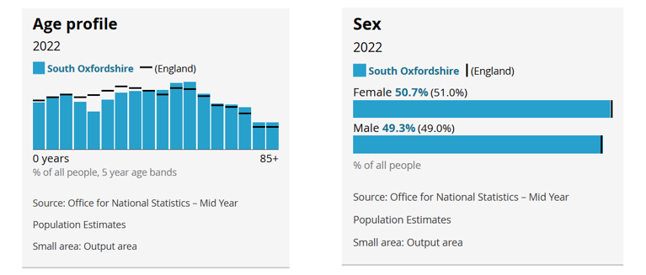
Figure 3. Age and Sex Profiles in [Plan Area] (Census [year])
    - In the [date] Census, [percentage] of all people in [plan area] identified as disabled under the Equality Act. This is [more/less] than the national average of [percentage].
    - General health was recognised as [above/below] the national average [percentage], with [percentage] of all people in [plan area] being in ‘very good health’. This is in comparison to very bad health, which [percentage] of respondents categorised themselves – in contrast to the national average of [percentage].

Household
    - The majority of households in [plan area] consist of [number] people (percentage), which is [higher/lower] than the national average of [percentage].
    - The second most prevalent household size is [number], at [percentage]. This is [higher/lower] than the national percentage of all households, which is [percentage], as visible in Figure 4.
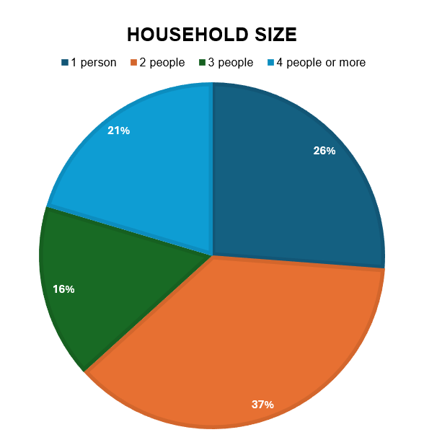
Figure 4. Household Size in [Plan Area]
    - In [plan area], the occupancy rating for +2 or more bedrooms in all households is [higher/lower] [percentage] than the national average [percentage] – see Figure 5 below.
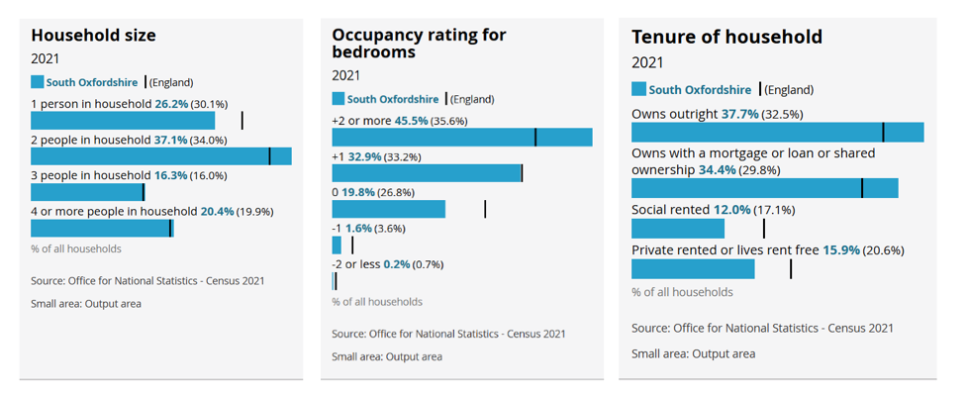
Figure 5. Household Size, Occupancy Rating for Bedrooms and Tenure of Household Profiles in [Plan Area] (Census [year])
    - Notably, the percentage of households that are owned outright in [plan area] is [percentage], which is [higher/lower] than the national percentage of [percentage]. This is [similar/different] for households that are owned with a mortgage, loan or shared ownership [percentage of area compared to national average percentage].
    - The prevalence of socially rented, privately rented or lives rent free as tenure of households within [plan area] is [higher/lower] than the national average of [percentage], as visible in Figure 5.

Issues and Opportunities

Overview of Land Use Issues
    - To understand the needs of [plan area] over the neighbourhood plan period, public consultation was undertaken in [date] via a [consultation method].
    - The [consultation method] was advertised [details on how the consultation was advertised]. In total, there were [number] responses to the [consultation method].
    - [Additional information regarding any other public consultation events undertaken]. The results of the [consultation method] have been made available on the [Town/Parish/Forum] website and highlighted below.
    - The following list of issues has been summarised from the responses as being of key importance for inclusion within the neighbourhood plan (see Figure 6 also):
- [Land Use Issue].
- [Land Use Issue].
- [Land Use Issue].
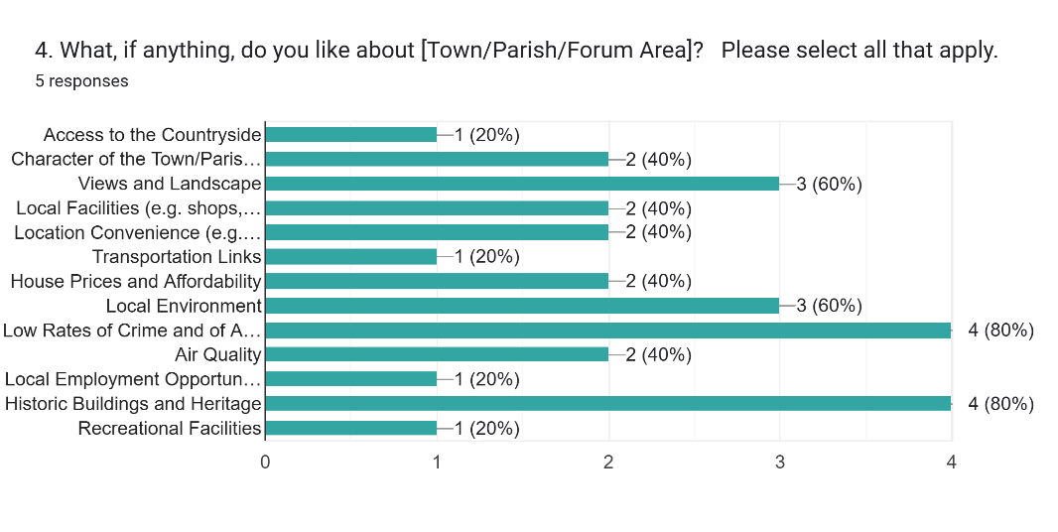
Figure 6. Community Consultation Results Detailing Resident's Likes about [Plan Area]

Overview of Non-Land Use Issues
    - Neighbourhood plans are focused on land use planning policies related to the development and use of land. As a result, important issues that are of particular interest to the local community - but do not fall within the remit of planning policy - are often not addressed directly.
    - However, the [Town/Parish/Forum] recognises the significance of these non-planning matters to residents and has chosen to highlight them within this plan as community aspirations. These aspirations represent key concerns the community wishes to see progressed and may be pursued through [Town/Parish/Forum] appropriate bodies. The non-land use issues identified through community consultation are illustrated in Figure 7 below and include:
- [Non-Land Use Issue].
- [Non-Land Use Issue].
- [Non-Land Use Issue].
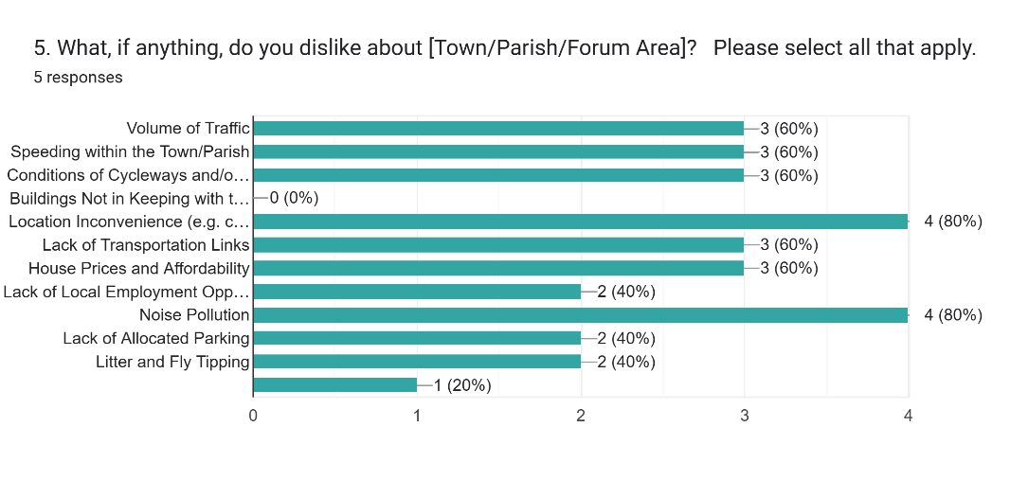
Figure 7. Community Consultation Results Detailing Resident's Dislikes about [Plan Area]

Vision and Objectives
    - The vision statement below has been consulted upon in community consultation and refined based on useful returns made by residents within [plan area]. Every effort has been made to ensure that it reflects the views expressed.
[Please add to this vision as you wish to address local circumstances]
The [plan area] Neighbourhood Plan seeks to protect and enhance the unique character and qualities of the [plan area], with a focus on maintaining its identity.
It aims to safeguard the surrounding landscapes, natural environment and valued views, while reinforcing the [plan area] distinct separation from nearby settlements.

    - Moreover, following public consultations, a list of objectives was created and grouped into two categories: the natural environment and built environment.

Objectives for the Natural Environment
    - Below is a list of [number] objectives for the natural environment, as consulted upon and agreed by the community [add and delete objectives as appropriate to your area].
Protect and enhance key landscape features and their surrounding environments and habitats, safeguarding them from disruption and pollution.

Protect and enhance local green spaces and recreational areas to provide leisure opportunities that support community health and wellbeing.

Conserve and strengthen existing habitats by establishing wildlife corridors and planting native trees and hedgerows.

Protect the tranquillity of our night skies by reducing noise and light pollution.

Protect and enhance identified important views.

Objectives for the Built Environment
    - Below is a list of [number] objectives for the built environment, as consulted upon and agreed by the community [add and delete objectives as appropriate to your area].
Protect and enhance designated and non-designated heritage assets in the [plan area].

Ensure new development respects the identified character of the area, [as identified in the Character Appraisal].

Promote the development of identified community services and facilities, specifically [local community services/facilities].

Support the creation and maintenance of footpaths, bridleways and cycle paths.

Advocating for improved public transport services.

List of Policies
    - The following policy options and topic areas have been devised in response to the Vision and Objectives and the community engagement and consultations that have taken place to date.
Policy Title and Number | Topic Area
Policy 1: Landscape Character and Settlement Identity | Natural Environment
Policy 2: Important Views and Vistas | Natural Environment
Policy 3: Local Green Spaces | Natural Environment
Policy 4: Biodiversity and Habitats | Natural Environment
Policy 5: Green and Blue Infrastructure | Natural Environment
Policy 6: Dark Night Skies | Natural Environment
Policy 7: Landscape Buffers | Natural Environment
Policy 8: Local Gaps | Natural Environment
Policy 9: Settlement Boundary | Built Environment
Policy 10: Flooding and Drainage | Built Environment
Policy 11: Non-Designated Heritage Assets | Built Environment
Policy 12: Character and Design | Built Environment
Policy 13: Sustainable Construction, Resources and Climate Change | Built Environment
Policy 14: Housing Allocation | Built Environment
Policy 15: Housing, Infill and Redevelopment | Built Environment

The Natural Environment

Background
    - This section provides an overview of the natural environment within [plan area], highlighting its significance and the need for its protection. It will cover important topics such as biodiversity, green spaces, flooding and drainage.
    - The following policies for preserving and enhancing these natural assets, ensuring that future development respects the ecological and environmental values of the area are outlined below.

National Character Areas
    - Through an understanding of the existing landscapes and the key characteristics within [plan area], appropriate local landscape policies have been devised. At a national level, Natural England publishes National Character Types (NCAs), which highlight distinct landscape areas, their features and their significance.
    - [Plan area] is split into [number] national character areas, listed below and visible in Figure 8:
- [National Character Area].
- [National Character Area].

[National Character Area 1]
    - [Description on National Character Area].

[National Character Area 2]
    - [Description on National Character Area].

MAP OF NEIGHBOURHOOD PLAN AREA WITH NATIONAL CHARACTER AREAS
Figure 8. [National Character Area] and [National Character Area]

Parish Landscape Character Areas
[Include this section if the work has been undertaken to complete a Parish Landscape Character Assessment]
    - At a local level, [plan area] can be split into [number] local character areas, listed below and visible in Figure 9:
    - [Local Character Area].
    - [Local Character Area].

MAP OF NEIGHBOURHOOD PLAN AREA WITH LOCAL CHARACTER AREAS
Figure 9. [Local Character Area] and [Local Character Area]

[Local Character Area 1]
    - [Description of Local Character Area].

[Local Character Area 2]
    - [Description of Local Character Area].

[Local Character Area 3]
    - [Description of Local Character Area].

Natural Features
    - Drawing on both national and local character area assessments, we have identified several distinctive and valued characteristics that define the identity of the area. These include [key characteristics], which together shape [plan area].
    - [Description of key characteristics and how they contribute to the visual, historical and environmental qualities of the plan area].
    - It is important that these characteristics are protected, preserved and where possible, enhanced, so that they continue to contribute to the character of the area.
    - The myriad of key valued characteristics are visible on the map below.

MAP OF NEIGHBOURHOOD PLAN AREA WITH NATURAL FEATURES MAPPED
Figure 10. Natural Features of [Plan Area]
Policy 1 – Landscape Character and Settlement Identity

For policy examples and further information on how to write a policy for Landscape Character and Settlement Identity, please see South Oxfordshire’s Neighbourhood Development Plan Policy Table and South Oxfordshire’s Landscape Consideration Guidance.

Important Views and Vistas
    - [Plan area] is characterised by a wide variety of key views, which are described in greater detail in the [plan area] Character Appraisal (Appendix [X]).
    - This policy identifies [number] views within [plan area] (as visible in Figure 11), established through extensive consultations with residents and stakeholders who recognised them as being of particular significance.
    - These views have been deemed significant due to their contribution to:
- Landscape and Built Character: Preserving the unique character of individual settlements and the landscape between them within the plan area.
- Heritage Assets: Recognising the proximity to designated heritage assets.
- Visual Amenity: The aesthetic value of the undulating landscape setting with a number of views gained from elevated points.
    - When considering development proposals within the plan area, careful consideration must be given to the potential impact on the following identified significant views.
    - This policy does not seek to prevent all development within the view but to ensure that the scale, massing and height of proposals do not result in the integrity of the view being undermined. Further information on the Important Views and the reasons for their inclusion can be found in the Appendix [X].

MAP OF IMPORTANT VIEWS

Figure 11. Map of Important Views in [Plan Area]

Important Views

IV1: [Name of view]. | [Image of view] | IV2: [Name of view]. | [Image of view]
IV3: [Name of view]. | [Image of view] | IV4: [Name of view]. | [Image of view]
IV5: [Name of view]. | [Image of view] | IV6: [Name of view]. | [Image of view]
IV7: [Name of view]. | [Image of view] | IV8: [Name of view]. | [Image of view]
IV9: [Name of view]. | [Image of view] | IV10: [Name of view]. | [Image of view]
IV11: [Name of view]. | [Image of view] | IV12: [Name of view]. | [Image of view]
IV13: [Name of view]. | [Image of view] | IV14: [Name of view]. | [Image of view]

Policy 2 – Important Views and Vistas

For policy examples and further information on how to write a policy for Important Views and Vistas, please see South Oxfordshire’s Neighbourhood Development Plan Policy Table and South Oxfordshire’s Landscape Consideration Guidance.

Local Green Spaces
    - This policy proposes [number] Local Green Spaces which are identified as important green areas within the community (see Figure 13). These are to be protected from development by their designation as Local Green Spaces in accordance with Paragraphs 106, 107 and 108 of the NPPF.
    - Public consultation exercises, where residents were asked to nominate important green spaces and the reasons for which they should be protected, have fed into the final list of Local Green Spaces.
    - Each space has been individually assessed in accordance with the NPPF criteria and found to be demonstrably special to the local community. They have also been deemed to be local in character and not an extensive tract of land. A full description of each site and the justification for its designation can be found in Appendix [X], with a summary set out below.
    - Local Green Space designations are subject to the same development restrictions as Green Belt, significantly reducing development potential on the site. This will mean that the land will remain open and continue to contribute to the character of the area.
    - It should be noted that a Local Green Space does not give the right of public access to spaces where it does not exist already. This is particularly relevant for private land, restricted access sites or those with wildlife or visual amenity value.
    - It should also be noted that a site cannot be designated if the site has planning permission for a use which would conflict with the designation, such as for housing or employment development.
    - Each area was considered using the following criteria as set out in Figure 12.
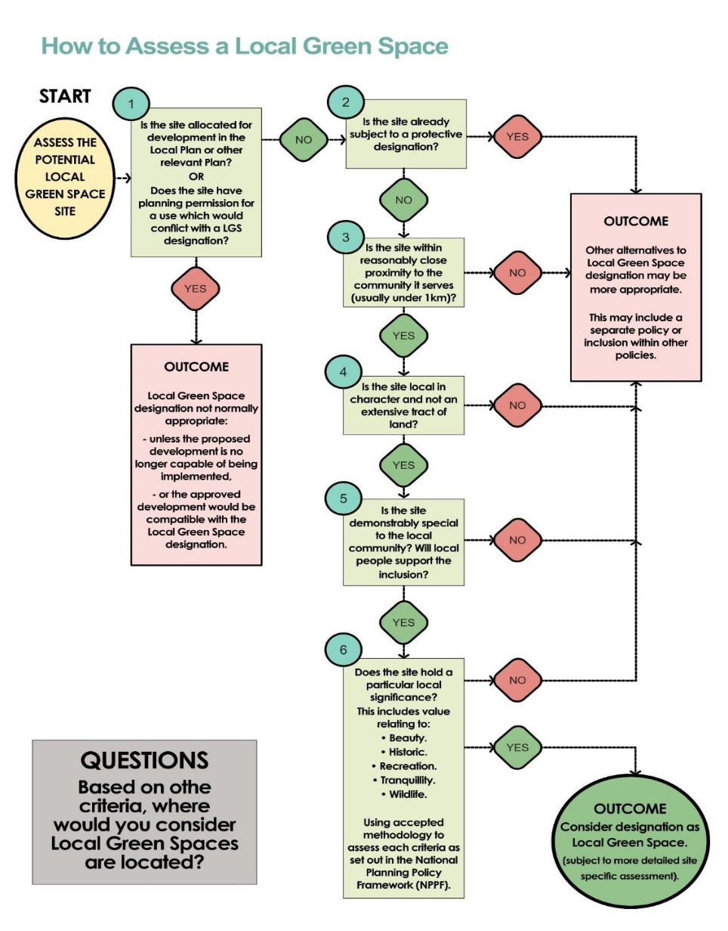

Figure 12. Local Green Space Assessment
MAP OF LOCAL GREEN SPACES
Figure 13. Map of Local Green Spaces in [Plan Area]

Local Green Spaces

LGS1: [Name of LGS]. | [Image of LGS (Change for All)] | LGS2: [Name of LGS]. | [Image of view]
LGS3: [Name of LGS]. | [Image of view] | LGS4: [Name of LGS]. | [Image of view]
LGS5: [Name of LGS]. | [Image of view] | LGS6: [Name of LGS]. | [Image of view]
LGS7: [Name of LGS]. | [Image of view] | LGS8: [Name of LGS]. | [Image of view]
LGS9: [Name of LGS]. | [Image of view] | LGS10: [Name of LGS]. | [Image of view]
LGS11: [Name of LGS]. | [Image of view] | LGS12: [Name of LGS]. | [Image of view]
LGS13: [Name of LGS]. | [Image of view] | LGS14: [Name of LGS]. | [Image of view]

Policy 3 – Local Green Spaces

For policy examples and further information on how to write a policy for Local Green Spaces, please see South Oxfordshire’s Neighbourhood Development Plan Policy Table and South Oxfordshire’s Landscape Consideration Guidance.

Biodiversity and Habitats
    - [Plan area] contains [amount] of [biodiversity characteristic, such as Ancient Woodland], primarily located in [location].
    - Additionally, the area consists of several Priority Habitats, notably in [locations with priority].
    - These habitats are critical for supporting local ecosystems, providing essential resources for various plant and animal species, such as [list of local plant and animal species], including those that are rare or threatened, such as [list of local plant and animal species].
    - There are opportunities for habitat restoration, management of invasive species and the creation of buffer zones in and around these areas, notably in [identified locations in need of restoration and/or management].
    - The local community is keen to ensure that existing nature and wildlife resources in the plan are safeguarded to encourage and maintain wildlife and biodiversity. The protection of existing hedgerows, flora and fauna and other natural habitats of significance is particularly important.
    - The neighbourhood plan policy sets out below that the relationship between new development and the surrounding natural environment is an important consideration within [the plan area]. Existing biodiversity features, such as [native trees, shrubs and wildflower areas], make a significant contribution to local character, ecological connectivity and landscape quality. Retaining such features wherever possible helps to maintain habitat value and minimise ecological disruption.
    - Where vegetation cannot be retained due to development requirements, ecological best practice highlights the importance of appropriate replacement planting. Using native species that are characteristic of the local landscape supports habitat restoration and helps ensure long-term resilience, particularly where the future use of the site may place pressures on existing green infrastructure.
    - Hedgerows also play a key role in the area’s ecological network, providing habitat, screening and landscape structure. In cases where existing hedges are lost, ecological guidance suggests that replanting with diverse native species can help to reinstate ecological function and maintain the rural character of the neighbourhood.
    - The map overleaf highlights those areas here the greatest opportunities for habitat creation and restoration lie, enabling the efficient focusing of resources to where they will have the greatest positive conservation impact. This information has been sourced from [reference to evidence].

MAP OF NEIGHBOURHOOD PLAN AREA WITH BIODIVERSITY MAPPED
Figure 14. Biodiversity in [Plan Area]
Policy 4 – Biodiversity and Habitats

For policy examples and further information on how to write a policy for Biodiversity and Habitats, please see South Oxfordshire’s Neighbourhood Development Plan Policy Table and South Oxfordshire’s Nature Recovery and Biodiversity Guidance.

Green and Blue Infrastructure
    - Green and blue infrastructure is a network of natural features and spaces within and around the plan area, enhancing biodiversity and enabling ecosystem services. The ‘green’ refers to vegetative elements and spaces including parks, open space, woodland, hedgerows, street trees, green roof etc. The blue refers to water-based elements and spaces including rivers and their tributaries, ponds and areas of wetlands water meadows.
    - One of the most notable features of green infrastructure in [plan area] includes [description of green infrastructure – such as hedgerows and ancient woodlands].
    - [Plan area] is also home to [further examples of green and blue infrastructure]. Ongoing efforts to conserve and enhance these natural assets are therefore crucial for ensuring that [plan area] remains a haven for biodiversity.

MAP OF NEIGHBOURHOOD PLAN AREA WITH GREEN AND BLUE INFRASTRUCTURE MAPPED
Figure 15. Map of Green and Blue Infrastructure in [Plan Area]

Policy 5 – Green and Blue Infrastructure
For policy examples and further information on how to write a policy for Green and Blue Infrastructure, please see South Oxfordshire’s Neighbourhood Development Plan Policy Table and South Oxfordshire’s Nature Recovery and Biodiversity Guidance.

Dark Skies
    - The CPRE Dark Skies Mapping (see Figure 16) provides a map indicating the level of light pollution within [plan area]. [Description of light pollution in the area based on the CPRE map].
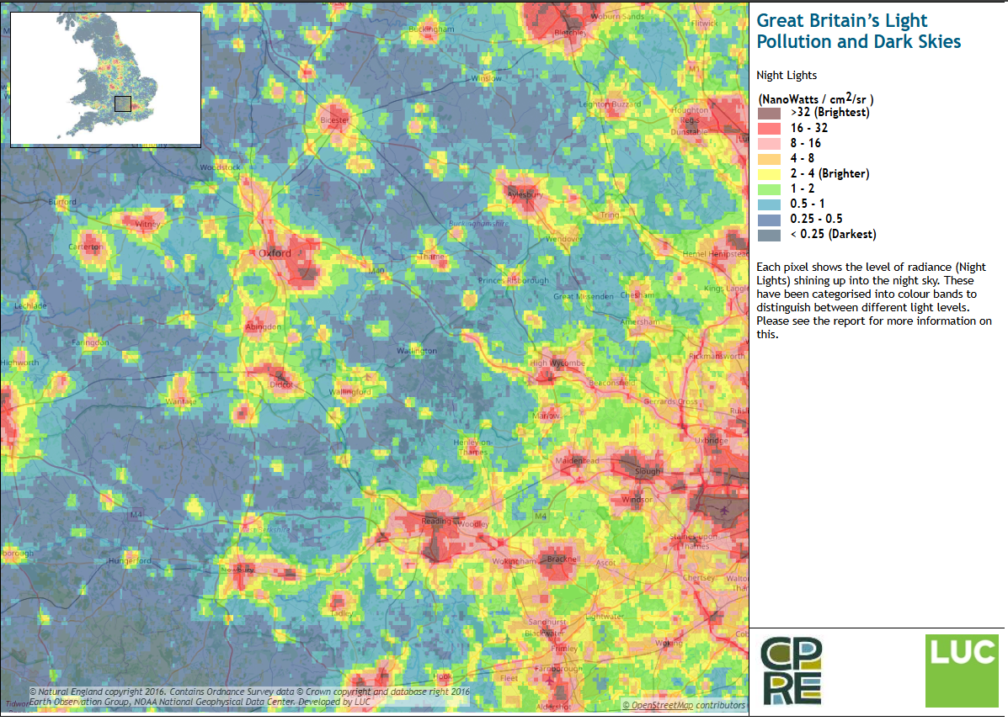
Figure 16. Map of Light Pollution in [Plan Area]
    - Streetlighting is located [location – along the main roads or within the settlement boundary]. The public consultation indicated that [no] further streetlights are considered necessary.
    - Development proposals should carefully consider the requirements set out in the policy. Prior to submitting a planning application applicants should consider the type of artificial lighting proposed, the location, the hours of operation, the quantity of lights proposed, brightness, control and direction of the beam.
    - Where planning permission is required and where lighting is deemed necessary, appropriate mitigation and control measures can be secured through planning conditions to prevent unnecessary light pollution. These may include:
- Limiting hours of operation through the use of automatic timers and nighttime dimming settings.
- Ensuring all lighting incorporates shielding or hoods that direct beams downward, below horizontal level.
- Using non-reflective surface materials to reduce glare and light reflection.
- Introducing appropriate planting or landscaping to help contain light spill.
- Adhering to the latest best practice guidance regarding lighting specifications, including lumens, wattage, beam angle, mounting height, colour temperature and warmth.
Policy 6 – Dark Skies
For policy examples and further information on how to write a policy for Dark Skies, please see South Oxfordshire’s Neighbourhood Development Plan Policy Table and South Oxfordshire’s Landscape Considerations Guidance.

Landscape Buffers
    - The neighbourhood plan recognises the importance of ensuring that new development integrates sensitively with its surrounding environment. Landscape buffers are areas of vegetation or open space provided at the edges of settlements to help soften the transition between built development and the countryside. They play a vital role in maintaining local character, protecting key views and supporting biodiversity.
    - When development is proposed on the edges of settlements, particularly near sensitive landscapes, well-designed landscape buffers can help mitigate visual and environmental impacts, ensuring that new development sits harmoniously within its setting.
    - Landscape buffers should aim to:
- Soften the transition between built development and open countryside by introducing vegetated edges that blend with the wider landscape and respect key views.
- Support biodiversity by incorporating native species, including locally appropriate trees, hedgerows and habitat corridors.
- Reflect the guidance and principles of local and national landscape character assessments, such as Natural England’s National Character Areas and relevant National Landscapes guidance.
- Be designed as part of an integrated approach to new development, complementing built design policies to maintain the distinct character of the area.
    - Where appropriate, landscape buffers can be multifunctional, providing visual screening, recreational opportunities or ecological benefits, while still fulfilling their primary role of managing the edge of development sensitively.

MAP OF NEIGHBOURHOOD PLAN AREA WITH LANDSCAPE BUFFERS MAPPED
Figure 17. Map of Landscape Buffers in [Plan Area]

Policy 7 – Landscape Buffers
For policy examples and further information on how to write a policy for Landscape Buffers, please see South Oxfordshire’s Neighbourhood Development Plan Policy Table and South Oxfordshire’s Landscape Considerations Guidance.

Local Gaps
    - Public consultation within [plan area] has consistently highlighted strong support for retaining the settlement boundary and preventing development creep into the surrounding countryside. The plan seeks to support modest and proportionate development to meet local needs within the settlement, while recognising that there may be development pressures from neighbouring [towns or urban areas].
    - The priority is to safeguard the countryside and rural character of the settlement, ensuring that it is not compromised by major development which would be out of keeping with the local character.
    - A review of recent development, alongside evidence from landscape and character assessments, has identified areas at risk of coalescence with neighbouring settlements, either through piecemeal or cumulative development. These areas are shown diagrammatically in Figure [X] to highlight current development pressures.
    - In response, this plan proposes [number] local gaps to maintain effective visual and physical separation between the settlement and [neighbouring areas] (see Figure [X]).
    - These gaps respond to areas where the setting of the settlement could be significantly affected by large-scale development, either outside the plan area or along key transport routes. Appropriate gaps should include only the land necessary to fulfil this function, reflecting the elevated topography, important views and historic character of the settlement.
    - For example, Gap [Number] (see Figure [X]) may be required between the settlement and neighbouring development to maintain the openness of key corridors. The precise location and extent of the buffer should be determined in line with any future development proposals, ensuring that an effective landscape buffer is implemented and maintained.
    - Gap [Number] (see Figure [X]) may be identified along sensitive routes or areas where incremental development could otherwise result in urban sprawl or the loss of rural character. Any new development in these areas should respect the historic and landscape setting, maintain gaps between buildings and avoid ribbon development along primary routes. These areas play a key role in preserving the visual and physical separation between settlements and protecting locally valued landscape features.
Policy 8 – Local Gaps
For policy examples and further information on how to write a policy for Local Gaps, please see South Oxfordshire’s Neighbourhood Development Plan Policy Table and South Oxfordshire’s Landscape Considerations Guidance.

Settlement Boundary
    - Public consultation within the neighbourhood plan area has demonstrated strong support for defining a settlement boundary to distinguish between the built-up area of [settlement name] and the surrounding countryside.
    - The settlement boundary is intended to ensure that future development occurs within the built-up area of [settlement name], preventing development creep into the surrounding countryside and protecting the rural character, historic environment and landscape setting of the village.
    - A review of recent development within the settlement area has highlighted pressures for expansion beyond the built-up area, including proposals that could extend development into sensitive landscapes or open countryside. The settlement boundary aims to manage growth in a way that is proportionate to local needs while maintaining the integrity of the village setting.
    - The boundary has been informed by local evidence, including [local character or landscape assessments] and community consultation, which consistently indicates strong support for a defined boundary. It is also consistent with relevant Local Plan policies that focus development within existing settlements and on allocated strategic sites.
    - Proposals for new development of an appropriate scale for [settlement name] will be supported where they are within the settlement boundary and accord with the policies of this neighbourhood plan and the Local Plan. This includes housing, shops, businesses and other commercial activities that are suitable to the size, services and infrastructure of the settlement.
    - The settlement boundary excludes areas of known flood risk, environmentally sensitive land and other locations where development would have a harmful impact on the character or setting of the settlement. This ensures that growth is sustainable, safe and does not erode the valued rural and historic aspects of the area.
    - The settlement boundary is shown on Figure [X]. It generally follows natural and historic edges of the settlement and consultation feedback, providing a clear and definitive basis for directing future development within the plan area.

Policy 9 – Settlement Boundary
For policy examples and further information on how to write a policy for Settlement Boundaries, please see South Oxfordshire’s Neighbourhood Development Plan Policy Table and South Oxfordshire’s Settlement Boundaries Guidance.

Flooding and Drainage
    - Local Plan Policy EP4 sets out details on minimising the risk and impact of flooding, highlighting the importance of Flood Risk Assessments and when they should be used. The NPPF guides development to areas with minimal flood risk. The following policy does not need to repeat the national position on this; it highlights the importance of flood risk management and surface water drainage strategies at a local level.
    - As illustrated in Figures 19 and 20, several areas within [plan area] are susceptible to surface water flooding. In locations prone to flooding, any new development should be designed to avoid exacerbating existing drainage challenges.

MAP OF NEIGHBOURHOOD PLAN AREA WITH FLOODING MAPPED

Figure 18. Map of Flooding in [Plan Area]

Policy 10 – Flooding and Drainage
For policy examples and further information on how to write a policy for Flooding and Drainage, please see South Oxfordshire’s Neighbourhood Development Plan Policy Table and South Oxfordshire’s Climate Change Guidance.

The Built Environment
    - The built environment shapes the character, identity and everyday experience of [plan area]. This section outlines the current form and function of our built environment, identifies key challenges and opportunities and sets out policies to guide future development in a way that enhances the quality, sustainability and distinctiveness of our area.
    - Policies in this section aim to ensure that new development respects the local character, contributes positively to the landscape and meets the evolving needs of residents and businesses. This includes encouraging high-quality design, protecting heritage assets and improving connectivity and accessibility.

Heritage

Historic Environment
    - In [plan area] there are [number] listed buildings, of which [number] are Grade II and [number] is Grade II*. There are also [number] Conservation Areas in [plan area] (see Figure 21).

MAP OF NEIGHBOURHOOD PLAN AREA WITH DESIGNATED HERITAGE ASSETS MAPPED

Figure 19. Map of Designated Heritage Assets in [Plan Area]
    - Understanding the heritage of a settlement is essential to shaping its successful future. It is crucial that the significance of listed buildings and their settings is recognised, as this awareness supports their ongoing maintenance and protection. Increased knowledge also enables the architectural and historic value of these buildings to be celebrated and reflected in future development across [plan area].
    - The neighbourhood plan has identified a series of non-designated heritage assets across [plan area]. Non-designated heritage assets are locally identified ‘buildings, monuments, sites, places, areas or landscapes identified by plan making bodies as having a degree of heritage significance meriting consideration in planning decisions but which do not meet the criteria for designated assets’ (PPG, paragraph: 039). Although non-designated heritage assets carry less statutory weight than designated assets, they remain important components of the local historic environment. The NPPF requires that the significance of non-designated heritage assets be considered when determining planning applications that may affect them. Where harm to or loss of such assets is proposed, a balanced judgment must be made, considering both the scale of the harm or loss and the heritage value of the asset.
    - Policy 11 seeks to protect the significance of locally important heritage assets and their settings, where appropriate. According to the NPPF, significance is defined as:
“the value of a heritage asset to this and future generations because of its heritage interest. The interest may be archaeological, architectural, artistic or historic. Significance derives not only from a heritage asset’s physical presence, but also from its setting.”
Historic England describes conservation as “the process of maintaining and managing change to heritage assets in a way that sustains and enhances their significance”.
    - For detailed guidance on identifying and protecting non-designated heritage assets, refer to Historic England's advice note on Local Heritage Listing.
    - The assets which have been identified within [plan area] are considered by residents to be of local importance, owing to their age, character, appearance or historical associations (see Figure 22). More information about each of the identified non-designated assets can be found in Appendix [X].

MAP OF NEIGHBOURHOOD PLAN AREA WITH NON-DESIGNATED HERITAGE ASSETS MAPPED
Figure 20. Map of Non-Designated Heritage Assets in [Plan Area]
Policy 11 – Non-Designated Heritage Assets
The Neighbourhood Plan identifies a series of non-designated heritage assets within the plan area, as set out in Appendix [X].
Development proposals that affect an identified non-designated heritage asset should demonstrate how the proposal will preserve or enhance the significance of the asset and its contribution to local character and distinctiveness.
Where a proposal would result in harm to a non-designated heritage asset, the level of harm should be clearly justified and will be weighed against the public benefits of the proposed development, having regard to the impact on the identity and character of the area.

For further policy examples, please see South Oxfordshire’s Neighbourhood Development Plan Policy Table.

Character and Design
    - The National Design Guide was published in 2019 and sets out the characteristics which create the physical character of an area and a sense of place and community. These characteristics are:
- Context – enhances the surroundings.
- Identity – attractiveness and distinctive.
- Built Form – a coherent pattern of development.
- Movement – accessible and easy to move around.
- Nature – enhanced and optimised.
- Public Spaces – safe, social and inclusive.
- Uses – mixed and integrated.
- Homes and Buildings – functional, healthy and sustainable.
- Resources – efficient and resilient.
- Lifespan – made to last.
    - The National Model Design Code (NMDC) was produced in June 2021 and forms part of the government’s planning practice guidance. It is intended to be read alongside the NPPF, National Planning Policy Guidance (PPG) and the National Design Guide. Its purpose is to assist with producing Design Guides and Codes, such as the [plan area] Design Guide.
    - The Joint Design Guide was adopted in June 2022 and is a supplementary Planning Document that is a material consideration when determining planning applications. The guide explores overarching themes including; place and setting, natural environment, movement and connectivity, space and layout, built form and climate and sustainability.
    - The above documents should be viewed in conjunction with the [Plan Area Design Guide/Code] that has been prepared in support of this neighbourhood plan. Together these documents form the Design Principles for each of the Character Areas that have been identified within the Design [Guide/Code].
Policy 12 – Character and Design
In addition to the other policies of the Development Plan, proposals for new residential development within the built-up areas of [settlement name] will be supported where they demonstrate that:
- scale, density, height, layout, landscape design and choice of materials preserve or enhance local character and distinctiveness, having regard to [local character assessment, design code or evidence base];
- impacts on the natural environment are minimised and proposals deliver net gains for biodiversity, in line with relevant local and national policy;
- the unnecessary loss of trees is avoided, particularly those which:
- have high amenity value and make an important contribution to local character; and
- represent valuable natural capital and contribute to health and wellbeing;
- care is taken to avoid unacceptable harm to the significance of designated and non-designated heritage assets and their settings;
- unacceptable impacts arising from noise, odour, air pollution and light pollution are avoided; and
- sufficient outdoor space is provided for refuse and recycling storage, as well as for the safe and convenient parking of cars and bicycles.
Where proposals require the establishment of new property boundaries, these should incorporate, where possible, boundary treatments using native or biodiversity-enhancing hedgerow species. The use of fencing or walls, where necessary, should reflect the local character and rural context of the settlement and be of a height and form that preserves openness and key views.
For further policy examples, please see South Oxfordshire’s Neighbourhood Development Plan Policy Table and the Design Guidance and Template.

Sustainable Construction, Resources and Climate Change
    - Sustainability is a cornerstone of both national and local planning policy. The Joint Nature and Climate Action Plan 2025-29 presents a set of actions to help the district achieve their goal of carbon neutrality by 2030 (district-wide).
    - As a result of this initiative and in recognition of the significance of climate change and its effects to the public health and environment, sustainable development is a key focus of this neighbourhood plan.
    - The Joint Nature and Climate Action Plan 2025-29 sets out several actions for the District Council to implement to help businesses and members of the community ensure that the carbon neutrality targets are met. These include providing advice and guidance on:
- reducing carbon emissions to businesses and residents;
- energy efficient operations;
- climate friendly lifestyle changes, including ways of making homes more energy efficient;
- climate funding opportunities for businesses; and
- relevant housing energy efficiency schemes.
    - It will be important to ensure that measures to mitigate the effects of climate change are incorporated into the design of new development in the plan area, as this will help the district with meeting their carbon neutral targets.
    - Special consideration should also be given to the design of new development within the Conservation Area or that could affect the setting or significance of a historic asset.
    - [This is supported by public consultation, which demonstrated that a large proportion of residents within [plan area] are interested in the creation of policies that actively contribute towards reducing energy use and making more use of renewable energy sources].
    - Therefore, proposals for individual renewable energy systems will be supported, provided they align with relevant development policies and the neighbourhood plan.
    - New developments should be designed to minimise both embodied carbon during construction and operational carbon emissions, following a ‘Fabric First’ approach.
    - A ‘Fabric First’ design strategy prioritises the performance of building materials and components before introducing mechanical or electrical systems. Future applicants should consider the following principles:
- Reduce the use of high carbon-intensity materials such as concrete, cement and steel.
- Increase the use of sustainable materials like timber, hemp or other plant-based fibres.
- Apply modern design standards such as EnerPHit for retrofits and Passivhaus for new buildings to ensure excellent airtightness and insulation.
Policy 13 – Sustainable Construction, Resources and Climate Change
New development should demonstrate a high standard of sustainable design and construction. Proposals should be designed to minimise carbon emissions, maximise water and energy efficiency, and be capable of meeting future regulatory standards, including being Future Homes Standard ready where applicable.
Development will be supported where it makes efficient use of land through high-quality design and incorporates the following principles, where appropriate to the site and its context:
- buildings are orientated, subject to topography and layout, to optimise solar gain while maintaining good urban design and a coherent relationship with the street;
- solar access is maximised, particularly to principal elevations, with appropriate use of shading, passive design measures and opportunities for natural ventilation;
- renewable and low-carbon energy technologies are incorporated, such as photovoltaic panels, solar thermal systems, air-source or ground-source heat pumps or equivalent technologies, where they are sensitively designed and respond positively to local character;
- the use of low embodied-carbon materials is encouraged, supported by proportionate life-cycle assessment where appropriate; and
- measures are included to reduce water consumption, including efficient fittings and appliances. Residential development should seek to achieve a high level of water efficiency and non-residential development should aim to meet high recognised sustainability standards, such as BREEAM “Excellent” for water use, where applicable.

Innovative construction methods and approaches to delivering low-carbon development, including but not limited to Passivhaus or equivalent standards, will be supported where proposals otherwise comply with the Development Plan.
Development proposals that incorporate on-site renewable or low-carbon energy generation will be supported.
For further policy examples, please see South Oxfordshire’s Neighbourhood Development Plan Policy Table.

Housing

Housing Need
    - Information about the existing housing stock in [plan area] can be found within the Census data broken down above in section [section]. This shows that: [summarise the relevant housing elements of the Census data relating to the plan area].
    - To obtain an up-to-date picture of the current housing situation in [plan area] a Housing Needs Assessment was carried out between [date] and [date] by [source or organisation]. A total of [number] [consultation method, e.g. surveys] were distributed to households within the neighbourhood area, with [number] responses received, resulting in a response rate of approximately [percentage]. A summary of the results from the survey can be found in Appendix [X].
    - Based on the survey findings, the data indicates a minimum requirement for [type of housing] within the neighbourhood area over the next five years. There is a preference for [type of dwelling preference, e.g. size, number of bedrooms].
    - The neighbourhood plan seeks to meet this requirement through a housing allocation.

Housing Allocation
    - The South Oxfordshire Local Plan 2035 sets out an approach to housing growth across the district's settlement hierarchy. [The actual housing requirements for individual settlements are set out in the Local Plan's Table 4d (Towns) and Table 4f (Larger Villages)].
    - Remove if not applicable - Town:
[The Local Plan proposes an additional 15% growth of housing stock in Towns, in addition to existing commitments from the Core Strategy. Table 4d of the Local Plan sets out the minimum outstanding housing requirement for each Town based on this approach.
Both Thame and Henley-on-Thames have prepared neighbourhood plans to address their respective housing requirements. However, these requirements remain applicable until the allocated sites are built out, meaning there may still be value in a neighbourhood plan review addressing housing delivery and any remaining capacity, particularly where there are opportunities to meet local needs or respond to changed circumstances.
The neighbourhood plan must explore opportunities to address local needs and provide allocations to meet or exceed the minimum requirements set out in Policy H4 and Table 4d].
    - Remove if not applicable - Larger Villages:
[The Local Plan proposes 15% growth in Larger Villages, calculated using the housing stock as it was in 2011 (the base date of the Local Plan) and in addition to Core Strategy allocations where these exist. Table 4f of the Local Plan sets out the minimum outstanding housing requirement for each Larger Village.
It should be noted that the majority of Larger Villages have a zero (0) outstanding housing requirement as shown in Table 4f. Where a Larger Village does have an outstanding requirement, in most cases a neighbourhood development plan has already been prepared to address it.
Where there is an outstanding housing requirement, the neighbourhood plan must explore opportunities to address local needs and provide allocations to meet or exceed the minimum requirements set out in Policy H4 and Table 4f. Where there is no outstanding requirement, communities may still choose to allocate housing sites if doing so would enable community benefits or help meet specific local housing needs].
    - Remove if not applicable - Smaller and Other Villages:
[In the Local Plan, Smaller and Other Villages have no defined requirement to contribute towards delivering additional housing (beyond windfall and infill development) to meet the overall housing requirement of South Oxfordshire.
Despite no requirement in the Local Plan to allocate housing, this plan has decided to allocate [number] housing sites to address the identified local need].
    - To identify appropriate sites that may be capable of delivering housing to meet the identified local needs, a site selection process was undertaken.
    - The process began with two key inputs: a review of sites submitted through South Oxfordshire’s 'call for sites' process, and a separate locally led ‘call for sites’ specific to the neighbourhood area.
    - These calls for sites identified a range of potential locations, submitted by landowners and developers, for consideration for residential development. Developers and landowners were invited to provide supporting information, including indicative dwelling numbers and any infrastructure enhancements.
    - An independent site assessment was then carried out, using an adapted methodology based on that used by South Oxfordshire, with additional locally relevant assessment criteria.
    - From this process, sites considered to be deliverable were identified. The term ‘deliverable’ is defined in the NPPF:
“To be considered deliverable, sites for housing should be available now, offer a suitable location for development now, and be achievable with a realistic prospect that housing will be delivered on the site within five years. In particular:
- sites which do not involve major development and have planning permission, and all sites with detailed planning permission, should be considered deliverable until permission expires, unless there is clear evidence that homes will not be delivered within five years (for example because they are no longer viable, there is no longer a demand for the type of units or sites have long term phasing plans).
- where a site has outline planning permission for major development, has been allocated in a development plan, has a grant of permission in principle, or is identified on a brownfield register, it should only be considered deliverable where there is clear evidence that housing completions will begin on site within five years”.
    - Sites with significant constraints or issues that could not be resolved at the present time were discounted.
    - A public consultation was held to present all shortlisted sites to the local community. The consultation included information on each site’s deliverability and potential advantages and disadvantages.
    - Community feedback was used to help shape the selection of preferred sites. Respondents were invited to indicate their site preferences, which were then analysed to identify levels of community support for each option.
    - As a result of this process, [number] sites were identified as preferred options for housing allocations in this plan. These are shown on the accompanying maps and are supported by an appropriate policy to guide development.
    - Development proposals should respond to the identified housing needs of the neighbourhood area and demonstrate a sensitive approach to local character. Proposals should reflect the design guidance set out in the local Design Code, including considerations of layout, density and materials.
Policy 14 – Housing Allocation
[Site Reference/Site Name], located at [location], is allocated for residential development of approximately [number] dwellings, as shown on the Figure [X].
Proposals for residential development on this site will be supported, subject to the delivery of a comprehensive scheme that is consistent with Development Plan policies and addresses the following requirements:
- the layout of development should minimise adverse visual and amenity impacts on existing adjoining properties, including the protection of privacy and outlook;
- the design and layout should protect and, where appropriate, maintain identified key views and landmarks (see Figure [X]);
- building and landscape design should reflect and respond positively to local character, including the setting of any nearby heritage assets or conservation areas;
- sufficient on-site parking should be provided to meet the needs of residents and visitors to minimise on-street parking;
- where appropriate, provision should be made to enable or facilitate the enhancement or extension of nearby community facilities (see Figure [X]) or shared parking areas;
- safe and appropriate access to the site should be provided, with particular attention given to pedestrian safety and the design of site entrances, especially where routes to schools, open spaces or community facilities are affected; and
- opportunities to enhance biodiversity should be maximised, including the provision of wildlife-friendly design measures and habitat connectivity with surrounding areas, as visible in Figure [X].
For further policy examples, please see South Oxfordshire’s Neighbourhood Development Plan Policy Table.

Housing, Infill and Redevelopment
    - Remove if not applicable - Smaller and Other Villages:
[In line with national and local planning policy, infill development may be appropriate in smaller and other villages where it is in keeping with the character of the area and proportionate in scale].
    - In accordance with Local Plan Policy H16, infill development is defined as the filling of a small gap in an otherwise continuous built-up frontage or on other sites within settlements where the site is closely surrounded by buildings. The scale of infill should be appropriate to its location.
    - It is important to note that many open spaces and gaps between buildings contribute positively to the character and setting of the settlement, including views of and from designated and non-designated heritage assets. Where appropriate, other policies in the neighbourhood plan have sought to protect these important spaces. Inappropriate development in these areas may result in significant harm to the local character.
    - Any proposals for infill or redevelopment must demonstrate high-quality design and be sympathetic to their surroundings. Key considerations should include the siting, scale, massing, form and appearance of new buildings, ensuring they reflect the established character of the area.
    - The Design Code (see Appendix [X]) sets out detailed guidance on appropriate built form, plot ratios and architectural character. It also highlights the importance of respecting prevailing styles and materials where a consistent design approach is evident.
    - Proposals should consider how to integrate with neighbouring properties, existing landscape features and the overall streetscape. Sensitive and responsive design will be essential in maintaining and enhancing local distinctiveness.
    - Through the introduction of a settlement boundary the neighbourhood plan seeks to add a local level of knowledge to the infill policy context. The settlement boundary identifies the extent of the built-up area and provides clarity on where infill development under Local Plan Policy H16 may be appropriate.
    - Infill development within settlement boundaries will be supported where it is of an appropriate scale and respects the existing pattern of development, as guided by the local Design Code.

Policy 15 – Housing, Infill and Redevelopment
Within the settlement boundaries of [settlement] (as identified on Figure [X]), infill development, the redevelopment of previously developed land or buildings and backfill development will be supported where such proposals accord with relevant policies in the Development Plan.
In addition to the approach set out in the Local Plan, proposals should respond positively to the following principles:
- the proposal respects and responds to the local character of the area, as identified in the [landscape or character assessments];
- the development is of an appropriate and proportionate scale, bulk, height, density, plot coverage, siting, layout and mass in keeping with the immediate locality and reflects the design characteristics identified in any relevant design guidance or codes;
- the proposal provides suitably sized front and rear gardens, together with adequate soft and hard landscaping, in line with local design guidance;
- the development can be safely accommodated within the local highways and transport network; and
- any natural landscape features, including trees, hedgerows and other ecological assets (see Figure [X]), are retained, integrated and enhanced as part of the development.
For further policy examples, please see South Oxfordshire’s Neighbourhood Development Plan Policy Table.

Dwelling Extensions
    - Extensions should be subservient to the main dwelling in both scale and design. This approach helps maintain the character and architectural integrity of the original dwelling and prevents over-development that could dominate the street scene or harm visual amenity. Extensions should preserve the established built form to plot size ratio characteristic of the surrounding area.
    - The design of extensions should be sympathetic to the original dwelling, using a complementary palette of materials and architectural details. Reference should be made to the Character Appraisal (Appendix [X]) and the Design Code (Appendix [X]), as well as to the prevailing character of neighbouring properties.
    - Where possible, care should be taken to retain the existing stock of [size] to [size] sized homes. Ideally, proposed extensions should not result in a significant increase in the overall size of the dwelling, to maintain housing mix and affordability within the community.

Policy 16 – Dwelling Extensions
Development proposals for residential extensions will be supported where they accord with relevant Development Plan policies and take account of any applicable design guidance or codes, such as the Joint Design Guide and local design guidance.
Extensions should be designed in scale and form to retain appropriate spacing between buildings, including provision for landscaping, to maintain the character and appearance of the surrounding area.
For further policy examples, please see South Oxfordshire’s Neighbourhood Development Plan Policy Table.

Local Economy
    - The [Town/Parish/Forum] recognises the importance of a diverse and resilient local economy that supports a range of employment opportunities. Local businesses, services and community enterprises play a crucial role in reducing the need for out-commuting, providing accessible jobs - particularly for those without private transport - and sustaining the vitality of the area.
    - [Provide some local context on the local economy in the neighbourhood area, e.g. is there a high street, a collection of shops and services, are they well used by the community].
    - Employment-generating development plays an important role in supporting the local economy in [plan area] and contributing to the community’s long-term vitality.
Development proposals are most effective when they make good use of existing employment sites where possible, are appropriately scaled and designed to reflect their surroundings and avoid adverse impacts on neighbouring residential properties. Providing suitable access, parking and servicing arrangements, aligned with Oxfordshire County Council standards, also helps ensure the safe and efficient operation of employment uses within the neighbourhood area.
Policy 17 – Local Economy
Proposals for new or expanded workspace to support existing or new small-scale businesses will be supported where they comply with relevant Development Plan policies and:
- can be safely and satisfactorily accommodated within the local transport and highway network; and
- can be integrated into the surrounding area without causing unacceptable impacts on light, noise or the general amenity of the locality.
For further policy examples, please see South Oxfordshire’s Neighbourhood Development Plan Policy Table.

Community Facilities
    - Community services and facilities play a vital role in supporting the social, spiritual and physical well-being of residents. They are central to the vitality and long-term viability of [plan area], contributing to a strong sense of place and enhancing overall quality of life. These spaces often serve as key hubs for social interaction and community cohesion.
    - New or enhanced community facilities have the potential to make a valuable contribution to local quality of life, particularly where they respond to an identified need within the neighbourhood area. Ensuring that such facilities align with the Design Code and reflect the guidance for the relevant Character Area (see Appendices [X] and [X]) helps maintain consistency with the area’s built and natural context and supports well-integrated, locally appropriate development.
    - The NPPF emphasises that valued community facilities should be retained where possible. Paragraph 98 sets out how planning policies and decision “should plan positively for the provision and use of shred spaces, community facilities and other local services to enhance the sustainability of communities and residential environments”.
    - [Plan area] contains a range of services and facilities, the following facilities are considered important to the community (as highlighted by the community consultation):
- [List of community facilities],
- [List of community facilities], and
- [List of community facilities].
    - The shops and services are greatly valued by the community. Therefore, any proposals which are submitted which would enhance provision of, and create better accessibility to, these services would be supported in principle.
    - Not only this, but the public consultation results highlighted the need for additional services such as [needs and additional information from public consultation].

Policy 18 – Community Facilities
- Proposals for new or improved community facilities, will be supported where they:
- provide flexible space, where appropriate, to accommodate a range of community uses;
- are located within the built-up area of the settlement, making the most of opportunities to encourage walking, cycling and use of public transport;
- are easily accessible to all members of the community; and
- respond positively to local character, design policies and any relevant guidance in the Neighbourhood Plan.
- Proposals for community facilities as part of mixed-use development will be supported where the uses are complementary and conflicts such as noise or odour are avoided. Proposals which provide larger community spaces serving the wider settlement will be supported where the need is identified.
- Temporary uses of vacant buildings that provide healthcare or wider community uses will be supported, particularly where they benefit from good public transport access.
- Wherever practicable and commercially viable, social and community facilities that form part of major development proposals should be delivered during the early phases of development.
- Proposals involving the loss of existing community facilities (see Figure [X]) will only be supported where they result in:
- significant improvements to an existing facility, or
- replacement with a facility of equal or greater convenience and quality, or
- demonstrable evidence that the facility is no longer required, or, in the case of commercial services, is no longer economically viable.
For further policy examples, please see South Oxfordshire’s Neighbourhood Development Plan Policy Table.

Transport and Infrastructure
    - [Plan area] is [rural/urban] in character with many [country lanes/roads]. The [road name] provides access to the centre of [plan area] and is [information on traffic levels, areas of congestion, accident rates etc.].
    - The community consultation results highlighted the level of concern over [concerns – traffic safety, volumes and noise and lack of accessibility to local facilities by foot or bicycle etc]. The [name] junction is constrained due to [reasoning such as on-street parking and narrow road widths].
    - Notwithstanding the above, there are several safety concerns within [plan area], as expressed during public consultation.
Specific areas with the highest levels of congestion are [name], notably the [location] (see Figure 23).

MAP OF NEIGHBOURHOOD PLAN AREA HIGHLIGHTING LEVELS OF CONGESTION

Figure 21. Map of levels of congestion in [Plan Area]
    - At present, there is also a lack of safe walking and cycling routes, not only within [plan area] but towards neighbouring settlements.
    - The NPPF highlights the importance of the provision of safe and accessible green infrastructure and encourages walking and cycling to enable and support healthy lifestyles. It states that planning policies should “provide for attractive and well-designed walking and cycling networks with supporting facilities such as secure cycle parking (drawing on Local Cycling and Walking Infrastructure Plans);”.
    - Moreover “planning policies and decisions should protect and enhance public rights of way and access, including taking opportunities to provide better facilities for users, for example by adding links to existing rights of way networks including National Trails”.
    - [Because of the rural character and infrequency of public transport, car ownership is quite high. New development should ensure adequate off-street parking is provided for residents and visitors so as to not put additional strain on the existing road network].
Policy 19 – Transport and Infrastructure
As appropriate to their scale, nature and location, development proposals should:
- be designed to avoid adverse impacts on road safety within the neighbourhood area, particularly in locations identified as being of concern;
- include adequate off-road parking to prevent additional on-street parking problems;
- where justified, incorporate road safety improvements for pedestrians and cyclists that are sensitive to the local character and do not detract from the area’s rural or distinctive setting;
- maximise opportunities for sustainable travel within and between settlements and the surrounding area, including improvements to public rights of way and pedestrian/cycle networks (see Figure [X]); and
- be accompanied by sufficient information to demonstrate how any increase in traffic, including HGV movements, can be safely accommodated, together with appropriate mitigation measures.
Traffic calming measures, where required, should be designed to avoid increased noise, urbanisation of the area or unacceptable impacts on residents or users of the route.
Proposals for new pedestrian or cycle links that improve connectivity between settlements will be supported, subject to compliance with other relevant Development Plan policies.
For further policy examples, please see South Oxfordshire’s Neighbourhood Development Plan Policy Table.

Community Aspirations
    - The community aspirations in [plan area] are guided by a set of key priorities that reflect the values and needs of its residents.
    - There is strong support for [local projects] aimed at enhancing [infrastructure, amenities or facilities]. This includes:
- [initiatives],
- [initiatives]; and
- [initiatives].
    - The protection and enhancement of vital community services is a recurring theme in local feedback. Residents have expressed the importance of safeguarding existing facilities such as [facilities].
    - To support these aims, the [Town/Parish/Forum] is committed to working collaboratively with residents, developers and public bodies to ensure community priorities are reflected in future projects and funding decisions wherever possible.



GOV.UK (2025) National Planning Policy Framework. Available at: https://www.gov.uk/government/publications/national-planning-policy-framework--2
Resolution adopted by the General Assembly 42/187. Report of the World Commission on Environment and Development http://www.un-documents.net/a42r187.htm
Gov.uk (2025) National Planning Policy Framework [Online]. Available at: https://assets.publishing.service.gov.uk/media/67aafe8f3b41f783cca46251/NPPF_December_2024.pdf
Historic England (2025) Conservation Principles, Policies and Guidance [Online]. Available at: https://historicengland.org.uk/advice/constructive-conservation/conservation-principles/
Gov.uk (2025) National Planning Policy Framework [Online]. Available at: https://www.gov.uk/government/publications/national-planning-policy-framework--2
Gov.uk (2025) National Planning Policy Framework [Online]. Available at: https://www.gov.uk/government/publications/national-planning-policy-framework--2

