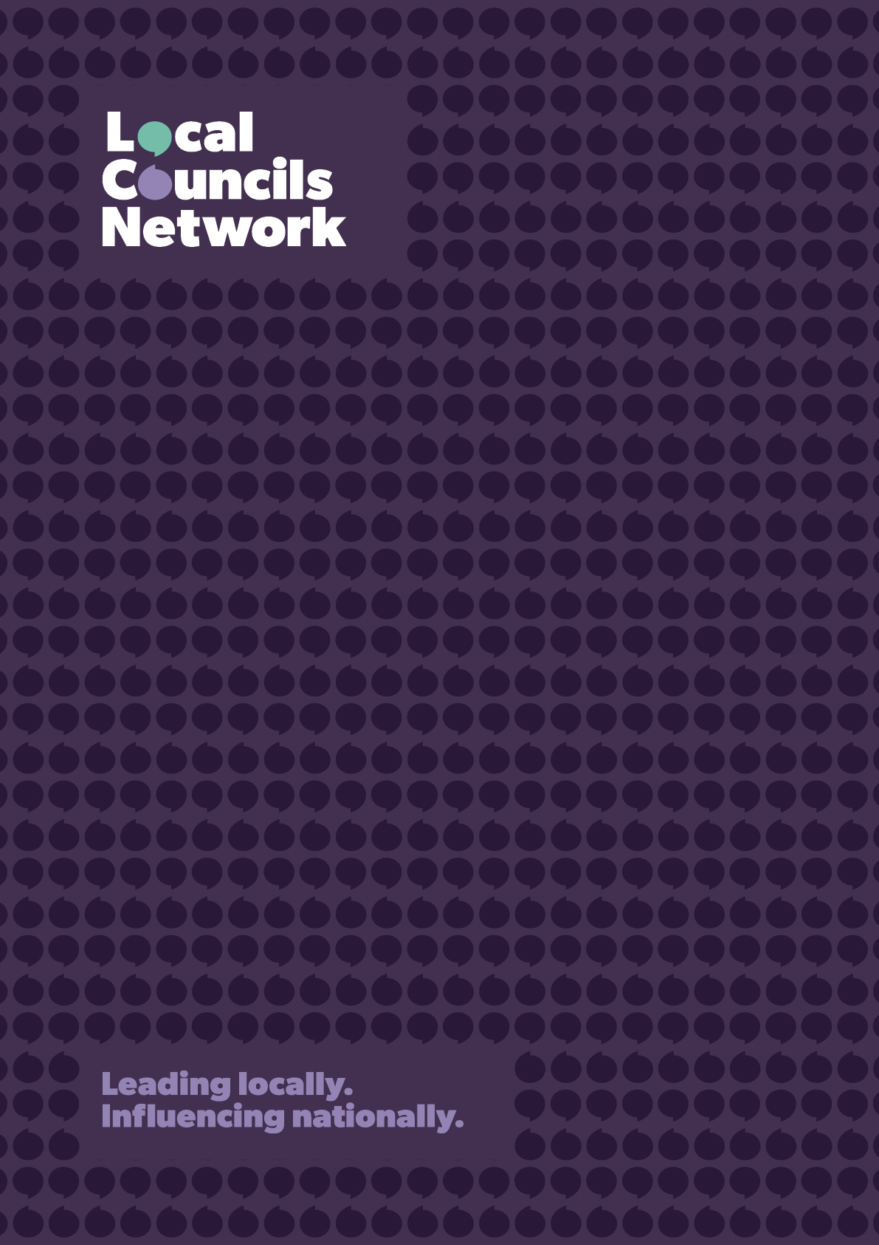
TEMPLATE FOR SUBMISSIONS
Local Councils Network: Local Councils’ Call for Change

Call for Ideas: Local Councils’ Call for Change

If central government could change one thing that would help you deliver better outcomes locally, what would it be?

The Prime Minister has made devolution, local leadership and public sector reform central to the Government's agenda, with a clear commitment to move power out of Whitehall and into the hands of the people and places best placed to use it.

As local leaders, we know that councils often have the insight, experience and practical understanding that central government simply cannot. We see first-hand the challenges facing our communities. We know where national rules, regulations and funding arrangements get in the way. And we know what changes would unlock better outcomes for residents, businesses and local places.

Too often, however, those ideas remain local. There is no single, coordinated mechanism for councils to come together and make the case for change.

We want to change that.

As a network, we are developing a Local Councils’ Call for Change – a practical, evidence-based set of proposals to present directly to ministers, civil servants and policy-makers. Our aim is simple: to shape the next phase of the Government's devolution and local leadership agenda from the ground up.

We want this document to be rooted in the real-world experience of councils and focused on the barriers that prevent local leaders from delivering the outcomes their communities need.

Why This Matters

This approach has worked before.

In 2008, Government invited councils via the Local Government Association (under the Sustainable Communities Act process) to identify legislative and policy barriers preventing local action. More than a third of the proposals submitted were subsequently accepted, in full or in part, by Government and helped shape future reforms.

Measures taken forward included business rates retention, HRA self-financing, the Community Right to Bid for Assets of Community Value, and the Community Right to Build, changes that have had a lasting impact on local government's ability to shape and support communities.

Unlike that formal, government-led process, this exercise would be led by the local government sector itself and would not have a legislative footing. It is an opportunity for councils to speak with a stronger, collective voice and put forward practical solutions to Ministers on the issues that matter most.

What We're Looking For

We are inviting councillors and officers to submit proposals for changes to national legislation, regulation, policy, funding arrangements or local powers.
Your proposal could relate to:
- Planning and housing
- Licensing
- Environmental health
- High streets and local economies
- Waste and recycling
- Community safety
- Social care
- Public health
- Transport and highways
- Leisure and culture
- Devolution
- Council tax
- Business rates
- New local tax-raising powers
- Procurement
- Climate and net zero
- Homelessness
- Local government finance
- Democratic governance

Or any other area where a change in national policy would help your council achieve better outcomes locally.

How to Submit

Please complete the template below and return it to lcn@local.gov.uk by 23 September 2026.

Please keep submissions to no more than 1,000 words.

Please note that all submissions must be cleared by your Chief Executive and/or Council Leader before submission.

Council
Name
Role
Email Address
Telephone Number
Proposal Title
Problem
What challenge is your community facing?
Barrier
What legislation, regulation, policy, funding arrangement or government requirement is preventing progress?

Proposal for Change
What specific change would you like central government to make?

Benefits
How would this improve outcomes for residents, businesses or communities?

Evidence
Please include any examples, data or experiences that support your proposal.

What Happens Next?

We will review all submissions and identify the strongest themes, priorities and opportunities emerging from across the network.

The most compelling and widely supported proposals will be brought together into a Local Councils’ Call for Change, which will be used to inform discussions with ministers, civil servants and parliamentarians.

This is an opportunity to influence national policy with ideas that are grounded in local experience.

Whether it is a small regulatory change, a new local power, a funding reform or a major shift in how public services are delivered, we want to hear from you.

Local government has a rare opportunity to shape the future of devolution, local leadership and public service reform.

This is our chance to shape the national agenda, not simply respond to it.

Together, we can use our collective experience, credibility and influence to make the case for change and secure the powers and freedoms communities need to thrive.

Questions?

If you have any questions or would like to discuss a proposal before submitting it, please contact Alison Potter, Assistant Director, at alison.potter@local.gov.uk, or the LCN team at lcn@local.gov.uk. We would be happy to help.

