Legal and Democratic Services  HEAD OF SERVICE: Vivien Williams | 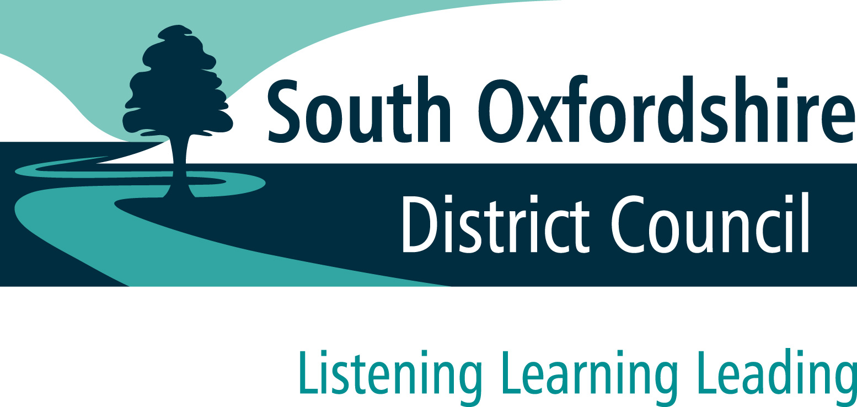
 | 
CONTACT OFFICER: Emily Barry
Emily.barry@southandvale.gov.uk
Tel: 07717 272442

Abbey House
Abbey Close
Abingdon
OX14 3JE

Dear Applicant

APPOINTMENT OF INDEPENDENT REMUNERATION PANEL

Thank you for your interest in becoming a member of the Independent Remuneration Panel. I hope that this pack provides you with useful information to aid you in completing the application form.

The appointment process is as follows:
- There is an application form which you need to complete.
- Please return the completed application form by 5pm on Monday 8 April 2024, either by post or email.
- We will then consider your application and will draw up a shortlist of candidates for interview.
- Interviews will take place in April. These will take place in person at Abbey House, Abingdon. Within reason we will try to arrange the interview to suit you.
- The interview process will not involve any other tests or activities. If you want to know anything more about the process, please contact Emily Barry at emily.barry@southandvale.gov.uk
- The council’s head of legal and democratic services will appoint members to the Independent Remuneration Panel, in consultation with the interview panel.
- We will let you know the decision on your application as soon as possible after its meeting.
- If successful, you will be appointed until May 2028.

I hope that having read this letter and the material enclosed with it, you will wish to apply for the position. If you would like to be considered, please complete the form and return it to me at the address provided. If you would like to talk about what would be involved, please do not hesitate to contact me.

Yours sincerely

Emily Barry
Democratic Services Officer

Encs
South Oxfordshire District Council and Vale of White Horse District Council

JOINT INDEPENDENT REMUNERATION PANEL

Recruitment pack

Contents

- About South Oxfordshire and Vale of White Horse District Councils

- About councillors’ allowances

- Job description and personal qualities

- Application form

ABOUT SOUTH OXFORDSHIRE dISTRICT COUNCIL AND VALE OF WHITE HORSE DISTRICT COUNCIL

South Oxfordshire District Council exists to serve its citizens across four towns and over 80 parishes. Vale of White Horse District Council serves its citizens across 68 town and parish councils. The two district councils cover the rural areas and towns in the southern half of Oxfordshire but excluding the city of Oxford.

South Oxfordshire District Council has 36 councillors; Vale of White Horse has 38. Councillors are sometimes referred to as ‘members’ of the council.

Councillors are elected for a four-year period to represent the views of the local community as a whole as well as residents in their electoral ward. There are approximately 200,000 electors across the two districts. As part of representing the electorate, councillors are responsible for making decisions concerning the council’s services.

The key roles of a district councillor are to:
- collectively with fellow councillors, be the ultimate policy-makers for the district as a whole;
- contribute to the good governance of the district, and encourage community participation and citizen involvement in decision-making;
- effectively represent the interests of their electoral ward and of individual constituents;
- respond fairly and impartially to constituents’ enquiries and representations;
- participate in the governance and management of the council; and
- maintain proper standards of conduct and ethics.

ABOUT COUNCILLORS’ ALLOWANCES
The councils have a duty to establish and maintain an independent remuneration panel to review councillors’ allowances and make recommendations to the council. The councils can only approve a councillors’ allowances scheme having first considered the report of their independent remuneration panel.

The government has issued regulations and guidance to councils on councillors’ allowances. This sets out the types of allowances which can be paid and what the allowances cover. Under the regulations, councillors cannot claim an allowance for each meeting they attend. Instead, the councils must pay a basic allowance to all councillors for their work as a district councillor. Any councillor that undertakes a more specific role, such as a committee chair, chair of the council, or leader of the council, will have a significantly enhanced workload. To compensate for this extra work, the regulations allow the councils to pay special responsibility allowances. The independent remuneration panel’s role is to periodically review whether these allowances offer fair recompense to councillors to ensure they are paid for their time and are not out of pocket. The Panel will be supported by council officers who will provide training and provide administrative and research support. The panel then makes recommendations to the councils if it believes the allowances should be updated.

JOB DESCRIPTION AND PERSONAL QUALITIES

Term of office: This appointment is until May 2028

Remuneration: Travel expenses to and from panel meetings

Hours: As required

Location: Occasional meetings at the council offices, currently at Abbey House, Abingdon.

Job description

PRIMARY FUNCTION OF APPOINTMENT

To help the councils discharge their duty under The Local Authorities (Members’ Allowances) (England) Regulations 2003 to review councillors’ allowances and make recommendations to the councils so they can adopt councillors’ allowances schemes.

POST SPECIFIC TASKS FOR PANEL MEMBERS

- Reading and digesting the regulations and guidance on councillors’ allowances.
- Reading and digesting the current councillors’ allowances schemes for South Oxfordshire District Council and Vale of White Horse District Council.
- Attending daytime panel meetings at the councils’ offices, currently at Abbey House, Abingdon or online virtual meetings.
- Investigating whether the current allowances offer fair recompense for councillors’ time, effort and responsibility.
- Analysing comparative data from other councils.
- Interviewing councillors to ascertain the level of commitment to their various roles.
- Reaching a conclusion on balanced and reasoned conclusions in a fair and impartial manner.
- Recommending the two councils on a joint councillors’ allowances scheme or separate schemes if necessary.
- Preparing a councillors’ allowances scheme to recommend to parish councils.

Personal skills
These are assessed from the application form and at the interview. You will not need to have any specific education or experience. However, we are looking for the following competencies:
- a keen interest in ensuring fair recompense for councillors’ roles in local government;
- a wish to serve the public interest and the local community and to uphold local democracy;
- leadership qualities, particularly in respect of exercising sound judgement;
- an understanding of the concept of accountability;
- respect for others and high standards of personal honesty and integrity;

and the ability to:
- lead by example, and to always act in a way that preserves public confidence;
- take account of the views of others but able to reach your own conclusions on issues before you;
- show sound decision-making skills and to be objective, independent and impartial and to make decisions based on their merit;
- put aside political affiliation and personalities when making decisions;
- give reasons for decisions or actions taken whilst respecting issues of confidentiality;
- ask searching questions without confrontation; and
- demonstrate stewardship and prudence.

In addition to the above, it would be helpful but is not essential, to have some knowledge of local government.

APPLICATION FORM | 
Independent Remuneration Panel membership

All information provided will be treated as confidential and used only for the purposes of appointing members to the Independent Remuneration Panel.

If you wish to expand on your answers, please feel free to use separate continuation sheets. If you want to discuss any aspect of your application, please contact Emily Barry on 07717 272442, emily.barry@southandvale.gov.uk.

Personal details and declarations

Surname/Family Name | Title:
First Name(s):

Address:  Email: | Telephone number(s)  Home:  Mobile:  Work:  May we contact you at work?  No Yes .

Declaration:

If you answer yes to any of these statements, the law may (or may not) disqualify you from being an Independent Remuneration Panel member at this time. Please give details in the section below, or on a separate sheet if necessary.

- I am a member, co-opted member or officer of South Oxfordshire or Vale of White Horse District Council.  - I am a member, co-opted member or officer of a parish council of which South Oxfordshire or Vale of White Horse District Council is the principal authority.  - I am a relative, or close friend, of a member, co-opted member or officer of South Oxfordshire or Vale of White Horse District Council.  - I am a relative, or close friend, a member, co-opted member or officer of a parish council of which South Oxfordshire or Vale of White Horse District Council is the principal authority.  Within the last five years  - I was a member, co-opted member or officer of South Oxfordshire or Vale of White Horse District Council  - I was a member, co-opted member or officer of a parish council of which South Oxfordshire or Vale of White Horse District Council is the principal authority;  - I am now or have been a member of, or involved in, a political party in any capacity  - I have unspent criminal convictions  Details about any statements answered ‘yes’ | No Yes .  No Yes .  No Yes .  No Yes .  No Yes .  No Yes .  No Yes .  No Yes .
I can confirm that there is nothing in my private life, or in my past, or to my knowledge in that of any member of my family or close friends which, if it became generally known, might bring me or the council into disrepute.  If ‘no’ please give details below: | No Yes .

Please give the names, addresses and contact numbers of two people who can act as referees and provide us with an assessment of your suitability for the post.

Name | Name
Telephone | Telephone
Address | Address
Connection with you | Connection with you
May we contact this person without obtaining your consent beforehand? | May we contact this person without obtaining your consent beforehand?

I confirm that all the information given in this application is correct.

Signed |  | Date

Please return by 5pm on Monday 8 April 2024 to the contact officer detailed in the covering letter.

Supporting Information

This section is the most vital part of the form. We need you to give us relevant information to support your application in order for us to shortlist in a fair and unbiased way. Please refer to the information pack to help you with this. If you use continuation sheets please mark each sheet clearly with your name.

Please provide a brief account of your experience, including career, voluntary work, professional or academic qualifications, and involvement with politics and/or local government relevant to this role. Please also give details of your skills, knowledge and expertise relevant to this role. Please provide brief details of your current occupation and involvement with voluntary work, charities, politics and local government or special interest groups.

Skills, qualifications, voluntary activities, and experience
You may prefer to attach a copy of relevant parts of your CV.

Why do you wish to be considered for the position of member of the Independent Remuneration Panel?

Please provide any additional information you wish to be considered as part of your application.
You may prefer to attach a copy of relevant parts of your CV.

